Graphical Budget Planner 1.8.0
User Manual

Last revision date : 2026-06-25 20:10:49

Table of Contents
1. Table of Contents 2
2. License, disclaimers, source code repository, user manual 5
3. Supported platforms & languages, requirements 7
3.1 RAM and disk space 7
3.2 Screen resolution 7
3.3 Platforms supported 7
4. Installation 8
4.1 On Linux platforms 8
4.1.1 Ubuntu special case 8
4.2 On Windows® 11 Home Edition 8
5. Known issues 9
6. Introduction 10
6.1 Overview 10
6.2 Cash Stream Definitions (a.k.a. CSD) 11
6.2.1 Periodic Cash Stream Definition 12
6.2.2 Irregular Cash Stream Definition 12
6.3 Growth for periodic Cash Stream Definition 13
6.4 Scenario 14
6.5 Cash balance curve 14
6.6 Analysis 16
6.7 Tags 20
6.7.1 Key characteristics 20
6.7.2 Why tags are powerful 20
6.7.3 Editing tags 21
6.7.4 Using tags 21
6.7.5 Example 23
7. User interface description 24
7.1 Main window 24
7.1.1 Splitter 24
7.1.2 Menus 25
7.1.3 Cash balance curve 30
7.1.4 Toolbar buttons 31
7.1.5 Action zone for the chart 32
7.1.6 Selected point info panel 34
7.1.7 Statistics 35
7.1.8 Date range 35
7.2 Create new scenario 35
7.2.1 Choose a currency 36
7.2.2 Second Step : Edit the scenario 36
7.3 Edit scenario 36
7.3.1 Metadata editing 37
7.3.2 Cash Stream Definitions editing 40
7.3.3 Manage tags 42
7.4 Creating/editing a periodic Cash Stream Definition 45
7.4.1 Name 46
7.4.2 Description 46
7.4.3 Amount 46
7.4.4 Period and period multiplier 47
7.4.5 Start date 47
7.4.6 End date 48
7.4.7 Colorize name 48
7.4.8 Linked tags 49
7.4.9 Enabled 49
7.4.10 Advanced section 49
7.4.11 CSD Breakdown 50
7.4.12 Visualize occurrences 51
7.5 Creating/Editing an irregular Cash Stream Definition 52
7.5.1 Name 52
7.5.2 Description 52
7.5.3 Colorize name 52
7.5.4 Linked tags 53
7.5.5 Enabled 53
7.5.6 List of financial events 53
7.5.7 Actions buttons 53
7.5.8 CSD Breakdown 53
7.5.9 Visualize occurrences 54
7.5.10 Import 54
7.6 Options window 55
7.6.1 Location of the settings 55
7.6.2 Saving the settings 55
7.6.3 Resetting the settings 55
7.6.4 General options 56
7.6.5 Chart-related options 59
7.7 Analysis window 63
7.7.1 Relative weight tab 64
7.7.2 Period – chart 65
7.7.3 Period – list 67
7.7.4 Period – heatmap 68
7.7.5 Tags 71
7.7.6 Compare CSD 72
7.8 Present value calculator 73
7.8.1 Formulas used 74
7.8.2 Description of the fields 74
8. Usage 76
8.1 Preparing to create a budget 76
8.1.1 Collecting information 76
8.1.2 Practical examples of periodic Cash Stream Definitions 76
8.1.3 Practical examples of irregular Cash Stream Definitions 83
8.2 Creating the budget in GBP 86
8.3 Using tags efficiently 87
8.3.1 Overlapping categorization 87
8.3.2 Representation of hierarchies 89
8.4 Using a budget scenario as time goes by 92
8.4.1 Typical workflow 92
8.4.2 Alternate workflow 95
8.4.3 Future values vs present values 96
9. Command line parameters 99
9.1 Getting help 99
9.1.1 -h, --help 99
9.2 Appearance options 99
9.2.1 -usesystemfont 99
9.2.2 -windowslook=STYLE 99
9.3 Display server options 100
9.3.1 -xwayland 100
9.3.2 -noxwayland 100
9.4 Localization options 100
9.4.1 -locale=LANG-TERRITORY 100
9.5 Logging options 101
9.5.1 -logprivacy=PRIVACY_CHOICE 101
9.5.2 -logverbosity=VERBOSITY_CHOICE 101
9.6 Workspace options 101
9.6.1 -workspace=WORKSPACE_NAME 101
9.6.2 -workspace_list 102
9.6.3 -workspace_cleanup 102
10. Logs 103
10.1 Location 103
10.2 Naming 103
10.3 Cleaning 103
11. Glossary 104

License, disclaimers, source code repository, user manual
Graphical Budget Planner (a.k.a graphical-budget-planner or Gbp) is a free and open source Qt desktop application intended to ease significantly the process of creating, maintaining and analyzing a personal budget. Gbp focus only on the future and does not track past expenses or incomes.

This application and all its source code are licensed under the GNU Affero General Public License version 3 or later (AGPL-3.0-or-later). It's Free Software. See https://www.gnu.org/licenses/#AGPL/

Software repository for GBP can be found at :

https://github.com/redmoon1945/gbp

Being built with the Qt toolkit, GBP is subject to the Qt terms and conditions : see qt.io/licensing
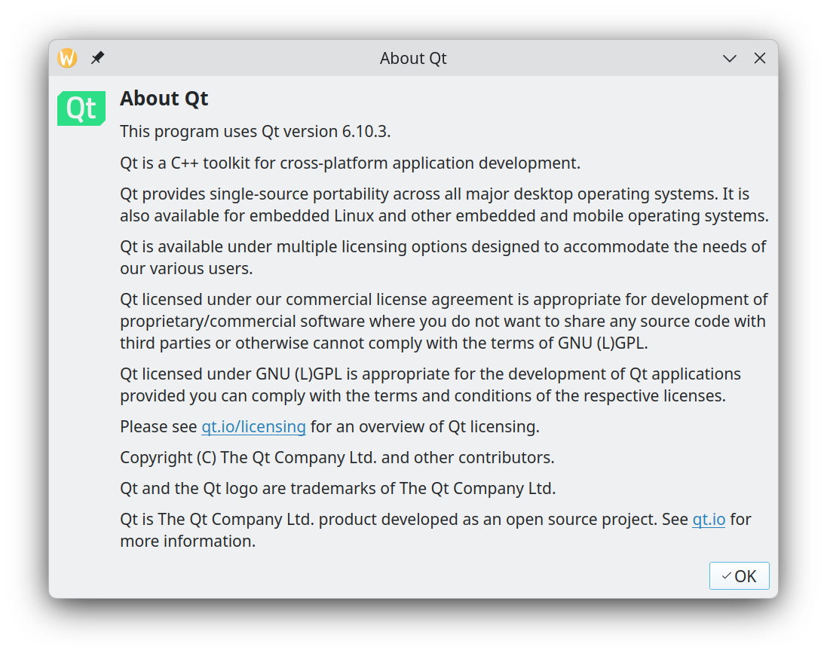
Credits :
- Tobias Leupold : code to calculate difference between 2 dates -> see https://nasauber.de/blog/2019/calculating-the-difference-between-two-qdates/

To contact the author(s) of this software, you can either
- create an issue in the repository’s issue tracker. This way, the owner and other collaborators can discuss and resolve the issue.
- Contact by email : redmoon1945@protonmail.com

This documentation is released under the GPL 3.0 license

It is possible to access a PDF version (english only) of this User Manual from within the application itself. Select menu "Help → User Manual". The application will copy its own internal and private copy of the User Manual in a temporary directory (the exact location is system dependent) and will then launch the default PDF viewer of the Operating System.
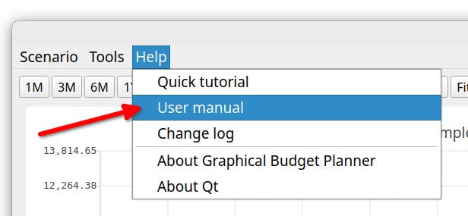

A quick tutorial (english only) is also available in this menu.

Supported platforms & languages, requirements
GBP is intended to be run first and foremost on the Linux Operating System. But since it is built using the Qt cross platform toolkit, a version of GBP for the Windows® Operating System is also provided and fully tested (on Windows® 11 Home Edition only). A version for Mac could easily be created if there is demand for it. A mouse is required to use the software.

RAM and disk space
GBP does not use a lot of RAM (typically between 100 and 200 MB) and necessitate roughly 50 MB of disk space (not taken into account the scenario files that you will create and GBP log files, which are all very small anyways).

Screen resolution
Usually 1500 x 900 is required. But it can be more depending on the application font used. Here are some guidelines :
- Linux
  - Noto sans 10, 12, 16, : 1500 x 900
  - Noto sans 24 : 1863 x 1047
- Windows
  - Segoe UI 9 : 1500 x 900
  - Segoe UI 24 : 1777 x 1035
  - Arial 18 : 1500 x 900
  - Comic Sans MS 18 : 1500 x 900

Platforms supported
As of July 2026, GBP has been extensively tested on the following platforms :
- Kubuntu 26.04 LTS, KDE 6.6.4, Wayland, Kernel 7.0.0-22
- Linux Mint Debian Edition 7, Cinnamon 6.4.13, X11, Kernel 6.12.94
- Windows® 11 Home Edition

It has also been tested, but not as extensively, on the following platforms :
- MX linux 25, XFCE 4.20.1, X11, Kernel 6.16.12
- Fedora 43, KDE Plasma 6.6.5, Wayland, Kernel 7.0.11-100
- OpenMandriva Lx 5.0, X11, KDE Plasma 5.27.9, kernel 6.6.2
- Ubuntu 24.04.04 LTS, Gnome 46, Kernel 6.7.0-35
- Ubuntu 22.04.5 LTS, Gnome 42.9, X11, Kernel 6.8.0-52
- Ubuntu 22.04.5 LTS, Gnome 42.9, Wayland, Kernel 6.8.0-52

GBP supports English and French languages. By default, English is used, but if the host Operating System is in French (whatever the country), then GBP will switch to French. More languages will hopefully be added in the future, if resources to translate are available.

Installation

On Linux platforms
GBP is distributed as an "AppImage", which is a single-file executable packaging format allowing a program to run on many Linux distributions. There is nothing else to install. After downloading the AppImage from GBP site (https://github.com/redmoon1945/gbp/releases), user just has to enable "executable" permission on the file and it is ready to be launched. For example, on Linux Mint, using the "properties" menu of the file :

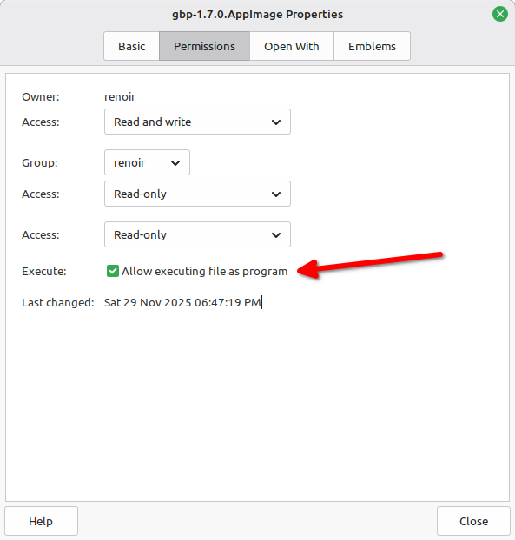

Ubuntu special case
On Ubuntu (tested on v 22.04, 24.04), one additional step must be performed. In order to run an AppImage, some packages are missing from the default distribution. Ubuntu needs the FUSE 2 library to run AppImage like GBP. Otherwise, when launched, you will get the following error :

dlopen(): error loading libfuse.so.2

AppImages require FUSE 2 to run. To solve this, do :

sudo apt install libfuse2

On Windows® 11 Home Edition
GBP is distributed as a simple zip file : unzip it in a folder of your choice and run the gbp.exe application found inside.

Known issues
- On Ubuntu Linux systems (tested on 22.04 and 24.04), secondary windows (e.g. popup dialogs) are tied by default to the Main Window and cannot be moved. To be able to move them (which is recommended as it adds flexibility), you can use the Gnome Tweaks application : go to Windows->Attach Modal Dialog and toggle to OFF. Another approach is to type the following command in a terminal : gsettings set org.gnome.mutter attach-modal-dialogs false
- In extreme scenarios (meaning that do not correspond to expected use cases of GBP), where really extremely large data set is generated (e.g. generate many events per day, every day, for 100 years), there could be a noticeable lag between the moment you click on a point of the Cash Balance curve and the relevant info is displayed in the right panel. This depends heavily on the speed of your computer. Performance improvements for this scenario type are planned for a future release.

Introduction

Overview
Graphical Budget Planner (GBP) is an open-source Qt desktop application designed to greatly simplify the process of creating and maintaining a personal budget. It focuses forecast planning and provides a range of powerful visualization and analysis tools.

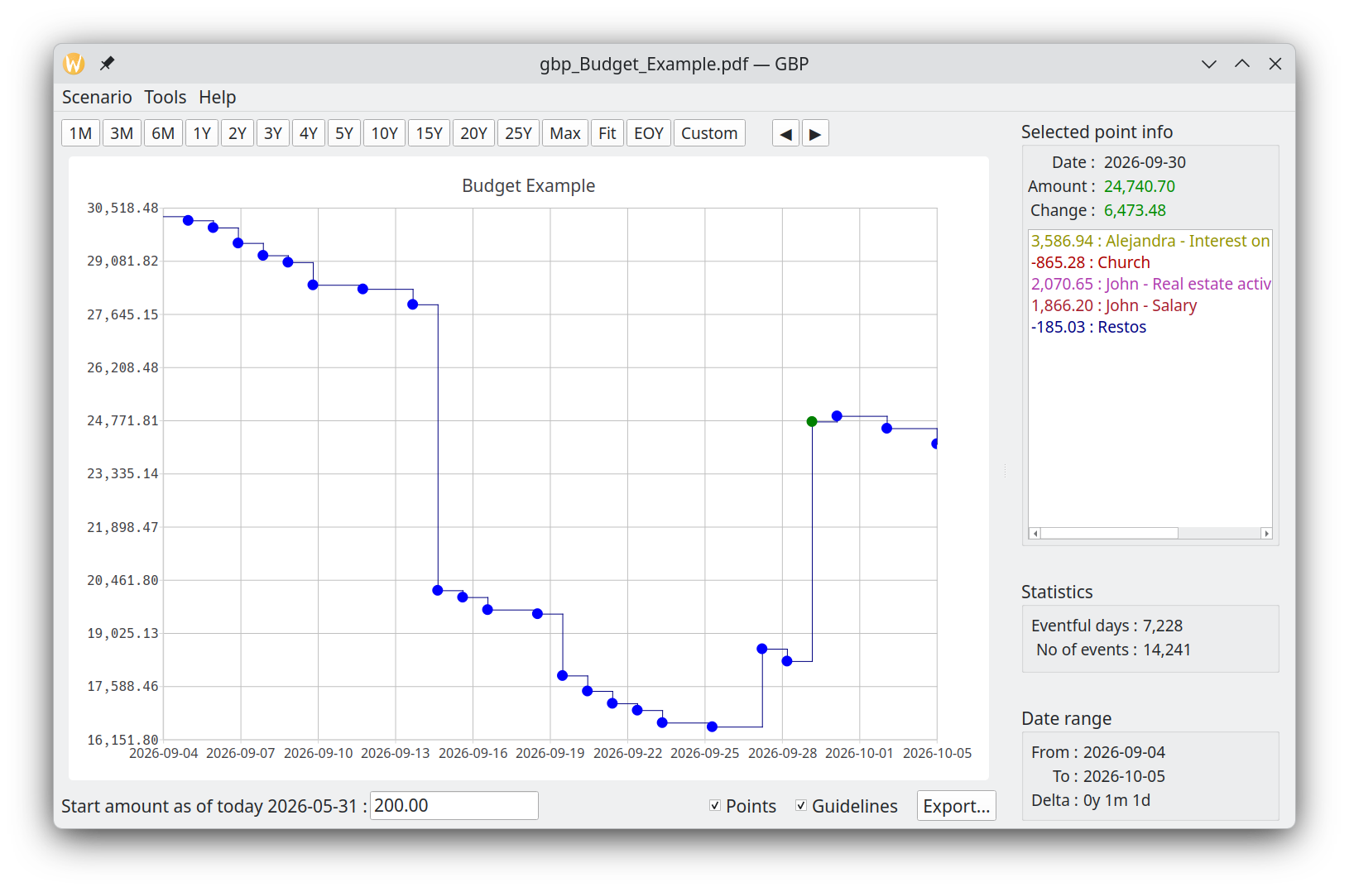
Key features include:

- Graphical cash-balance timeline — visualize how your cash balance evolves over time, across any period from 1 to 100 years.
- Smooth navigation — intuitive zooming and panning to explore your data easily.
- Flexible budget entry — define all forecast income and expense items, whether periodic or irregular, with minimal effort.
- Optional inflation modeling — set inflation as a constant rate or as a detailed series of varying values.
- Custom monthly growth patterns — define growth for any income or expense item using either a constant rate or a detailed month-by-month profile.
- Present-value conversion — optionally convert all financial events to present values using a configurable annual discount rate.
- Automated analysis tools — generate insights such as income/expense weight over a custom period, heatmap, and monthly or yearly reports.
- Open data format — scenarios are stored in human-readable JSON files, and all results can be exported to CSV.
- Full Unicode support — all text fields accept and display Unicode characters correctly.

GBP is all about cash-balance forecasting. Its core design principle is simple: it considers only future income and expense events — everything expected to occur starting from “tomorrow.”

Consequently, GBP is not intended for users who want to review how or when their money was spent in the past (the so-called income/expense tracking). That also means that if you start the program, lets say once a month, you may not see the same curve in the Main Window each month. This is because events that have occurred during a given month are now past when the next month occurs, and thus not taken into consideration. There is however a way in the Options Settings to overcome this behavior (see "Settings").

Cash Stream Definitions (a.k.a. CSD)
In GBP, you have to define all expected or forecast income and expense items for the future. From these definitions, GBP generates the cash-balance curve displayed in the Main Window.

Naturally, you don’t want to manually enter every single occurrence of each income or expense across months or years. To greatly simplify this process, GBP introduces a key concept: the Cash Stream Definition. You may create as many of these as you need.

A Cash Stream Definition is a declarative specification that describes how a flow of money (the financial-event “stream”) is produced over time. From each Cash Stream Definition, GBP automatically generates a sequence of financial events.

For example, consider a salary. Instead of manually entering every paycheck for decades, you can simply define a Cash Stream Definition such as: “Generate 2,000 USD every two weeks for the next 50 years.” GBP will then automatically produce all corresponding financial events. Each generated occurrence—such as a 2,000 USD salary payment on February 3, 2030—is a financial event. The next payment, e.g., on March 3, 2030, is another financial event, and so on.

They are 2 types of Cash Stream Definition : Periodic and Irregular.

Periodic Cash Stream Definition
It defines a fixed amount of money (income or expense) that occurs at regular intervals in time. The interval is specified by first defining a period type :
- Year
- Month
- End-of-month
- Week
- Day
And then a "period multiplier", which is an integer that is a multiplication factor of the period type selected (e.g. 3 years or 12 weeks).

A Periodic Stream Definition has a "Start Date" and an "End Date". Financial events will be generated only in that interval of time. The End Date can be explicitly specified ("Custom") or it can refer to a value that is defined at the scenario level.

An example of a Periodic Income would be a dividend received every 3 months or a salary received every 2 weeks.

Irregular Cash Stream Definition
This type of stream represents a set of amounts that occur at specific dates chosen by the user and that do not necessarily follow a periodic pattern. Each amount in the set can be completely different from the others, and there are no constraints on when these amounts may occur. They might coincidentally form a pattern, or they might not.

Example 1:

Suppose you expect the following future expenses over the next few years:

- 450 USD for dental work on June 12, 2036
- 1,200 USD for a home appliance replacement on January 5, 2037
- 300 USD for car repairs on October 21, 2028
- 900 USD for a planned short trip on April 14, 2029

These events do not follow any regular cycle. The amounts, dates, and spacing between events are all different. You simply enter each one as a date–amount pair in the Irregular CSD

Example 2 :
Another example is a revenue stream generated by complex financial instruments, such as dividends from multiple stocks. Since the dividend amount may vary from month to month—based on market conditions, company decisions, or portfolio changes—you might calculate these values externally (for example, in a spreadsheet or another financial tool) and then import them into GBP using a CSV file.
Because the amounts fluctuate and do not follow a constant or predictable growth pattern, they cannot be modeled using a standard Periodic Income stream. In such cases, an Irregular Cash Stream Definition is the appropriate choice: it lets you enter each varying dividend payment with its exact amount and date, preserving the accuracy of your cash-balance forecast.

Growth for periodic Cash Stream Definition
For a given Periodic Cash Stream Definition, it is possible to define a "Growth Pattern" that causes the initial fixed amount to change over time. There are 4 different ways to specify this grow pattern :

"No growth" :
The initial amount stays constant throughout the entire period [Start Date – End Date]

"Scenario’s inflation" :
The amount grows according to the inflation pattern defined in the scenario.
You may optionally apply an adjustment factor (default = 1) to scale the inflation effect.

"Custom – constant" :
You specify a single constant growth rate that applies only to this particular Periodic Cash Stream Definition.

"Custom - Variable" :
You define a custom series of growth values, allowing the amount to change in a non-uniform way over time. This variable pattern applies only to this Periodic Cash Stream Definition.

Scenario
In GBP, a scenario is a set of Cash Stream Definitions, plus other miscellaneous metadata.
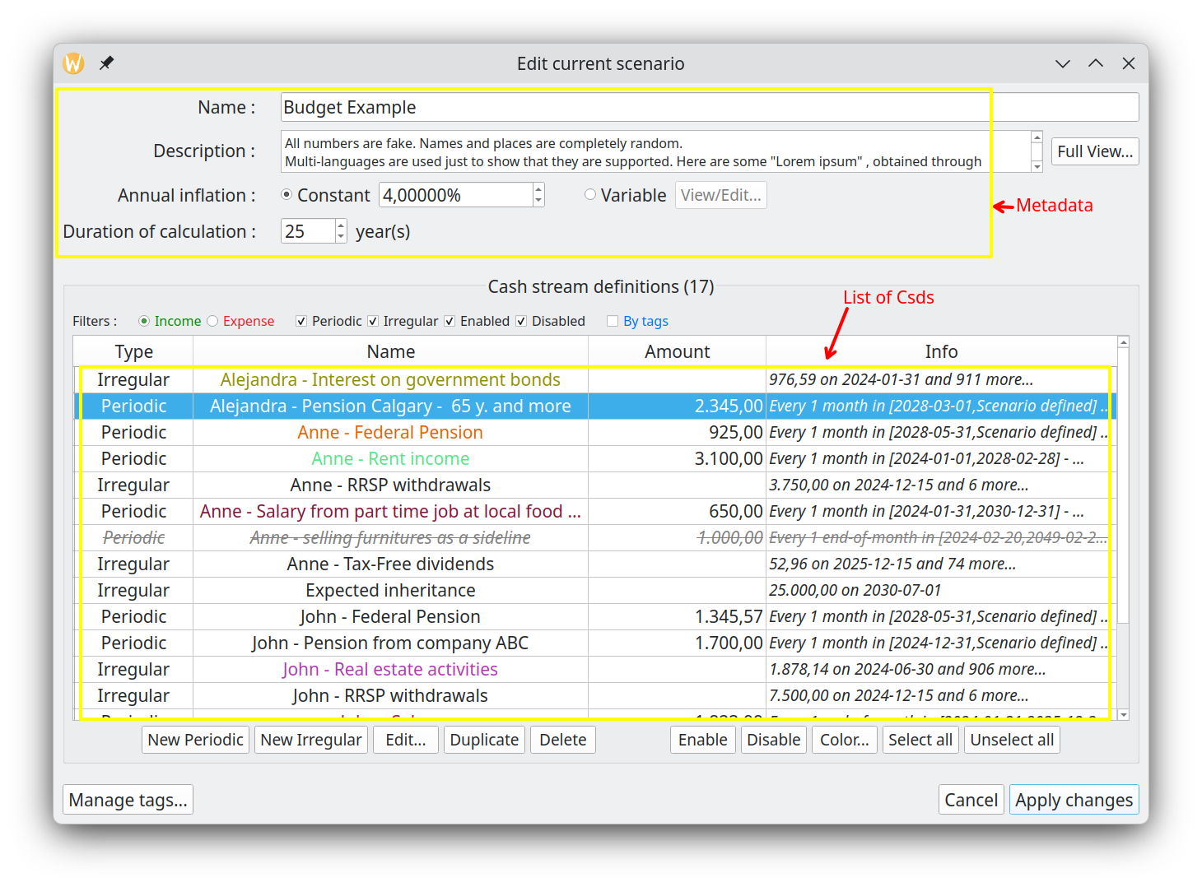All scenario data is stored in a single “.json” file — you choose the name. You can keep as many scenarios as you want, organized in any folder structure you like. They're ordinary JSON files, with no special requirements. There is only one scenario at a time that can be loaded in GBP. Once loaded via the "Scenario→Open" or "Scenario→Open Recent", scenario’s data can be inspected or edited using the "Scenario->Edit" menu.

Important: Any changes you make are kept in memory only until you save them. To make changes permanent, use Scenario → Save (overwrite the current file) or Scenario → Save As… (create a new file). Unsaved changes will be lost when you close the scenario or the application.

Cash balance curve
Once a scenario is loaded, the Cash Balance curve is automatically displayed in the Main Window. This curve shows the evolution of the cash balance over time, calculated from all income and expense events generated by the Cash Stream Definitions contained in the scenario. You can change the color of the curve in the Options dialog (accessible via Tools → Options).
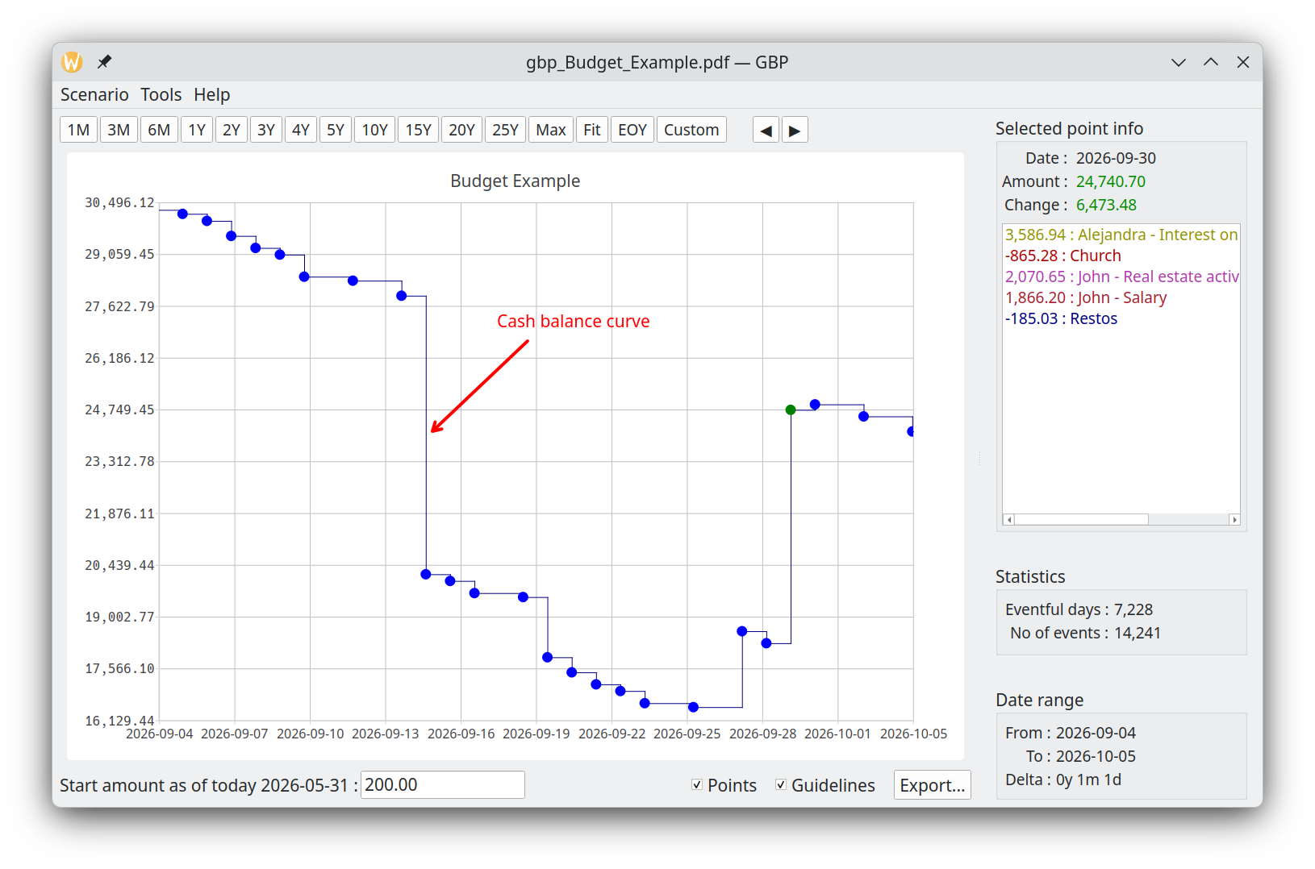
You can zoom the curve or move it with the mouse :

- Zoomed in/out with the mouse scroll wheel. 3 types of zoom operations are possible :
  - Scroll wheel alone : both horizontal and vertical zoom
  - Scroll wheel + SHIFT : horizontal zoom only
  - Scroll wheel + CONTROL : vertical zoom only
- Pan in any direction: Click and drag on the chart with the left mouse button.
- Pan left/right by window: Use the "<" and ">" toolbar buttons to move one full window width.
- Reset scale: Click the "predefined scales" toolbar buttons to quickly reset to standard zoom levels

Each data point shown (the small disk on the chart) represents an amount which is the sum of :
- all the financial event amounts that occurred in that very day
- the final cash balance of the previous data point.

If you click on a point, the color of the point changes (you set this color in "Options" Dialog.)

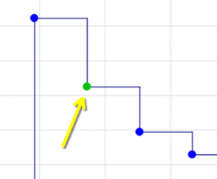

and the "Selected Point Info" panel to the right will show the details :

- Date : date of occurrence for that point
- Amount : total cash balance for that day, taking into account all the daily financial events
- Change : change in cash balance from the previous occurrence

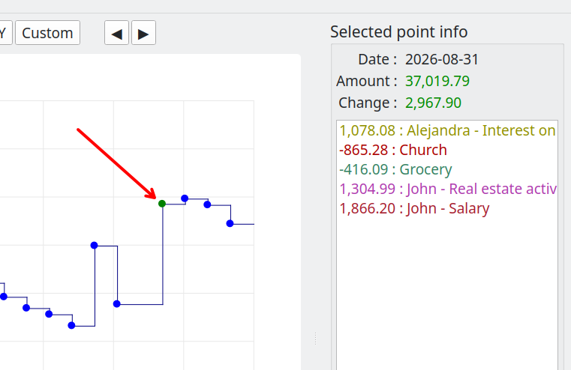

Re-clicking on the point clears this panel.

Analysis
GBP includes a powerful Analysis module that provides deeper insights into the data generated by the scenario’s Cash Stream Definitions. The Analysis module lets you explore key financial metrics, identify trends, detect potential cash-flow issues, and answer questions such as:
- Minimum, maximum, and average cash balance over any period
- Periods of negative cash balance (cash shortfalls)
- Longest stretch of negative or low cash
- Total income and expenses by category, stream, or time period
- Yearly or monthly summaries
- Projected liquidity risk and safety margins

More specifically, it offers :

=> A pie chart that illustrates the relative weight of each income (or expense). Very useful to understand what are the most important incomes or expenses over a specific time interval.

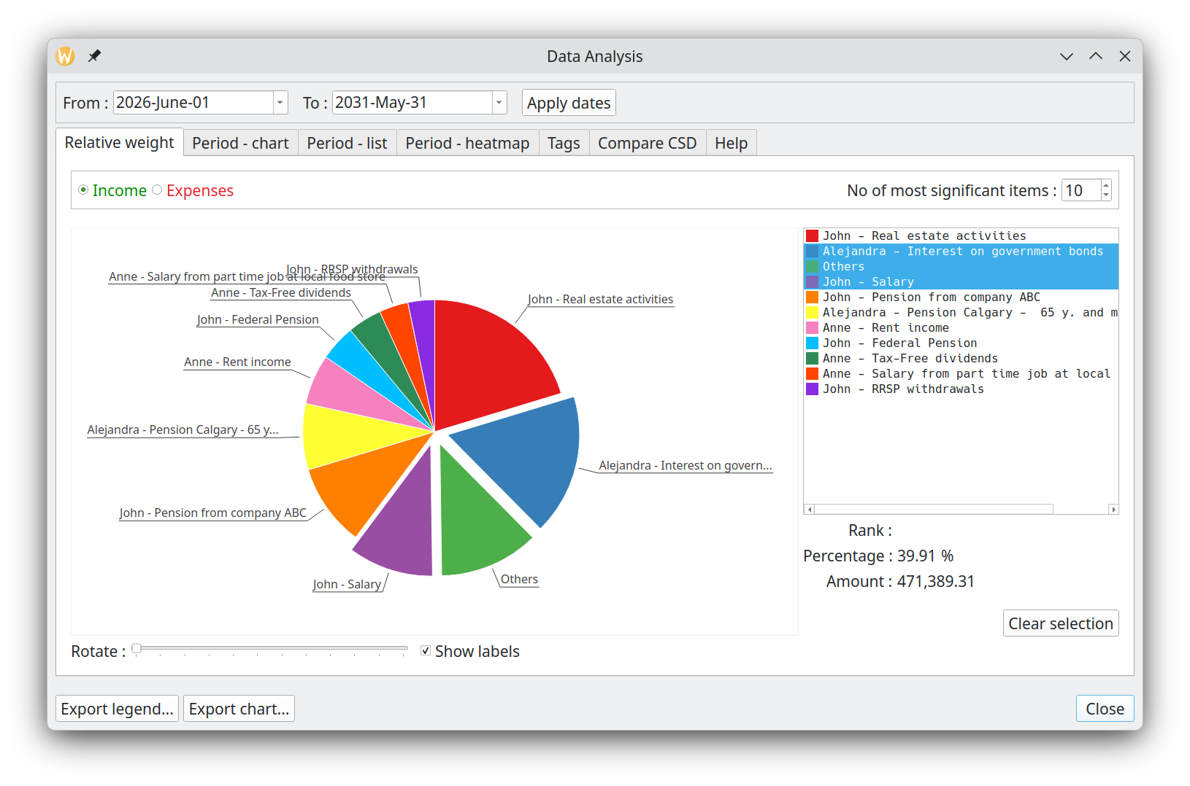

=> Bar charts showing the monthly/yearly total for incomes (or expenses)
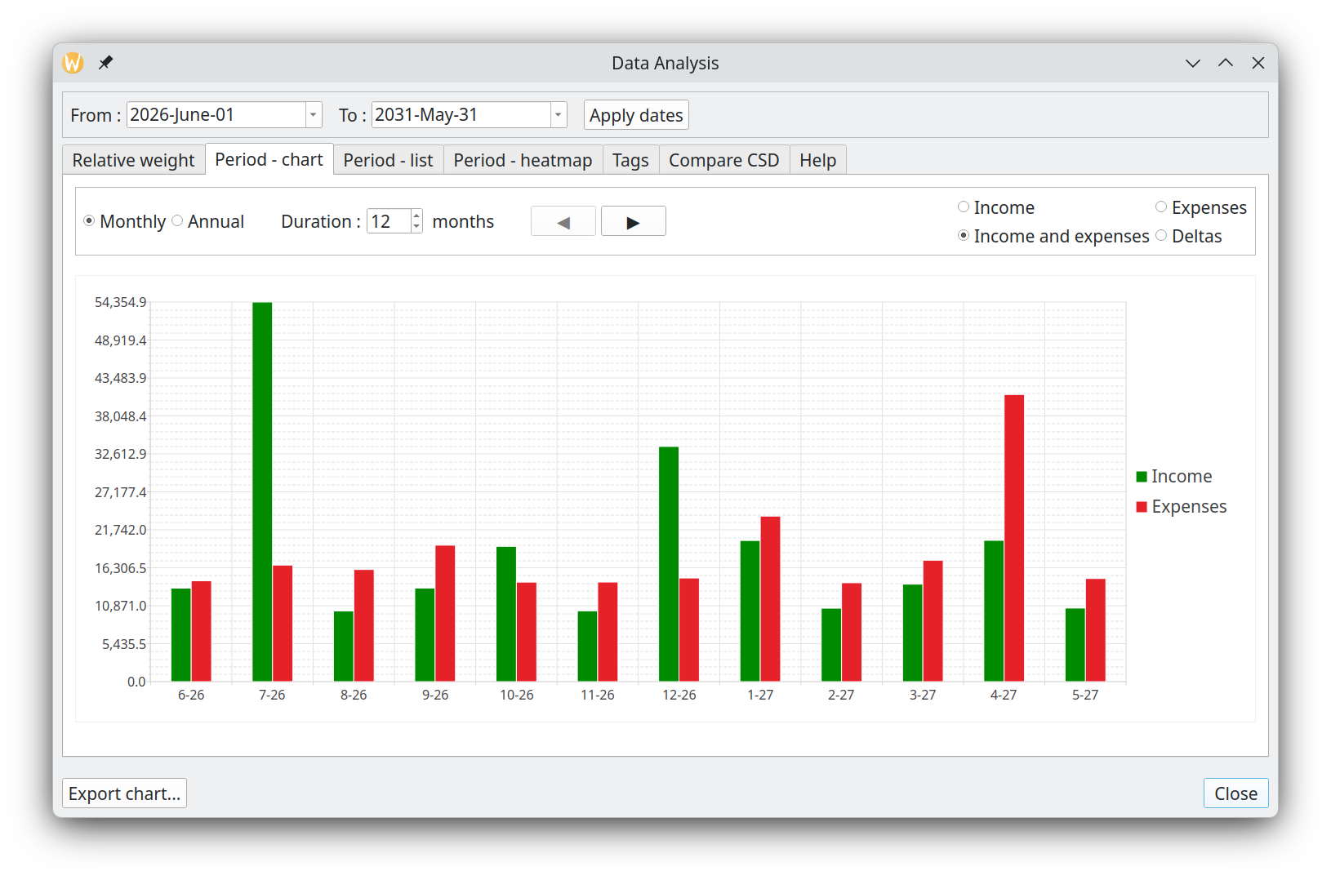

=> A tabular form of the previous
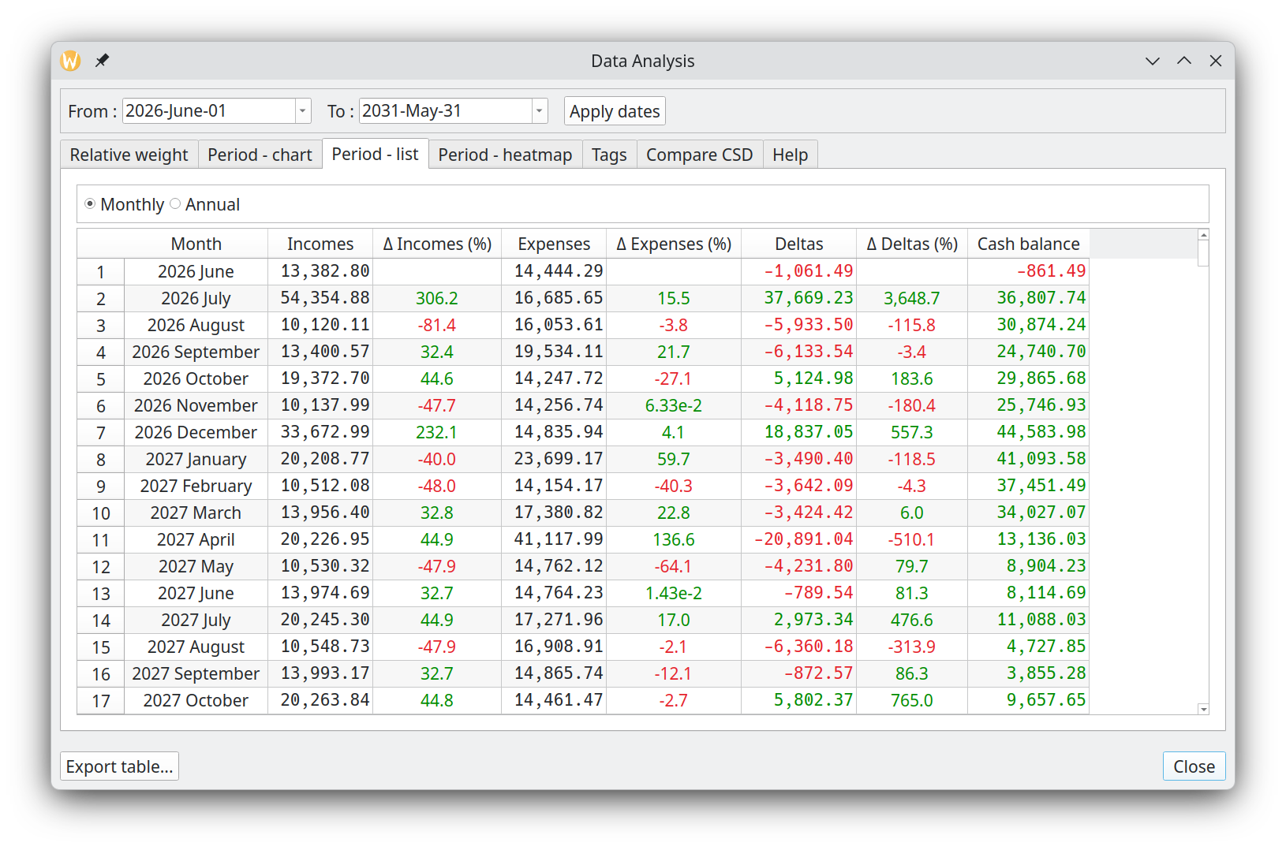

=> A Heatmap representation
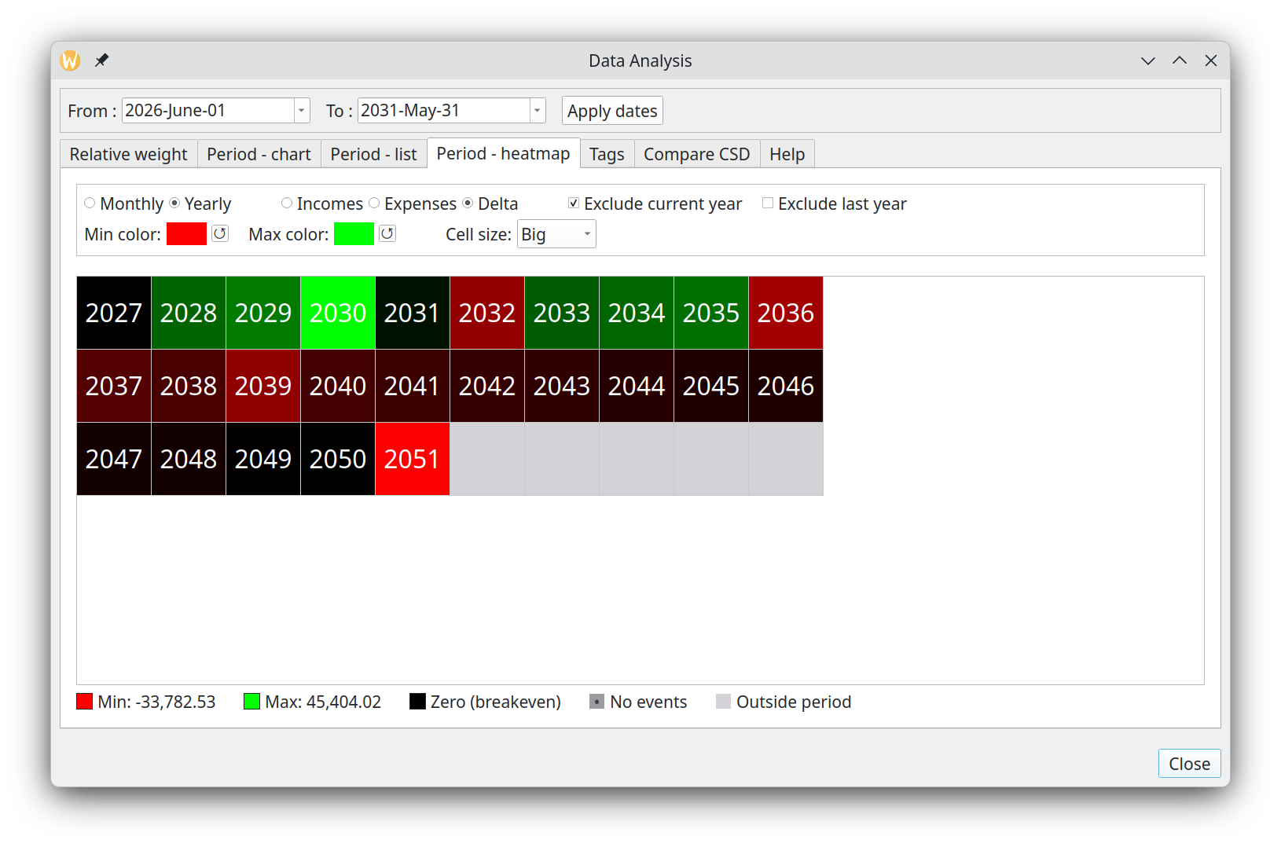

=> Statistics about the Tags used
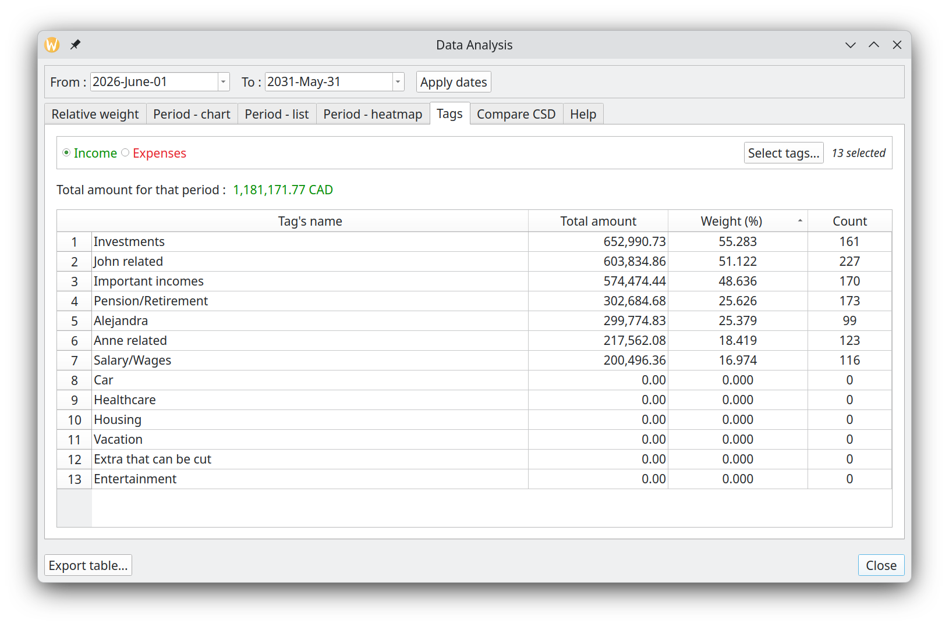

=> Compare a set of CSDs
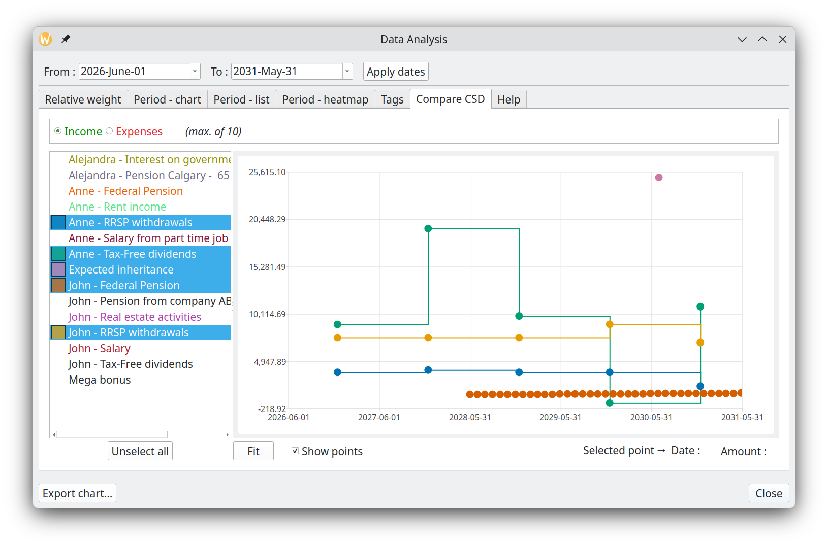

Tags
Introduced in version 1.6.0, the Tags feature provides a flexible and powerful way to categorize Cash Stream Definitions.

A tag is simply a user-defined label (or a short phrase) that acts as a single unit. You create tags according to your own needs—for example: “Salary”, “Taxes”, “Rent”, “Freelance”, “Marketing”, “Emergency Fund”, “House expenses”, etc. You associate tags to Cash Stream Definitions in order to “categorize” them.

Key characteristics
- Tags belong to a scenario: each scenario maintains its own independent set of tags (you can easily import tags from another scenario if desired).
- Tags and Cash Stream Definitions have a many-to-many (N-to-N) relationship:
  - One tag can be assigned to zero, one, or many Cash Stream Definitions.
  - One Cash Stream Definition can have zero, one, or many tags.

Why tags are powerful
This flexible system lets you categorize and filter cash flows in virtually unlimited ways, such as:

Many-to-many relationships — maximum flexibility
A tag can be linked to any number of Cash Stream Definitions (CSDs), and a CSD can carry any number of tags. This is not a rigid tree-based hierarchy — a single cash stream like "Netflix" can simultaneously belong to "Entertainment", "Subscriptions", and "Fixed Costs", enabling slicing from multiple angles at once.

Cross-cutting categories that survive restructuring
Because tags are independent labels, not folder-style categories, you can add a new dimension (e.g. "Deductible") to existing CSDs at any time without reorganizing anything. The structure of your scenario stays intact.

Boolean filter logic (AND / OR / NOT)
FilterTags supports three combination modes. You can ask for CSDs tagged with both "Work" AND "Travel", or any of "Housing" OR "Utilities", or streams that carry none of a set of tags. This makes analysis queries genuinely expressive rather than just name-matching.

Tag contribution analysis with weight
The Analysis dialog computes, for any date range, each tag's total amount and its percentage weight relative to the period total. You can instantly see that "Food" represents 23.4% of your expenses — with a sortable table and CSV export.

Separate income vs. expense views
The tag analysis distinguishes between income and expense processing. You can analyze how much of your income comes from "Freelance" tags, independently of how much you spend under "Freelance" expenses.

Import tags from another scenario
The Manage Tags dialog can load tags from any other GBP scenario file and merge them in (deduplicating by name, reassigning UUIDs). This lets you maintain a "master tag library" and share it across all your scenarios without manual re-entry.

Duplicate tags with their full relationship graph
A tag can be duplicated in one click, including all its CSD links. This makes it fast to create variations like "Food 2025" → "Food 2026" with the same stream assignments pre-populated, ready to be adjusted.

Editing tags
You manage tags in Scenario → Edit → Manage Tags dialog, where you can add, rename, delete, merge, or import/export them. Once assigned, tags are immediately available for filtering, coloring, and detailed reporting throughout GBP.

Using tags

Edit scenario dialog – filter view
In the Edit Scenario dialog, a powerful filter bar lets you show only the Cash Stream Definitions that match specific tag criteria (e.g. streams that have all of the selected tags, any of them, or none of them). This makes it easy to work with large scenarios containing dozens or hundreds of Cash Stream Definitions.
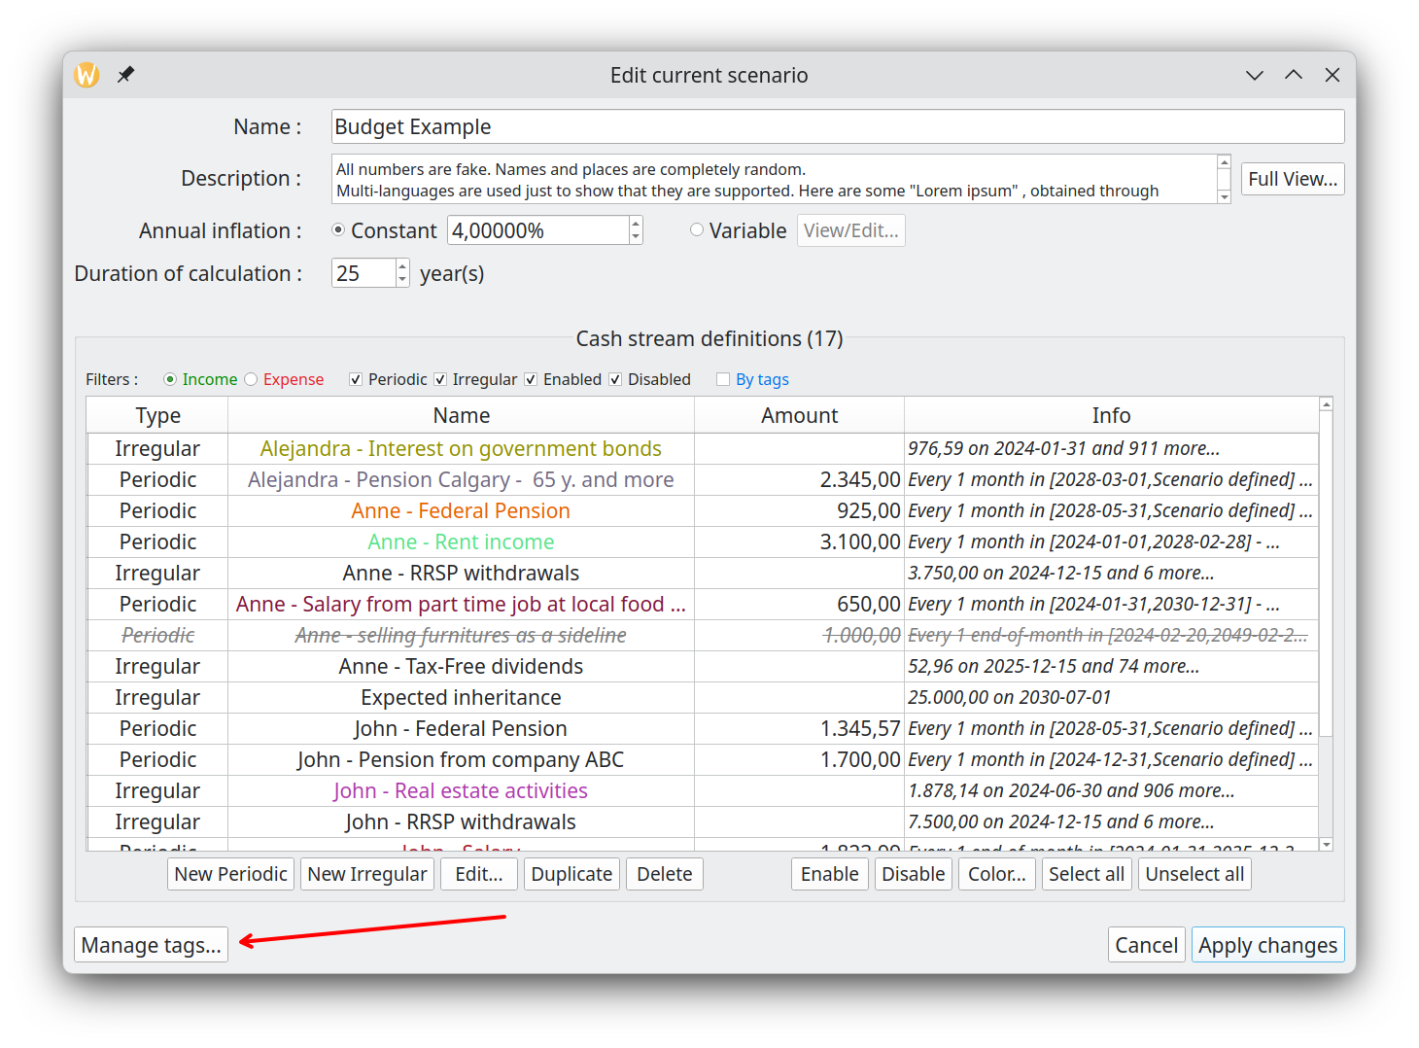

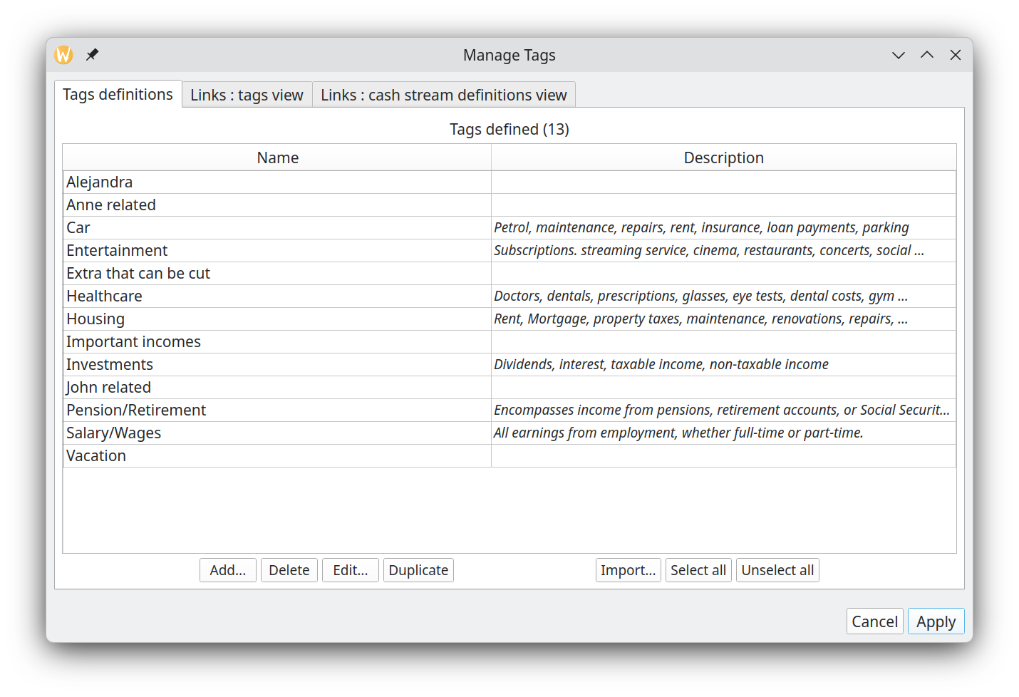

Analysis module – tags statistics
The dedicated “Tags” section provides detailed breakdowns and statistics for each tag (or combination of tags):
  - Total income/expense contributed by tag
  - Yearly, monthly, or custom-period summaries
  - Minimum/maximum cash balance impact

More features will be added in future version of GBP.

Cash stream definition editor
When creating or editing a Cash Stream Definition, the assigned tags are clearly listed in the Tags field. This gives you immediate visual confirmation of how the stream is categorized.

Thanks to these integrations, tags become a central and intuitive tool for organizing, filtering, and analyzing your financial scenarios.

Example
Lets say one has the following tags defined for a given scenario :
- Education
- Investments
- Health care fees
- House
- House insurance
- Employment
- Alejandra
- Pierre
- Confirmed

and the following Cash Stream Definitions (CSD) defined in the same scenario :
- Pierre’s Salary
- University program
- Pension from government

You could associate to CSD "Pierre’s Salary" the tags "Pierre" and "Employment". Or link the tag "Confirmed" to CSD "University Program" and "Pension from government".

You can define as much as 5000 tags per scenario (which is far more than you will ever need...).

User interface description

Main window
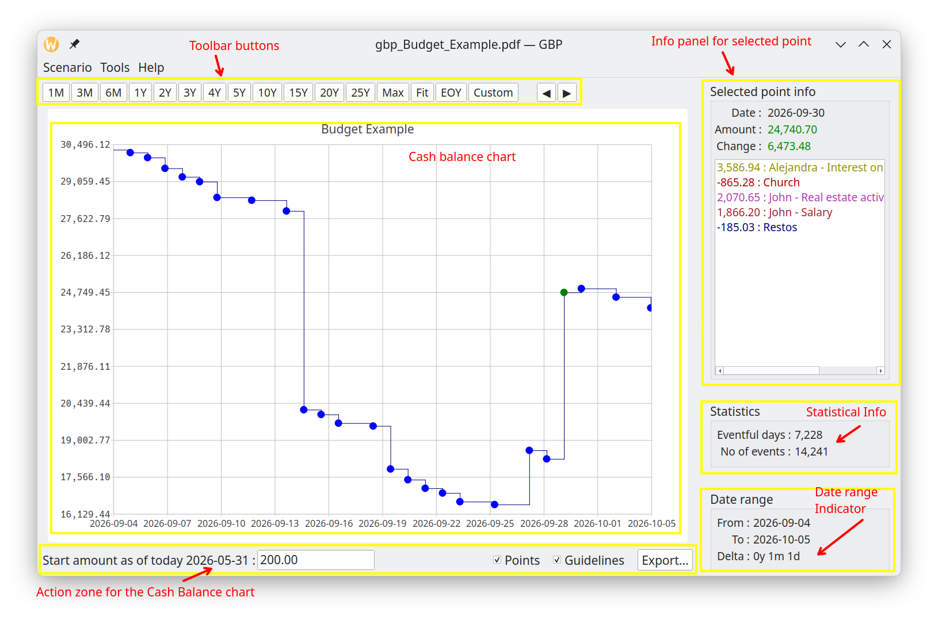
This is the first window displayed by GBP after being launched.

Splitter
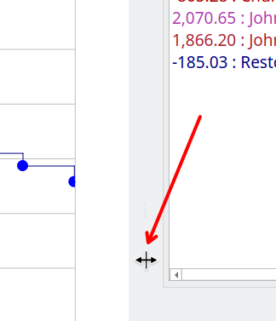

Use the splitter to adjust how the screen space is divided between the left and right regions. The splitter symbol itself is quite difficult to see, but the mouse cursor changes when hovering in that region. To rebalance the layout:

- Move your mouse over the separator line between the two regions
- When the cursor changes to a 2-way arrow, click and drag
- Drag right to give more space to the left region (and less to the right)
- Drag left to give more space to the right region (and less to the left)
- Release the mouse button to lock the new distribution
Note: The 2-way arrow cursor style depends on your platform (KDE, Windows, etc.).

Menus

Scenario

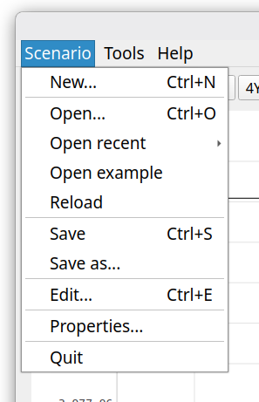

New
Create a new scenario in memory. If a scenario is already loaded and modifications made have not been saved yet, the following prompt will appear to give the user the opportunity to save the modifications before going forward :
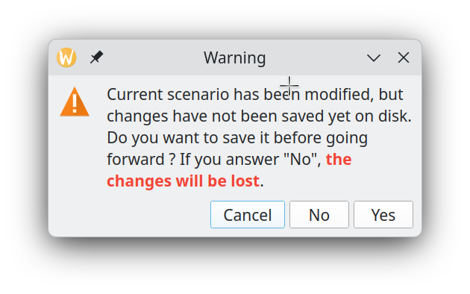

"Cancel" will abort the request (here, it is the creation of the new scenario), "No" will proceed with the request but will discard the changes made, "Yes" will also proceed with the request but will first save the changes in the associated scenario file.

Open
Open an existing scenario file on disk. If a scenario is already loaded and modifications made has not been saved yet, the same processing will happen than for "New".

Open recent
Open an existing scenario file on disk, from a list of the most recent scenario files opened. If a scenario is already loaded and modifications made has not been saved yet, the same processing will happen than for "New".

Open example
Load a pre-built sample scenario to see what graphical-budget-planner can do. A copy is automatically placed in your system's temporary directory, overwriting any previous copy with the same name, so you always get the current state of the example file. If you currently have an open scenario with unsaved changes, you'll be prompted to handle those changes before loading the sample (same behavior as creating a new scenario).

Reload
Discard the current scenario in memory and reload its content from the associated disk file.

Save
Save the current scenario data to the associated scenario file. This is a JSON file, default extension is ".json", but user can override it and select whatever he wants.

Save as
Save the current scenario data in a file chosen by the user. If the file already exists, user will get a warning and may replace the current content it if he wants. This is a JSON file, default extension is ".json", but user can override it and select whatever he wants.

Edit
Display the scenario data and allow the user to modify anything he wants, except the currency. Note that :
- User must press the "Apply Changes" button in order to update the currently loaded scenario in memory, and thus see the effect on the Cash Balance curve and the Analysis Dialog.
- The changes made are not yet saved to the scenario file on disk : this must be done explicitly using the "Scenario→Save" menu.

Properties
Show a Dialog displaying several properties of the scenario. The "Name", "File Name" and "Path" controls will display scroll-bars if the content is big. This way, very big Path and/or file name strings are supported.

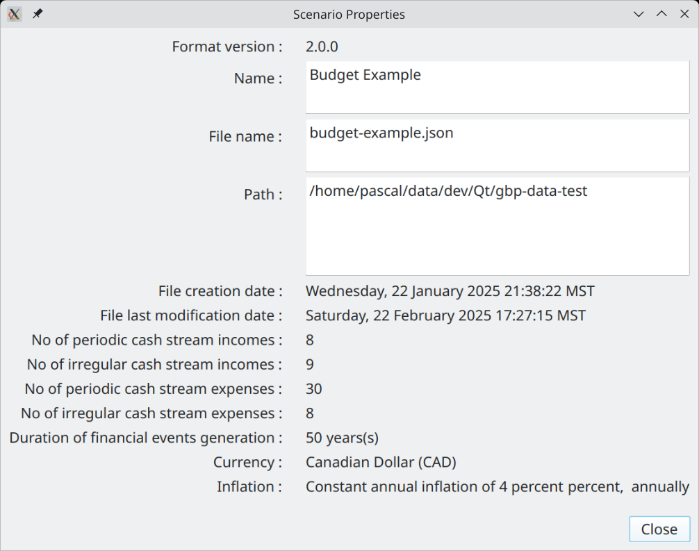

Quit
Terminate the application. If a scenario is already loaded and modifications made has not been saved yet, the same processing will happen than for "New".

Tools

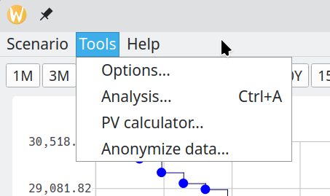

Options
Launch the Options Dialog to view or change the configuration.

Analysis
Launch the Analysis Dialog in order to conduct detailed statistical analysis on the financial event generated.

PV calculator
Launch the “Present Value” calculator.

Anonymize data
Replace all sensitive data in the currently loaded scenario with neutral placeholder values. This is useful when you want to share a scenario file for support or demonstration purposes without exposing personal financial information.
What is always anonymized (regardless of settings) :
- The scenario name is replaced with a generic label.
- The scenario description is replaced with “Lorem Ipsum” placeholder text.
- Every CSD name is replaced with a sequential generic label based on its type: "Periodic Income 01", "Irregular Income 02", "Periodic Expense 01", etc. The numbering restarts at 01 for each type.
- Every CSD description and every individual occurrence note (for irregular CSDs) is replaced with “Lorem Ipsum” placeholder text.
Note that tags are not affected: their names and descriptions are left unchanged.

Anonymizing amounts
When the Anonymize amounts checkbox is enabled, every amount in the scenario is individually perturbed by a random factor. The factor is drawn independently and uniformly for each CSD, so the relative proportions between streams are scrambled and cannot be reverse-engineered to recover the originals.
The intensity slider controls the width of the perturbation range. At 10%, each amount is multiplied by a random factor between 0.90 and 1.10, meaning it changes by at most ±10% of its original value. At 50%, the factor ranges from 0.50 to 1.50, allowing changes of up to ±50%. At the maximum of 100%, the factor ranges from 0.00 to 2.00, meaning each amount can end up anywhere between zero and double its original value.
When Anonymize amounts is unchecked, the intensity slider has no effect and all amounts are left exactly as they are.
The anonymization is applied immediately to the in-memory scenario but does not touch the scenario file on disk. The original file is preserved until you explicitly overwrite it via Scenario → Save or create a new file via Save As…. The recommended workflow is therefore to anonymize, then use Save As… to produce a separate anonymized copy, leaving the original file intact.

Help

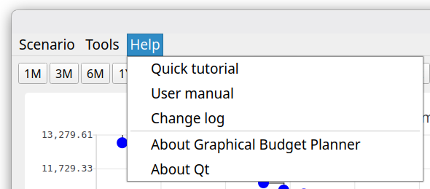

Quick tutorial
Open a short (roughly 7 pages) PDF document that provides a very quick tutorial about how to use graphical-budget-planner. The document is opened by the default system application for PDF reading (e.g. Okular on KDE). The document is in english only.

User manual
Open a long and detailed PDF document that provides an in-depth description of what is graphical-budget-planner and how to use it effectively. The document is opened by the default system application for PDF reading (e.g. Okular on KDE). The document is in english only.

Change log
Shows all the changes made to graphical-budget-planner since version 1.

About Graphical Budget Planner
Open a window that provides the application version, the license terms, source code location, credits and author(s) with email contact. When a workspace is active, the current workspace name is also shown. Many useful information is provided in the “Info” tab.
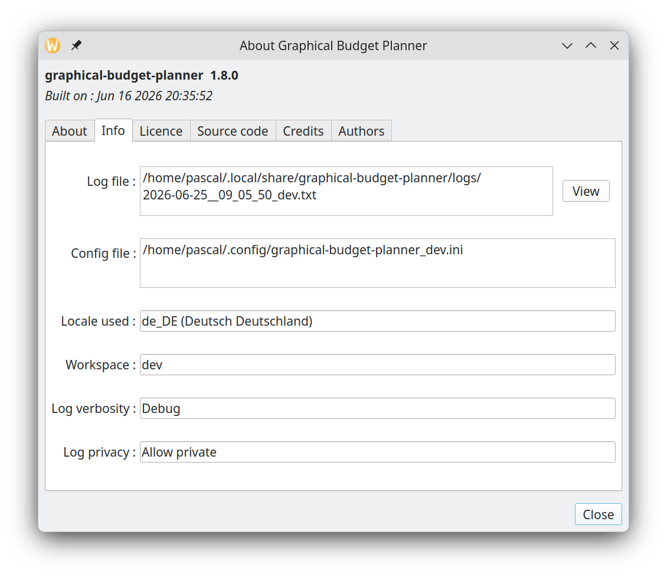

About Qt
Open a window showing misc info about the Qt toolkit used to build this application.

Cash balance curve
The Cash Balance Curve plots a point for every day that includes at least one financial event. Each point displays the day's closing balance, calculated by adding all that day's transactions (income and expenses) to the previous day's balance. Days without any financial activity are omitted from the curve. The X-axis displays your time interval, while the Y-axis shows the balance amounts in your scenario's currency.

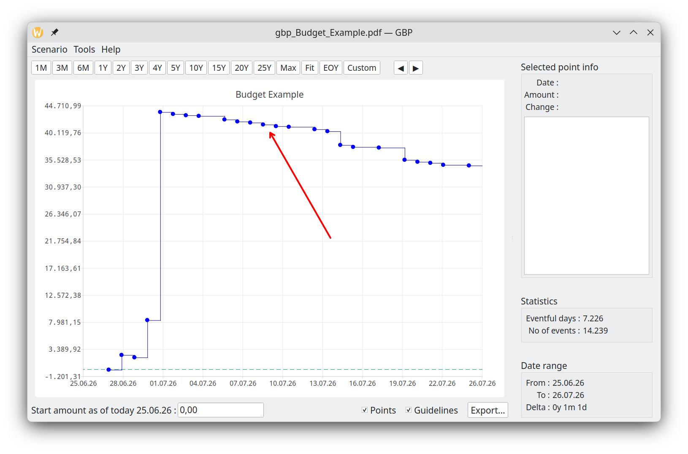

Toolbar buttons
This area is made of 2 zones :
- the predefined range buttons (to the left)
- the panning buttons (to the right)

1M to 25Y toolbar buttons
These buttons will rescale the chart for a predefined time interval range, starting at the date of "tomorrow". "M" stands for "month(s)", "Y" for "year(s)"

"Max" toolbar button
Rescale the chart so that the X range is from "tomorrow" to "last allowed date for the calculated data". The latter is set by the option "Scenario – No of years calculated" in the Option Dialog. Scenario’s calculated data may or may not end before this date, depending on the nature of the Cash Stream Definitions in the scenario. Y axis is rescaled to include the min and max values.

"Fit" toolbar button
Rescale the chart so that the X range covers exactly the date range of the Scenario’s calculated data. Y axis is rescaled to include the min and max values.

EOY toolbar button
Rescale the chart so that the X range covers exactly the date range starting from the date of "tomorrow" to Dec 31 of this year (“End Of Year”).

"Custom" toolbar button
Allow the user to enter its own X axis range. The start of the X axis can then be different than "tomorrow".
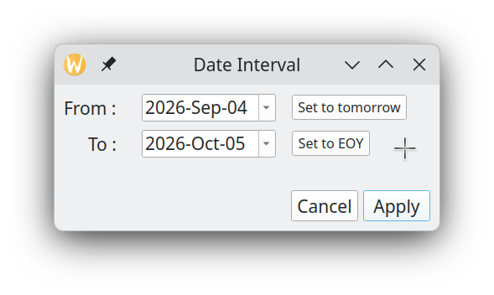
- The “Set to Tomorrow” button set the “From” date to GBP’s value of tomorrow.
- The “Set to EOY” button set the “To” date to the last day of the year where Tomorrow occurs.

Panning buttons


These buttons allow to "scroll" the chart to the left or to the right, by approximately the same date range width than the current date interval currently displayed.

Action zone for the chart
This area contains controls that may alter the chart content or appearance, or allow exporting the data to a CSV file.

Start amount

This features adds a "baseline" amount to the chart, which corresponds to the current starting amount before any financial events occurred. In other words, this is your current cash balance as of today. It is NOT part of the scenario and thus is NOT saved on disk. It has to be re-entered each time GBP is started, but this is the whole point...It represents the available amount of cash for the user as of "today". All the financial events will occurred from "tomorrow" and add/subtract to this initial amount. See "Usage" for more information about how to use it.

There is an option to set the value of "today" not to the system’s date at launch time (which is the default), but to an arbitrary value. See Options Dialog.

Show gridlines
A checkbox in the chart toolbar, checked by default. When unchecked, the X and Y axis grid lines are hidden on the Cash Balance chart, giving a cleaner appearance. Grid line colors can be customized per theme in the Options dialog (see Dark/Light mode color settings).

Show points
When OFF, the chart will not show the colored disk around the chart’s data points, used to help localize the data points on the chart. This is useful if there is a huge number of points and one want to see the overall shape of the curve.

Export
Allow to export ALL curve’s data points to a CSV file for further processing by other tools (like Libre Calc). The user selects a file name : by default, a .csv extension is added if the file name does not contains one, otherwise it uses what the user has entered.

The first line of the file is a header, with fields separated by a TAB character :

Date Total Daily Incomes Total Daily Expenses Total Delta Cumulative Total

with the following semantic for the columns :
- Date : Date for this data point (format = YYYY-MM-DD)
- Total Daily Incomes : The total amount of all the incomes that occurred during that day
- Total Daily Expenses : The total amount of all the expenses that occurred during that day
- Total Delta : Total Daily Incomes - Total Daily Expenses
- Cumulative Total : The final amount at the end of the day (cash balance)

The rest of the file contains the data points info (one line per data point), like for example

2024-07-01 3100.00 -3031.29 68.71 20068.71
2024-07-02 0.00 -333.00 -333.00 19735.71
2024-07-03 0.00 -375.02 -375.02 19360.69
2024-07-04 0.00 -310.60 -310.60 19050.09
2024-07-06 0.00 -281.79 -281.79 18768.30

where fields are separated by a TAB character.

By default, amounts are written in the form

Thousands separator : none
Decimal separator : ‘.’

but it is possible to generate a localized version : see Options Dialog

Selected point info panel
Provides information for the selected point on the chart.

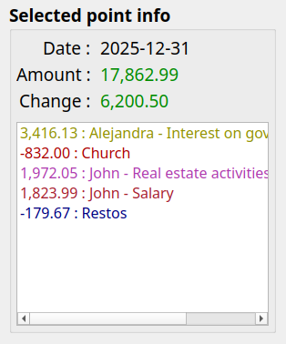

Date :
Date of the selected data point. Format is the “short” date format for the current locale. For example :

Locale code | Locale name | Short date format pattern | Example for 30 November 2025
en-US | English (United States) | MM/DD/YYYY | 11/30/2025
en-GB | English (United Kingdom) | DD/MM/YYYY | 30/11/2025
fr-FR | French (France) | DD/MM/YYYY | 30/11/2025
de-DE | German (Germany) | DD.MM.YYYY | 30.11.2025
Ja-JP | Japanese (Japan) | YYYY/MM/DD | 2025/11/30

Amount :
Current amount of the Cash Balance up to and including that day. It takes into account all the financial events of the day PLUS the daily amount of the previous occurrence. The amount is green if >=0, red otherwise

Change :
Net change for the day: total incomes minus total expenses

Financial events listbox content:
This is the list of all the financial events that occurred during the day. It is sorted by Cash Stream Definition name (sorting takes into account the Locale defined on the user’s computer).
Expenses are number < 0. Each financial event name is colorized if defined so.

Statistics
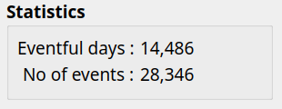

This section provides miscellaneous statistical information about the scenario’s calculated full Cash Balance curve (not just what is displayed). It changes only when a new scenario is loaded.

Eventful days
For the full Cash Balance curve, it tells how many days have at least one financial events associated with each of them. It corresponds also to the total number of data points on the Cash Balance curve.

No of events
Total number of financial events for the whole Cash Balance curve (hence not only for what is displayed with the current date interval). In the example below, there are 17 days displayed, but only 2 of them have 1 or more financial events associated. The first point has 1 financial event, the second one has 2 (this point is selected on the figure). The total no of events is thus 3.

Date range
Shows the time interval (X axis) currently used by the chart. Real-time refreshed when zooming or panning occurs.

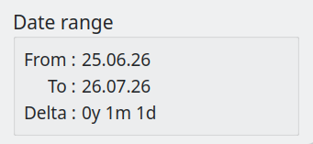

Create new scenario
Accessed with the "Scenario→New" menu. This is used to create a new scenario. To save it, use the "File→Save" or "File→Save As" menu.

Choose a currency
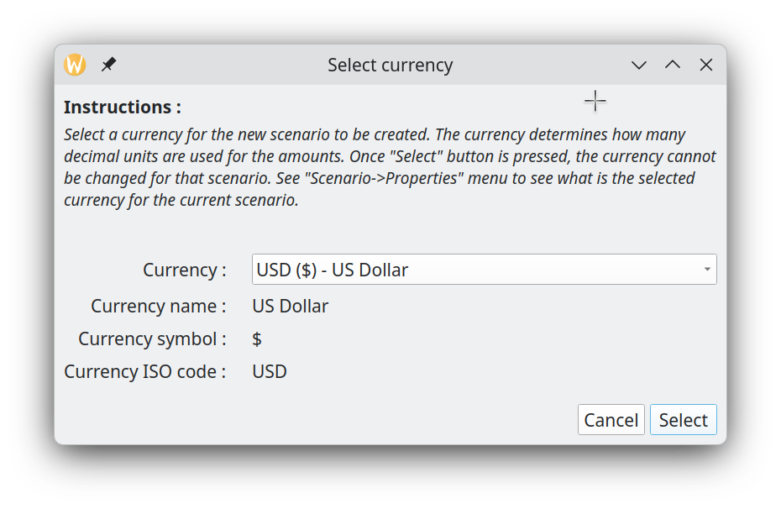
Create a scenario by first selecting a currency, which determines the decimal precision for all amounts. For example, Yen displays 0 decimals while Euro displays 2. Select the desired currency directly from the combobox. The currency list is sorted alphabetically.
Once selected, a currency cannot be changed for a given scenario.

Second Step : Edit the scenario
By default, an "empty" scenario is created and you will be brought to the "Edit Scenario" dialog, where you can change whatever parameter you want.

Edit scenario
Accessed with the "Scenario→Edit" or "Scenario→Recent" menu. This window is intended to view and/or change the content of an existing scenario.

=> Changes are NOT saved in the scenario file on disk until you select "File→Save" or "File→Save As" menu.
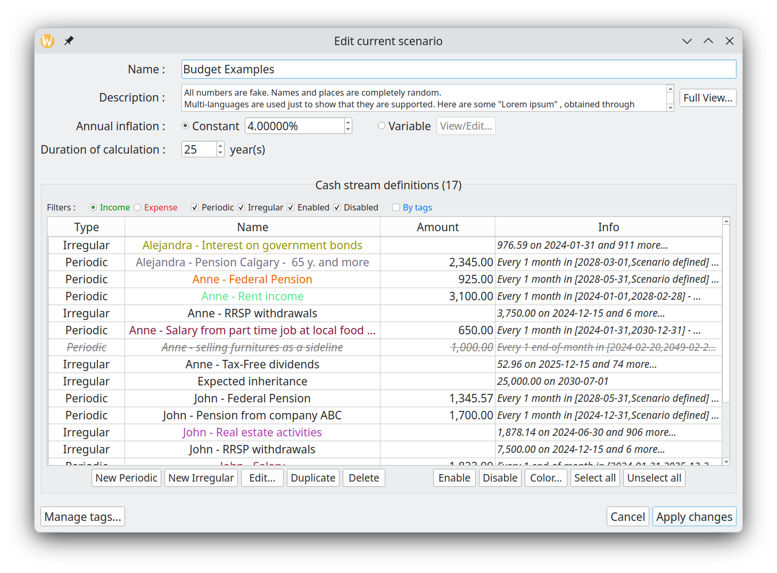This window is not modal, meaning that its content can be edited while still having access to the Main Window that shows the Cash Balance curve. This is on purpose and intended to ease and accelerate the editing work on a scenario. A typical use is to have the Main Window maximized on a monitor and the Edit Scenario window shown on another monitor. This way, change in parameters can be seen immediately in the Main Window, allowing for example zooming and panning.

All changes made to a scenario can be committed for the update of the cash balance curve by pressing the "Apply" button. Again, this does NOT save the data on disk.

Metadata editing
Metadata are located at the top half area of the Edit Scenario window.

Name
Just enter the new name in the right field. There is a limit of 100 characters for the name. This is NOT the name of the scenario file on disk !

Description
User’s notes about the scenario. An be up to 4000 characters. Click "Full View" to edit the Description in a much bigger window.

Annual inflation
A growth pattern specific to this scenario and used to define an inflation value that may affect all incomes/expenses (increase or decrease their values, depending on the inflation value) if you choose so. Inflation is made available to all Cash Stream Definitions to be used or not (this is optional).

Constant :
A constant inflation value ranging from -100% to 10000%. Default is 0. It stays the same in past, present, future. This is an ANNUAL value, but it is the equivalent monthly growth value that is actually applied on a monthly basis on the 1st of each month.

Variable :
A variable growth pattern : this is for advanced use.

It can be used to define a complex and changing pattern for inflation. It consists of a list of (month date, annual inflation value) "pairs", each defining a new inflation value to be applied from this date, until a new pair is defined or otherwise for ever. Before the first pair is defined, inflation value is 0. Each time a new pair is defined, a new inflation value becomes in force from that date. Inflation is always applied on the first day of each month.

For example, lets say we have the following pairs defined :

(1 jan 2000, 10%) , (1 jan 2002, -10%)

Here are the values of an amount of 1000 that starts existing on 1 jan 1998 and has a annual periodicity. It is submitted to this growth pattern:

- 1 jan 1999 : 1000 (growth = 0%)
- 1 jan 2000 : 1100 (new growth value=10%,)
- 1 jan 2001 : 1210 (growth value still at 10%)
- 1 jan 2002 : 1089 (new growth value=-10%)
- 1 jan 2003 : 980.10 (growth still at -10%, for ever)

If the amount of 1000 starts existing on 1 jan 2003, then we have

- 1 jan 2003 : 1000 (no growth applied on the first occurence)
- 1 jan 2004 : 900 (growth is -10% as lastly defined in 1 jan 2002)
- 1 jan 2005 : 810 (growth is -10% as lastly defined in 1 jan 2002)

Here is what looks like the definition of variable inflation (values are different from above) :

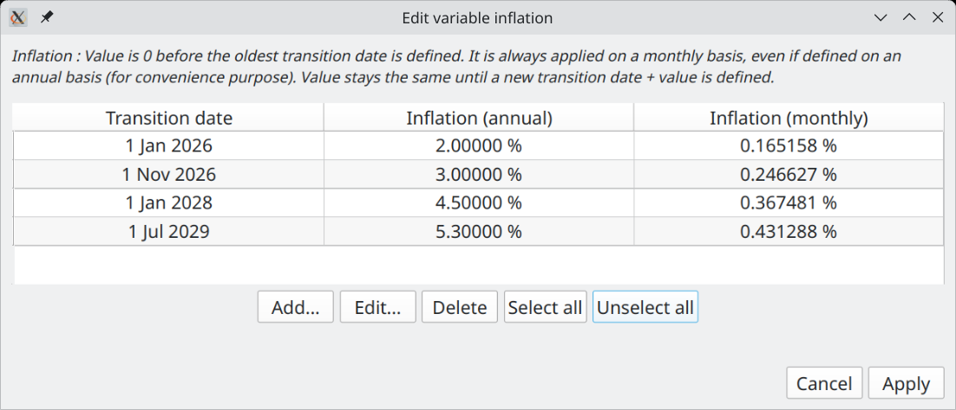

The buttons "Add", "Edit", "Delete" at the bottom are to change the list of "pairs". a.k.a "transition points". Note that "Delete" remove all the selected rows. The "Add" button pops up the following Window :

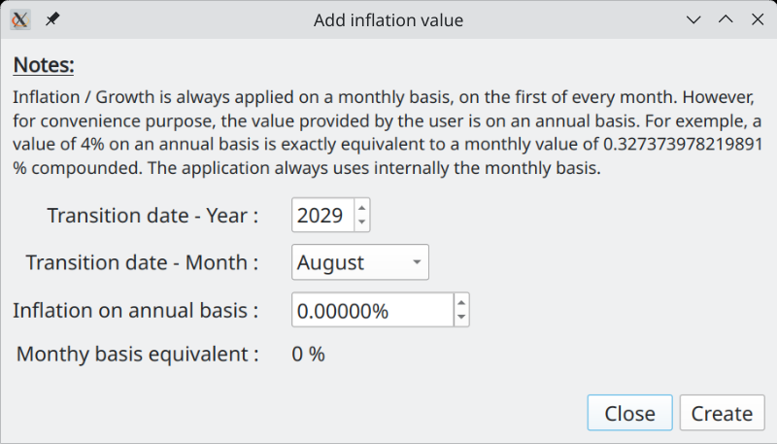

When adding a new "transition point" (date + inflation value), the value entered is always on an Annual Basis, but as mentioned before, it is actually the equivalent Monthly Basis that is used internally and applied every month on the 1st. This is why is shown the "Monthly Basis Equivalent" at the bottom. Note that you cannot create a new "transition point" with a date that already exists.

Editing a "transition point" uses essentially the same Dialog. One notable difference is that if you enter a date that already exists, it will be accepted and the new value of inflation replaces the old one for that date.

Duration of calculation
This value determines what is the limit date over which no financial events will be generated for the current scenario, whatever what the Cash Stream Definitions specify. The limit date is "tomorrow" + the value of this field minus 1 day.

The idea here is to limit the amount of calculation GBP has to do. The smaller this value is, the faster the calculation is done and the lesser system’s memory is consumed. The default of 25 years is probably more than adequate for most use. You can increase this amount however, up to 100 years.

Cash Stream Definitions editing
There are 3 zones in this part of the Edit Scenario Dialog (middle section of the window) :

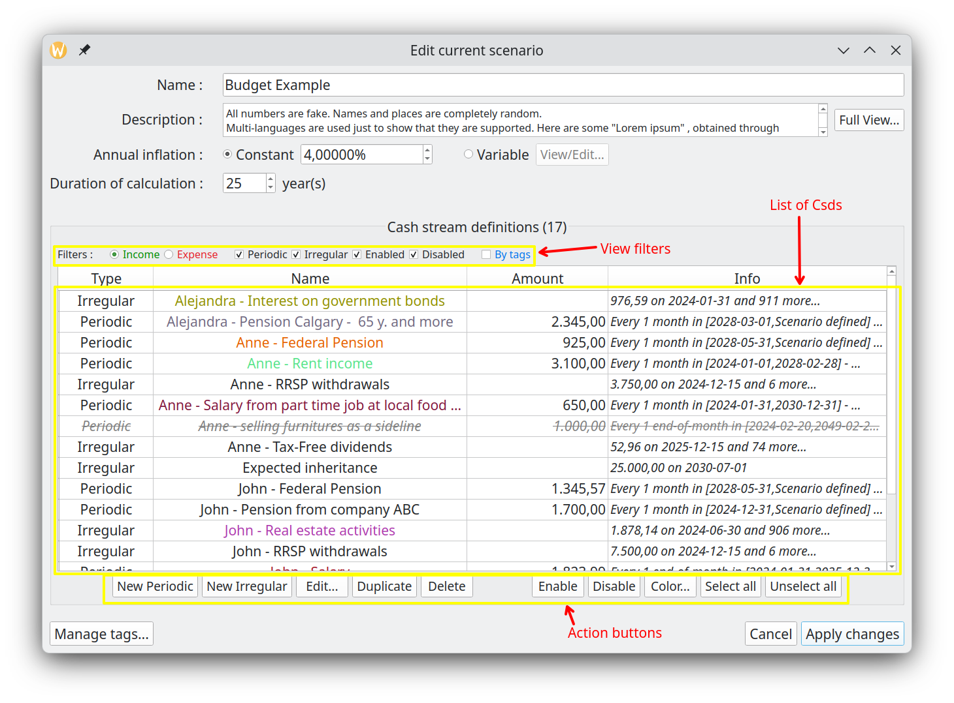

View filters
Filters change what you see in the list of Cash Stream Definitions by applying criteria to restrict what can be displayed. This is useful when you want to focus on Cash Stream Definitions that have specific characteristics.

=> Please note that filters DO NOT affect what is shown in the Cash Balance curve, nor the Analysis module.

List of Cash Stream Definitions
List some properties of the Cash Stream Definitions contained in the scenario (either Incomes or Expenses). To view the details, select one item and press the "Edit" button or just double-click on it. Names are colorized according to the Cash Stream Definition settings.

A disabled Cash Stream Definition is rendered as grey & strikethrough font and is NOT taken into account into the calculation of the cash balance curve.

The list is always sorted by name ("locale-aware", meaning the sorting takes into account your language).

Action buttons
Actions affect the selected Cash Stream Definitions of this scenario.

The left portion is associated to “CRUD” operations (Create / Read / Update / Delete) :

The right portion is for miscellaneous functions :

=> As a reminder, none of these actions are committed to the current scenario until you press “Apply changes”.

=> If you press “Cancel”, all of the changes made since the last “Apply” are discarded. The dialog is then hidden.

Note also the following :

- It is allowed to have identical names for 2 or more Cash Stream Definitions, although it is not a good practice. This is possible, because under the cover, each one has a unique ID (not shown in the dialog), name is just a property.
- "Delete" button remove all the selected rows (remove the Cash Stream Definitions from the scenario)
- "Duplicate" button make a copy of each selected Cash Stream Definition. The name of the duplicates will be prefixed by "Copy of".
- "Color…" button applies one color to the selection. Very convenient, as otherwise you have to go into each Cash Stream Definition and select its color. It also offers to the user the choice to revert back to the default system color for the selected Cash Stream Definitions .
- The very convenient "Disable" button will deactivate the selected Cash Stream Definitions : they will then NOT be taken into account when producing the Cash Balance curve, nor the graphs & tables in the Analysis module. It is as if they were deleted from the scenario (they aren’t). The disabled CSDs will be grayed and have their font changed to "Strikethrough". This is extremely useful if you want to explore alternate options without creating other scenarios.
- "Enable" button just do the inverse of "Disable".

Manage tags
Launch the Manage Tags Dialog that allows tags editing and also links editing for this scenario. Since each scenario has its own set of tags and links, this edition affects only the current scenario.

All the changes made are committed to the current scenario only if “Apply changes” is pressed. Otherwise, they are discarded.

Tags definitions
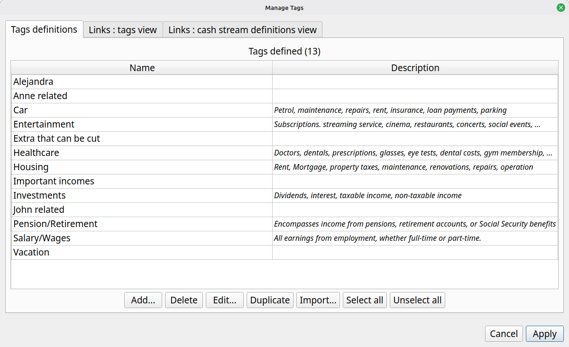

This is where tags are created/edited/deleted. When a tag is deleted, all its links to Cash Stream Definitions are also deleted. It is possible to import tags from another scenario : in that case, they are just copied and links are NOT transferred.

When “add” is pressed, the following dialog is presented to the user.

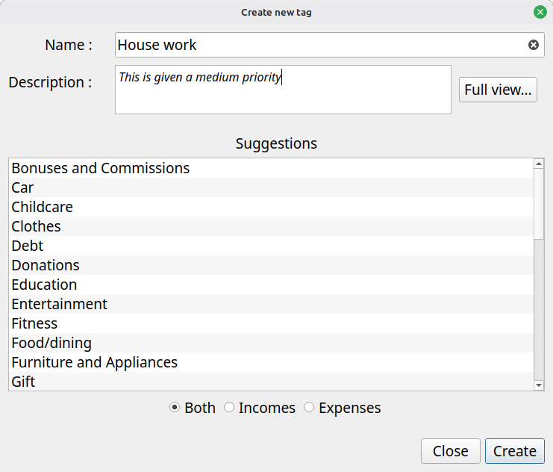

You can enter a name of your choice or select a suggested name from the list at the bottom.

Links : Tags view
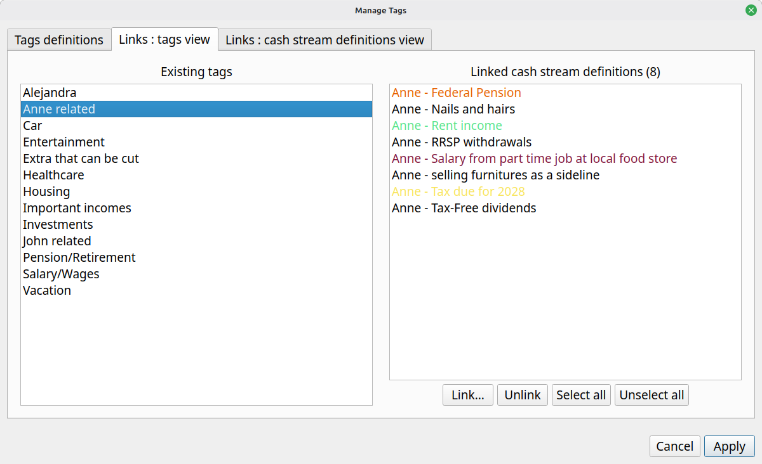

This is where we create links from tags to Cash Stream Definitions. This tab presents the view from the tags perspective. Once a single tag is selected (left panel), all the linked Cash Stream Definitions appear in the right panel.

It is possible to add more links, pressing the "Link…" button. The following dialog will appear, which present all the CSDs not already linked :

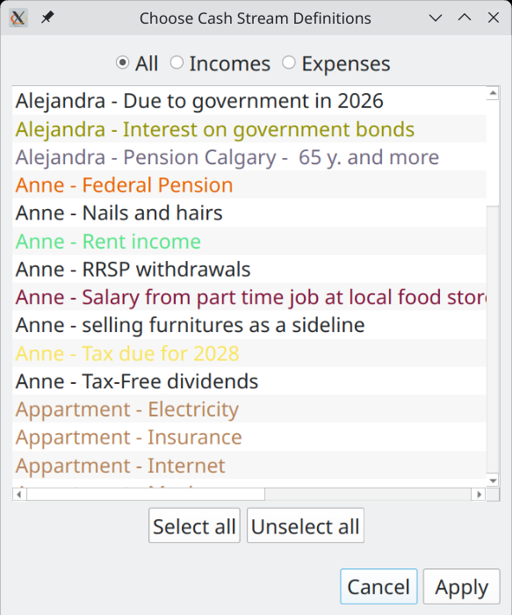

The idea is to select the additional Cash Stream Definitions to be linked to this tag. Select all that are required and press "Apply".

To delete links, select them in the right panel and press "Unlink".

Links : Cash Stream Definitions view
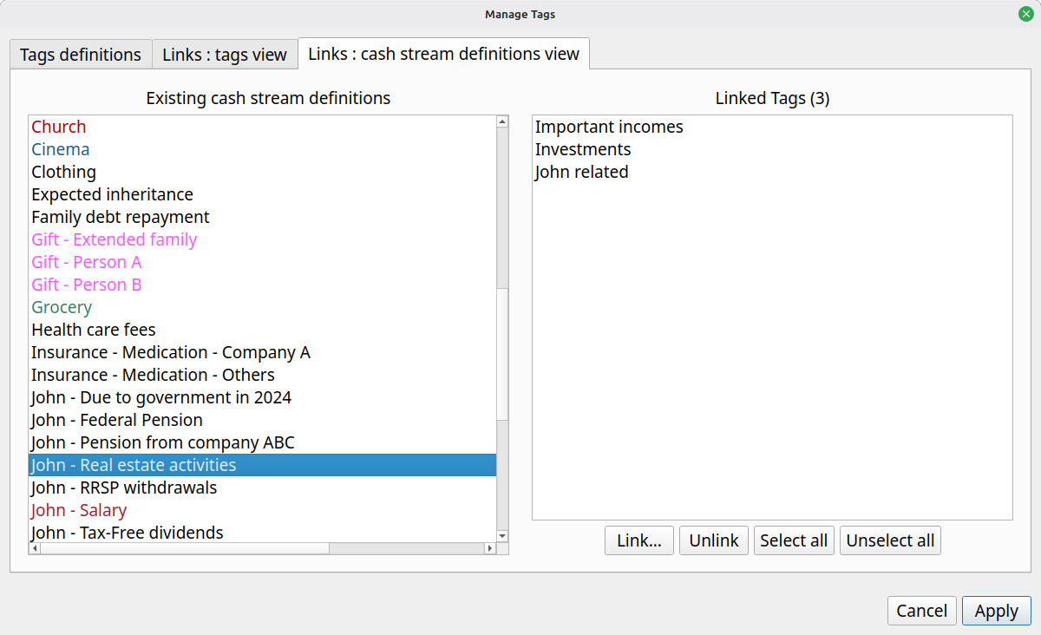

This window is used to links one or more tags to a specified CSD, selected in the list to the left. When “Link…” is pressed, all the tags not already linked to this CSD are shown to the user.

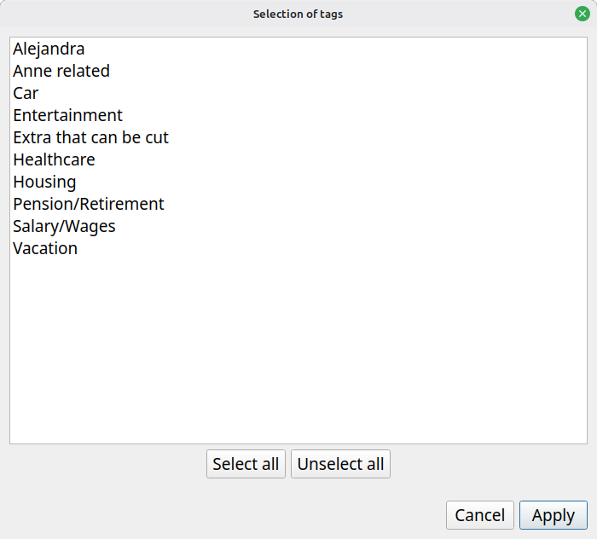

Applying the modifications
All changes (including for the tags) made must be committed to see the current scenario modified and the chart updated. This is accomplish by pressing the "Apply changes" button. Once pressed, the dialog will not be closed though : this is because in practice one may make many changes in exploring different options and opening-closing this window would be a burden. Pressing "Cancel" discards any change made since the last click on "Apply changes" button and then close the window.

Note that there is no way to “undo” the changes made before "Apply changes" is pressed. The only option is to reload the scenario (without saving it) from the menu.

*** Please not that "Apply" does NOT save the modifications on disk ! ***

Creating/editing a periodic Cash Stream Definition
This chapter describes in more details how periodic Csds can be edited from inside the Edit Scenario dialog.

- Pressing "New Periodic…" will display a dialog to create a new Periodic Cash Stream Definition. This will be an income if "Income" is selected in the filter, a new expense if "Expense" is selected in the filter.
- Pressing "Edit..." while a Periodic Cash Stream Definition is selected will bring essentially the same window (though names of the bottom buttons change), but filled with the data of the selected Cash Stream Definition.

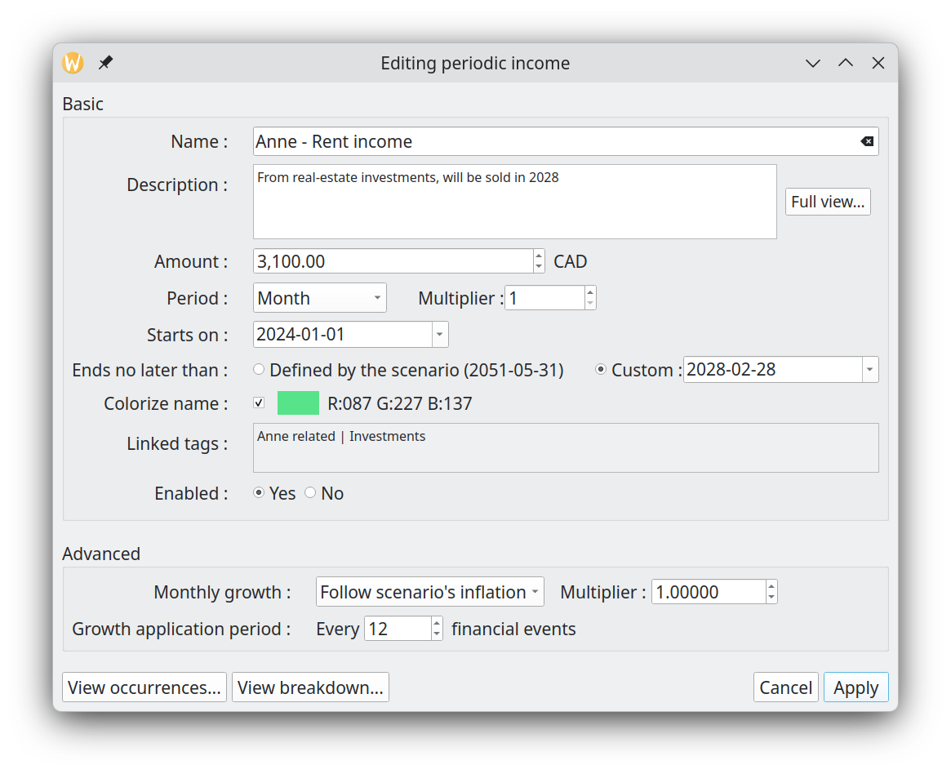

Name
Name of the periodic Cash Stream Definition (e.g. "Salary"). 100 characters maximum. It can be an exact copy of another Cash Stream Definition’s name, but it is not a good practice.

Description
User notes for this particular periodic Cash Stream Definition . 4000 characters maximum. Pressing the "Full View" allows for editing the content in a much bigger window.

Amount
The initial amount of money to be repeated periodically, before any inflation or growth is applied. If there is no growth pattern defined, this amount will stay constant. Note that if the advanced option "Convert to present value" is selected in Options Dialog, the amount will change even when no growth is defined.

Period and period multiplier
The interval of repetition for the amount is specified by first defining a period type, then a period multiplier.

Period type
- Year
- Month
- End-of-month
- Week
- Day

A note on "End-of-month" : this force the events to occur at the very end of a month. Since the last day of the month changes with month, the actual date will vary.

Consider a periodic Cash Stream Definition defined with a period of 1 end-of-month, with validity range of [29 Feb 2000 – 5 mar 2001]. The financial events generated will be (note in particular the date "2001-02-28") :

2000-02-29 : 1,000.00
2000-03-31 : 1,000.00
2000-04-30 : 1,000.00
2000-05-31 : 1,000.00
2000-06-30 : 1,000.00
2000-07-31 : 1,000.00
2000-08-31 : 1,000.00
2000-09-30 : 1,000.00
2000-10-31 : 1,000.00
2000-11-30 : 1,000.00
2000-12-31 : 1,000.00
2001-01-31 : 1,000.00
2001-02-28 : 1,000.00

Period multiplier
This is an integer that is used as a multiplication factor of the period type selected (e.g. 3 years or 12 weeks).

Start date
The first financial event of a Periodic Cash Stream Definition can only occur at the date specified by the Start Date field. The only exception to this is when the Period Type "End-of-month" is selected. In that case, it will occur at the NEXT end-of-month from this date.

End date
Specify when the flow of financial events will end : no financial event will be generated past this date. Note that it is possible that the last financial event occur before this date.

There are 2 options offered to the user :

- Specify explicitly the End Date : this is the "Custom" option. The data limit specified in the scenario metadata still hold however.
- Use the date limit defined at the Scenario Level (see "Duration of calculation" for the scenario metadata).

"Start Date" must not occur after "End Date" date.

Colorize name
To make it easier to distinguish one Cash Stream Definition from another in the user interface, it is possible (meaning optional) to associate a color to the name. There are 2 possibilities :

1) If the checkbox is unchecked (default for newly created item), it means no custom color is associated to this name and system default color will be used.

2) If the checkbox is checked, with a colored square and RGB value to its right, then this color is associated with the name

To select a color, click the colored square : a color selection dialog will appear.

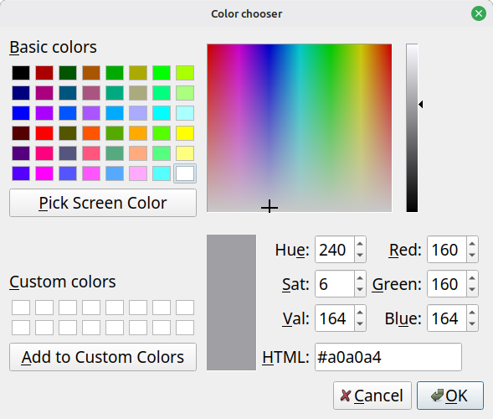

Select a color and press OK to have the color associated with the name. To apply the same color to many Cash Stream Definitions, you can copy the content of the "HTML" field and paste it as many time as required.

Linked tags
List all the tags that are linked to this Cash Stream Definition. Each of them are separated by the " | " characters. Note that this is a read-only list : to change it, go to the "Manage tags" Dialog.

Enabled
If "Yes" is selected (default), the periodic Cash Stream Definition will be taken into account in all the calculation and chart displays. If set to "No", it wont be taken into account anywhere.

Advanced section

Monthly growth
The amount defined can actually change with time, by following a specified growth pattern. This group of fields define the nature of the growth pattern.

There are 4 options :

- "No growth" : The initial amount stays constant for the whole validity range
- "Follow inflation" : Growth is exactly identical to the inflation pattern defined in the scenario (whether "constant" or "variable), multiplied by the value of the multiplier field. For example, if the scenario defined 4% constant inflation and the multiplier value is 1.5, then the actual growth applied to this Cash Stream Definition will be 6% constant.
- "Custom – constant" : Specify a constant growth
- "Custom - variable" : Specify a variable growth pattern. See "Scenario Inflation" above to have more information about how to specify a variable growth. Here, inflation is exactly like growth.

Growth application period
Lets first remember that GBP applies growth or inflation on a monthly basis, on the 1st.

This field determines how often the "cumulative" monthly growth is applied to the flow of financial event occurrences. By default, it is 1, meaning that every occurrence of the amount will be adjusted with the growth pattern defined.

Sometimes however, it may be required to restrict the application of the specified growth only every "n" occurrences. A good example is a rent. The amount stays constant for the duration of the rent (12 occurrences), but needs to be augmented when the rent is renewed (once every 12 occurrences), by the growth accumulated over 1 year.

Example

Lets say you have an annual rent, with 1000$ paid monthly. The renewal is on July 1st of every year. Lets also say that you want to specify a growth of 5% annually for this amount. Then the Periodic Cash Stream Definition to create would be something like this :

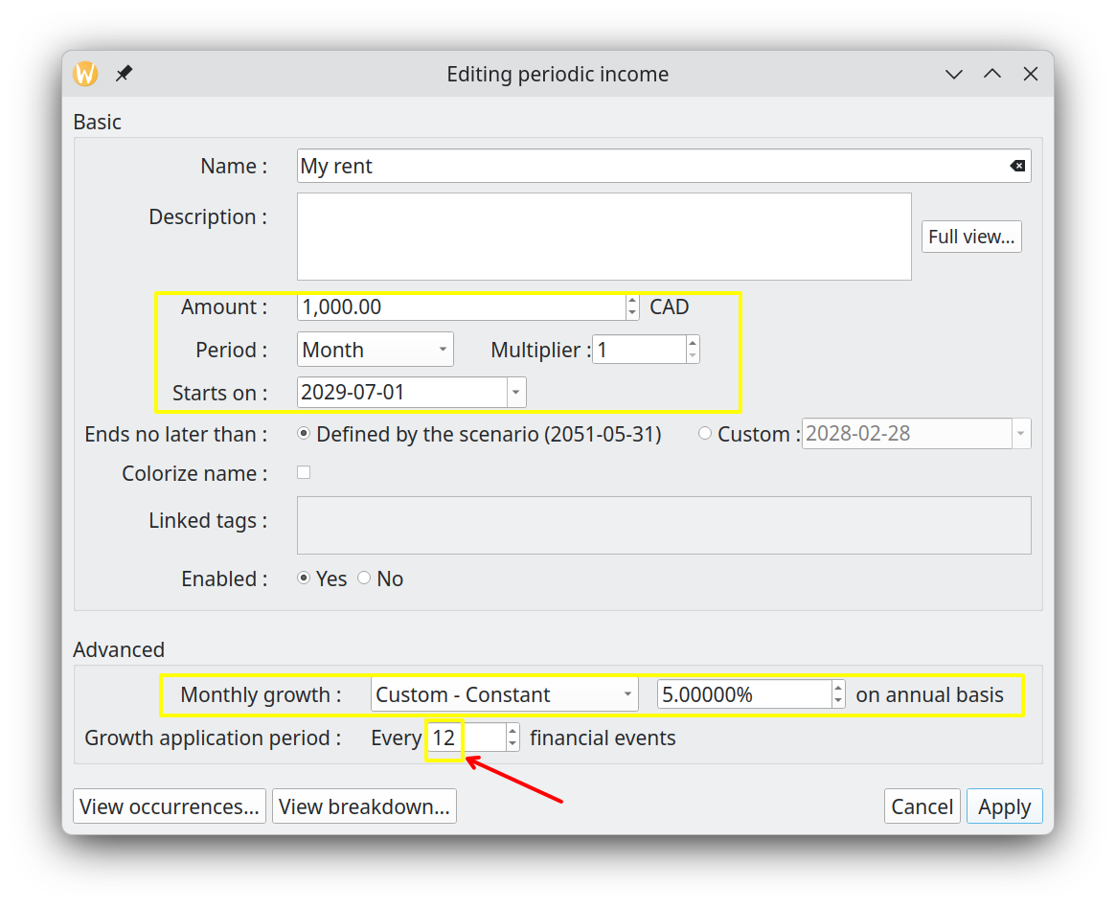
The value of Growth Application Period must be 12, in order to have 12 months of constant rent price. This would give the following financial events :

2029-07-01 : 1,000.00 CAD (cummul=1,000.00 CAD)
2029-08-01 : 1,000.00 CAD (cummul=2,000.00 CAD)
...
2030-06-01 : 1,000.00 CAD (cummul=12,000.00 CAD)
2030-07-01 : 1,050.00 CAD (cummul=13,050.00 CAD)
2030-08-01 : 1,050.00 CAD (cummul=14,100.00 CAD)
...
2031-06-01 : 1,050.00 CAD (cummul=24,600.00 CAD)
2031-07-01 : 1,102.50 CAD (cummul=25,702.50 CAD)

As expected, the monthly amount paid for the rent stays the same until 2027-07-01, when it is increased by 5%.

CSD Breakdown
This button opens a dialog displaying the period-by-period totals for this Cash Stream Definition up to the end of its validity period. A radio button selector switches between Monthly and Annual granularity. This is useful to inspect how growth or inflation compounds the amounts over time.
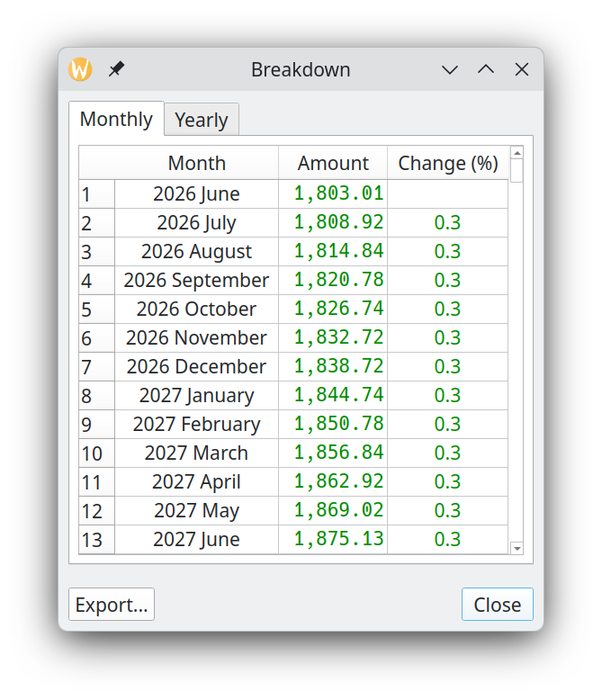

Visualize occurrences
This button uses all the values of the fields above and displays all the resulting occurrences for the defined validity range. Occurrences are color-coded and labeled with index markers for easy identification. This also takes into account the option to "Convert to Present values" all amounts, as defined in the Options Dialog.

The curve can be zoomed in/out with the mouse wheel. The "Fit" button restores the scaling to the maximum possible.
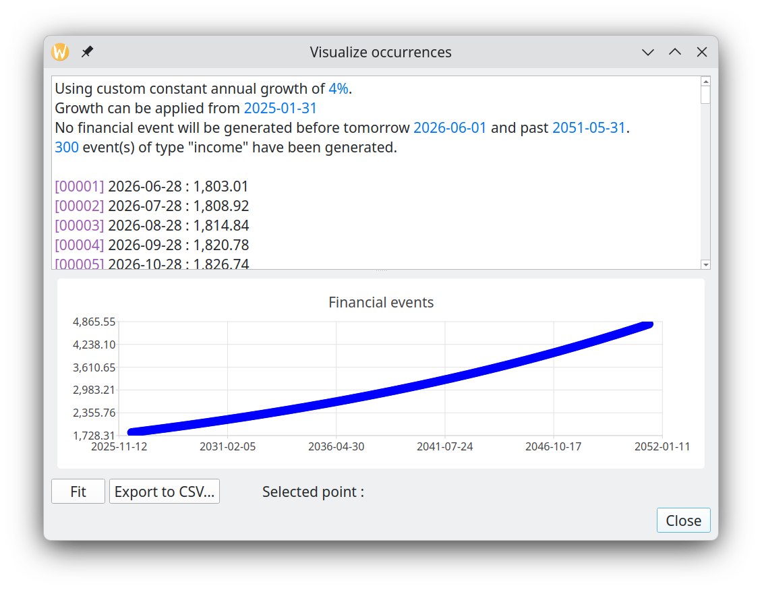

Creating/Editing an irregular Cash Stream Definition
This chapter describes in more details how irregular Csds can be edited from inside the Edit Scenario dialog.

- Pressing "New Irregular…" will display a dialog to create a new Irregular Cash Stream Definition. This will be an income if "Income" is selected in the filter, a new expense if "Expense" is selected in the filter.
- Pressing "Edit..." while a irregular Cash Stream Definition is selected will bring essentially the same window (names of the bottom buttons change though).

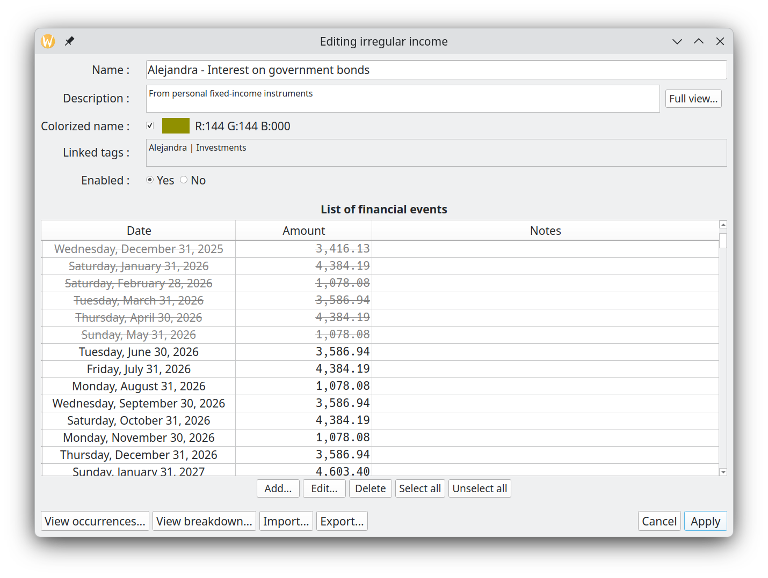

Name
Same as periodic Cash Stream Definition

Description
Same as periodic Cash Stream Definition

Colorize name
Same as periodic Cash Stream Definition

Linked tags
Same as periodic Cash Stream Definition

Enabled
Same as periodic Cash Stream Definition

List of financial events
List of all the financial events to be generated by this irregular Cash Stream Definition. Note that the amounts are always "future values" (the nominal amounts you have entered, before any present-value conversion). The date column uses the long date format to avoid ambiguity with regional short formats. Any entry whose date is earlier than tomorrow is shown in grey with strikethrough font to indicate it is outdated and will not generate a financial event.

Actions buttons

Add
Create a new financial event (occurrence) for the irregular Cash Stream Definition. The date must not be already used by an existing financial event defined in this Irregular Cash Stream Definition

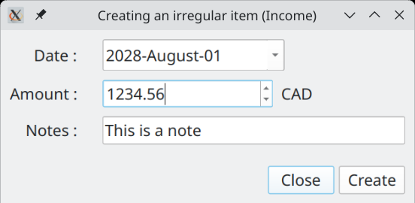
Edit
Same as "Add", but if there is already another financial event that is using this date, the new amount replace the old one.

Delete
The selected financial events are removed from this irregular Cash Stream Definition

CSD Breakdown
Same as for Periodic Cash Stream Definitions. Shows the period-by-period totals for this Irregular Cash Stream Definition up to the end of its validity period, at Monthly or Annual granularity.

Visualize occurrences
Show the actual financial events that will be generated (same as for periodic Cash Stream Definition Edition). Normally, they will be the same as the ones defined in the table. However, if option to "Convert to Present values" in Options Dialog is activated, the amounts will be different, since each one will be converted to their present value.

Import
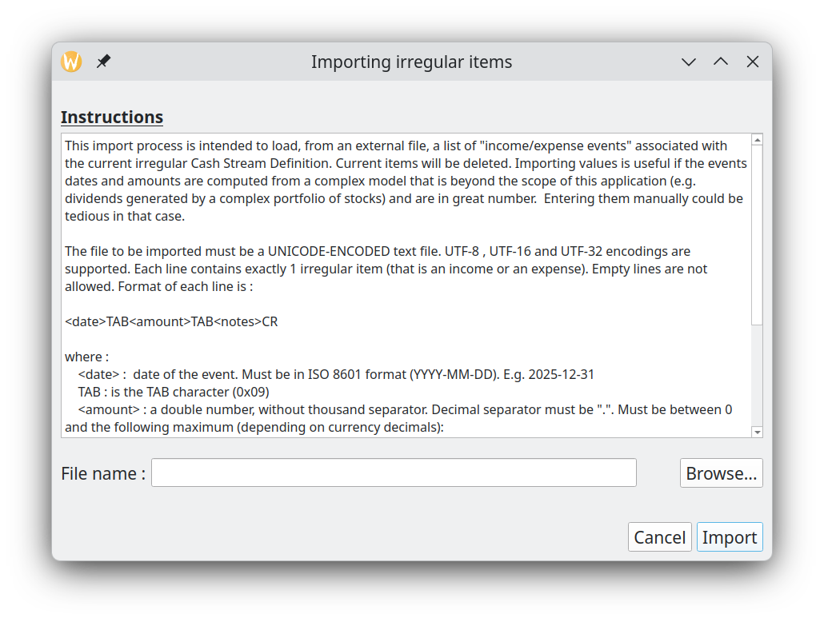
Import a list of financial events defined in a CSV text file. All financial events currently defined are removed and replaced by the new imported ones. Import is very useful if the financial events are computed from a complex model that is beyond the scope of this application (e.g. dividends generated by a complex portfolio of stocks) and are in great number. Entering them manually could be a tedious task.

The file to be imported must be a UNICODE-ENCODED text file. UTF-8 , UTF-16 and UTF-32 encodings are supported. Each line contains exactly 1 irregular financial event. Empty lines are not allowed. Format of each line is :

<date>TAB<amount>TAB<notes>CR

where :
<date> :
date of the event. Must be in ISO 8601 format (YYYY-MM-DD). E.g. 2025-12-31
TAB :
is the TAB character (0x09)
<amount> :
a double number, without thousand separator. Decimal separator must be ".". Not smaller than 0 and not greater than :
999,999,999,999,999 for currencies with 0 decimals (e.g. Yen)
99,999,999,999,999.9 for currencies with 1 decimal
9,999,999,999,999.99 for currencies with 2 decimals
999,999,999,999.999 for currencies with 3 decimals
<notes> :
a brief description of this item. Max 100 characters. Note that this field is OPTIONAL.
CR :
carriage return character (\n )

All imported items will be tagged as "enabled", meaning they will be considered for the Cash Balance curve.

Options window
Accessed through the "Tools→Options…" menu, this dialog allows you to see and modify the miscellaneous configuration parameters of GBP .

Location of the settings
The configuration of GBP is written in an ini-style configuration file named "graphical-budget-planner.ini". On Linux, it is located in the ~/.config directory. Exact name and location can be seen in the Help → About Graphical Budget Planner→ Info.

When GBP starts, it tries to find this configuration file. If found, it loads its content, otherwise it assigns default values to the configuration parameters.

Saving the settings
When button "Save" is pressed in the Options dialog, all changes are saved into this INI file. When "Cancel" is pressed, any changes made since the last appearance of the dialog is discarded.

When "Save" is pressed, most changes take effect immediately, unless stated otherwise by GBP with a special warning window. For example, changing the GBP font shows the following message after "Save" is pressed :

Resetting the settings
Default configuration (a.k.a. the factory settings) for all parameters can be restored by clicking on the “Reset” button (bottom left of the dialog) and then click “Save” button.

General options

How date of "Today" is set
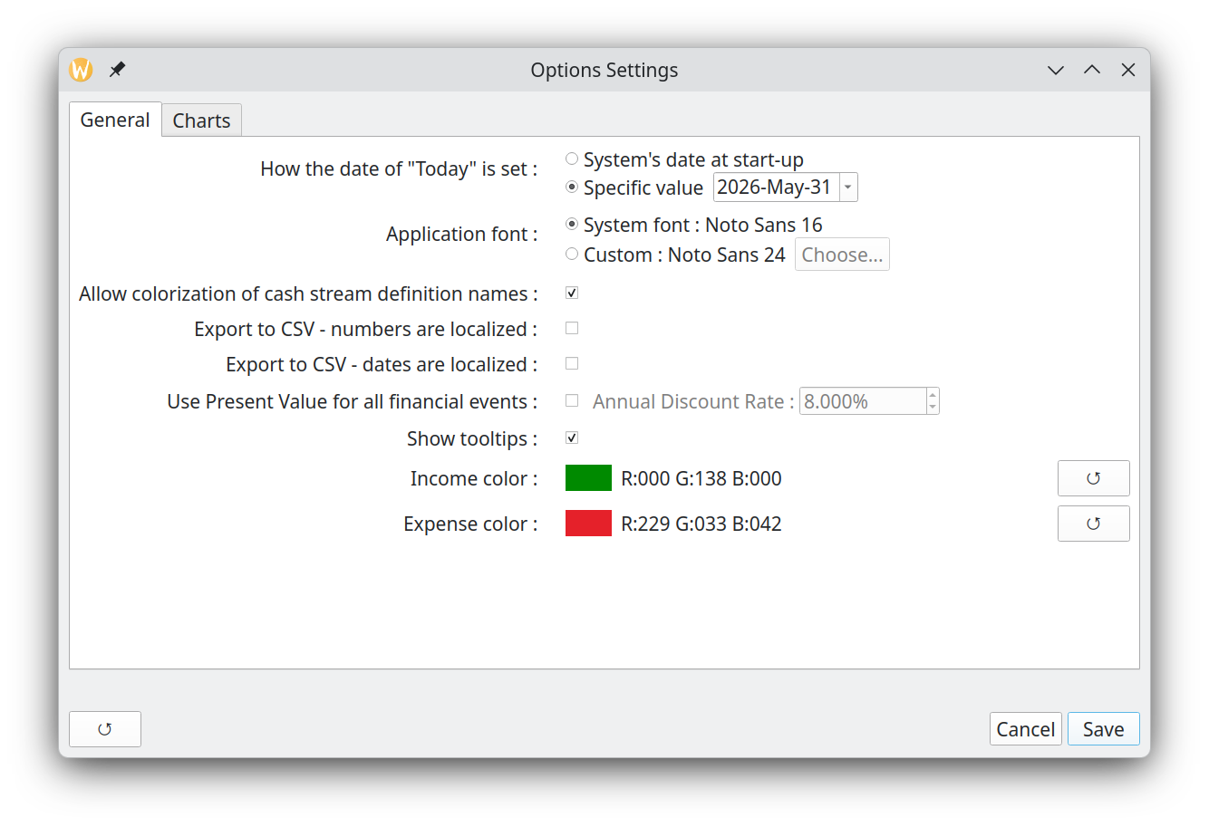
GBP is built to generate financial events starting from the date of "tomorrow", which is "today" + 1 day. By default, "today" is set to the system’s date as read by GBP when it starts. This is the expected behavior, because one are interested only into future events. Every time GBP is started, user updates the field "Start Amount as of Today", which provide the current total amount of cash available as of "today". This amount is determined by the user only (typically by logging into his bank accounts and looking at the current balance) and not by GBP. The section "Usage" describes how GBP is expected to be used and provide more details.

This being said, there are some use cases where it is beneficial to always have "today" set to a specific and constant value. One such case is testing, where repeatability of initial conditions is required. Another case is when user decides to "freeze" the view in time at a specific moment (e.g. the end of month), because it fits better his own way to update scenario data.

For those cases, it is possible to "freeze" the value of "today" to a specific date. Every time GBP will starts, it will use this value and discard the true current date obtained from the system. The value of "Today" is displayed at the bottom of the Main Window.

Application font
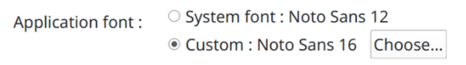

By default, GBP uses the default system font to display characters. If user prefers a different font style, without changing the system configuration, it may set GBP application font by selecting first the "Custom" radio button and then press the "Choose" button. He will then be able to select the required font. GBP must be restarted for the change to take effect. For example, here is the font selection dialog on Linux :

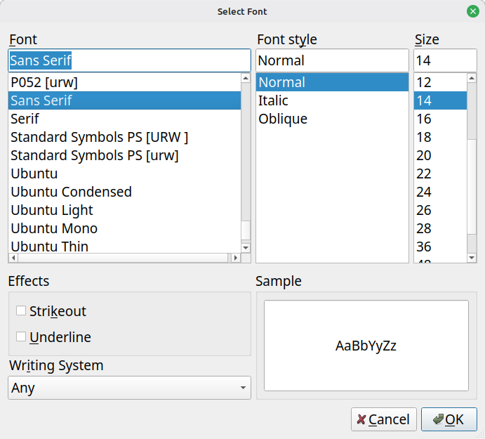

To return to default font, just select the "System Font" radio button.

If ever the user selects a font that make the text unreadable, GBP can be started in a terminal window with the argument "-usesystemfont". This will reset the font to system font.

Allow colorization of Cash Stream Definition names
Enable or disable the colorization of names for all Cash Stream Definitions. This can be useful if a scenario is used on an OS where custom theming makes difficult the reading of colorized name. "Disable" means that default Operating System text color will be used.

Export to CSV – Amounts are localized
When checked, any amount used in any CSV export process will be written using the conventions of the system’s Locale. For example, on a French system, the amount 12345.67 would be written :

12 345,67

When unchecked, no "thousands separator" is used and the "decimal separator" is ".".

Export to CSV – Dates are localized
When checked, any full date (meaning including year, month, day) used in any CSV export process will be written using the conventions of the system’s Locale. For example, on a German system, the date 01 feb 2026 would be written :

01.02.26

When unchecked, ISO format "YYYY-MM-DD" will be used.

Use present value
This is an advanced topic.

When checked, this option will convert all the financial event amounts of the calculated scenario data set from future values (default) to present values, using the annual discount rate selected to the right.

This applies for the Cash Balance curve in the Main Window, as well as all the data displayed in the Analysis Window. The formula used for the conversion is :

FV = PV / (pow((1 + 0.01*discountRatePercent), period))

where :

- FV : Future Value
- PV : Present Value
- pow : power function
- discountratePercent : monthly discount rate in percent, derived from the annual rate specified
- period : no of months away from "present". 0 means in the same month than present

Note that the calculation is a monthly basis : it means that the present value is the same for any day of the month for which a financial event occurs.

The section "Future values vs present values" describes in more details why one would want to use Present instead of Future Values, but basically, PV gives a better view of the equivalent current values of future incomes/expenses.

Show tooltips
A “tooltip” is a small window that is displayed temporarily when hovering over a particular UI element on the screen.
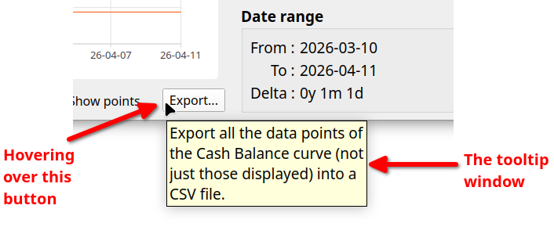
Tooltips help users understand the function of UI elements by displaying relevant information. Experienced users can disable all tooltips by unchecking this button if they find them annoying.

Income / expense color
Each time an income or expense amount is displayed, its color is taken from this values. The default is optimized to look good on light and dark theme. To change the color, click on the color rectangle.

Chart-related options
These settings are specific to curves and charts.
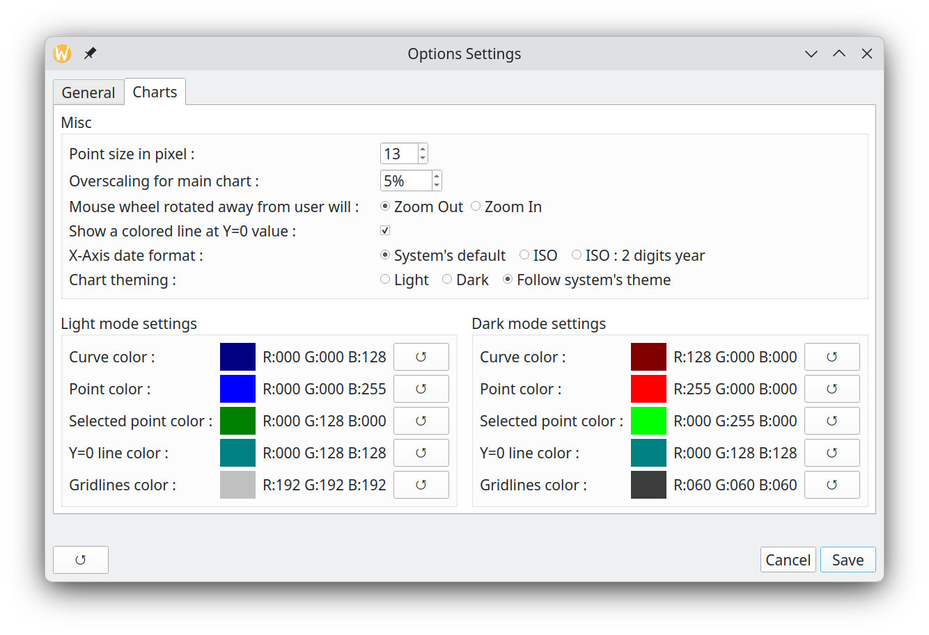

Point size in pixels
This parameter set the diameter of the disc superimposed on data points.
For example, here is the difference between 5 and 25 pixel wide point size : 10 point size is probably the most common option.
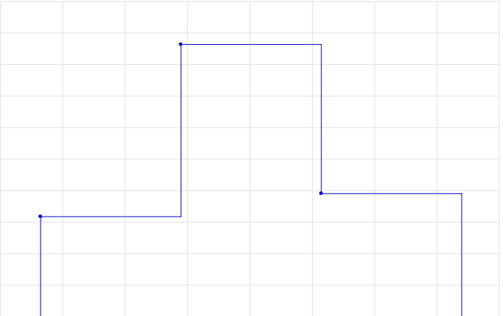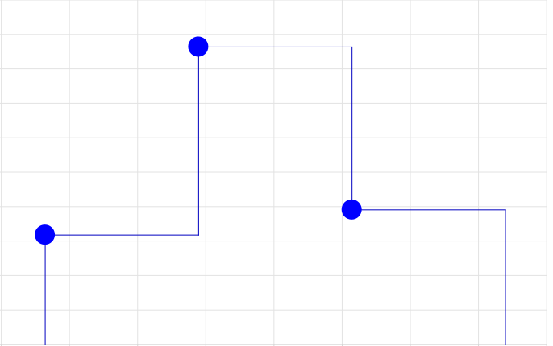

Overscaling for main chart
This applies only for the Cash Balance curve displayed in the Main Window, and the one displayed in the View Occurrence Dialog. It sets the level of "overscaling" to be applied on the charts X and Y axis. 0% means no overscaling,

By default, there is no overscaling applied. That means that the X and Y axis minimum and maximum match exactly the min/max values of the data points shown. This may lead to a problem clicking on such points, because the representation disk is clipped :

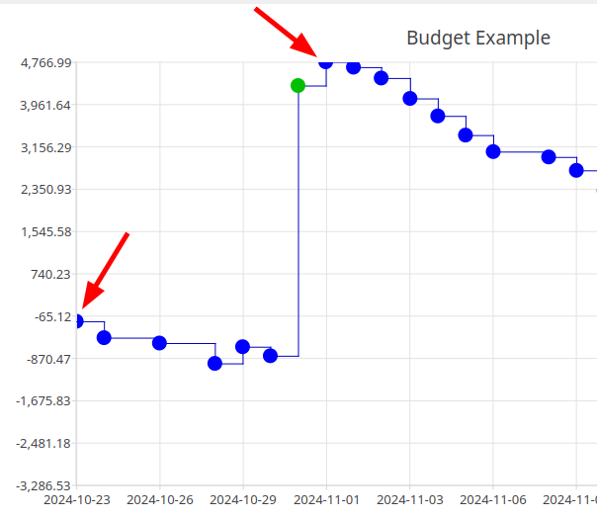

To alleviate this problem, GBP can "overscale" the X and Y axis, so that the min/max points are fully contained in the chart. For example, a 5% overscaling would produce the following result with the previous data shown :
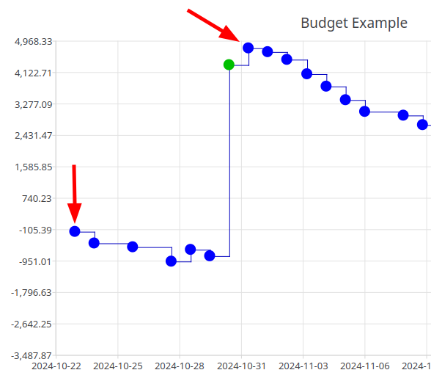

The inconvenient of overscaling is that, when one specifies a range with the upper toolbar buttons, the displayed chart is actually wider. For example, using the "Custom" range button to set an interval of [1 jan 2025 – 31 dec 2025], which is exactly 1 year, we get the following result for a 5% overscaling :

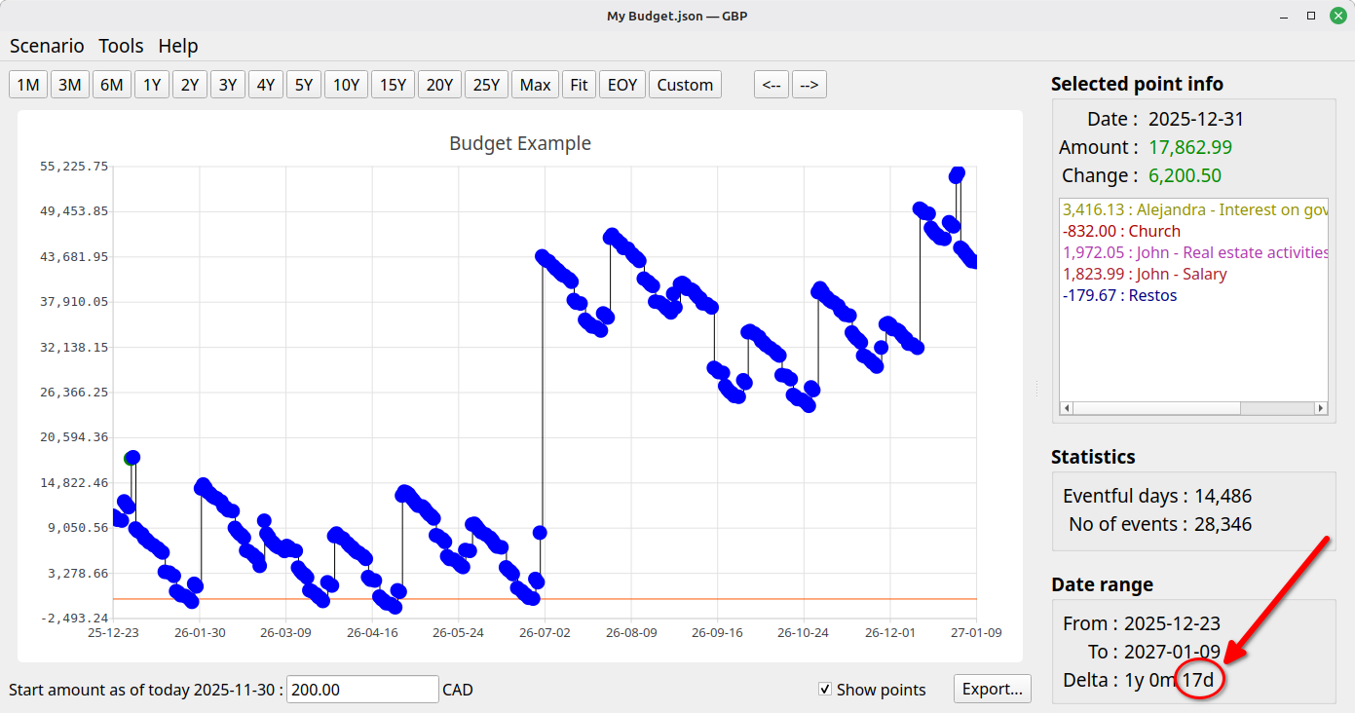

Note the "17 more days" over the 1 year requested. 17 days is roughly 5% of 1 year.

Mouse wheel rotation
Define if mouse wheel rotation “forward” will zoom in or zoom out.

Show a colored line at Y=0
If checked, a dashed colored line is superimposed on the Cash Balance curve at Y=0. This is helpful to see where the balance enters the "red" or the "green". The dashed style improves visibility over the curve. The color of the line is defined in the Dark/Light mode color settings section below.

X-Axis date format
The dates on the X-Axis can have one of 3 formats.

System’s default :
GBP use the default system configuration (a.k.a the default Locale) to determine the date format. For example, on Fedora KDE 44, this is set by this dialog :

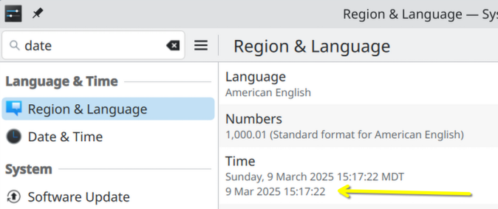

ISO :
Set the date format to ISO 8601, that is YYYY-MM-DD

ISO 2-digit year :
Same as ISO, but drop the first 2 digit of the year. This allows for bigger font to be used without screwing the X-Axis rendering.

Chart theming (dark or light mode)
Define how the charts (curves, histograms, pie charts) theme will be determined.

Force light mode
All charts always use the light theme.

Force dark mode
All charts always use the dark theme.

Follow system’s theme
For most platforms supported, GBP can detect which theming mode is in use for the system desktop, that is “dark mode” or “light mode”. When detection is successful, this option applied this theme to all charts. Otherwise, the light theme is used.

Dark/Light mode color settings
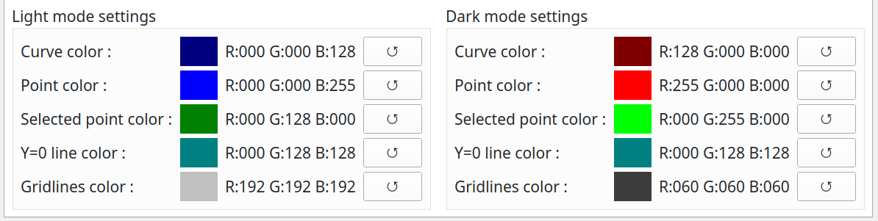

The left panel set the colors of misc items while in Light mode, the right side is for the Dark mode. Color can be set by clicking in the colored rectangle.

- Curve Color : this set the color of the Cash Balance curve itself.
- Point Color : this set the color of the data points in the Cash Balance curve
- Selected Point Color : this set the color of the selected data point in the Cash Balance curve
- Y=0 Line Color : sets the color of the dashed Y=0 line superimposed on the Cash Balance chart.
- Gridlines Color : sets the color of the X and Y axis grid lines on the Cash Balance chart.

Each color row has a reset button (↺) that instantly reverts that color to its factory default without closing the dialog. Color values are displayed in zero-padded three-digit format (e.g., R:005 G:064 B:128) so all labels stay the same width for easier reading.

Analysis window
This window provides more in depth statistical analysis of the resulting financial events stream displayed by the Cash Balance curve in the Main Window.

At the bottom of the window, there are buttons to export the content of the current tab either in CSV or in PNG. Depending on the tab selected, some can be hidden because not applicable.

Relative weight tab
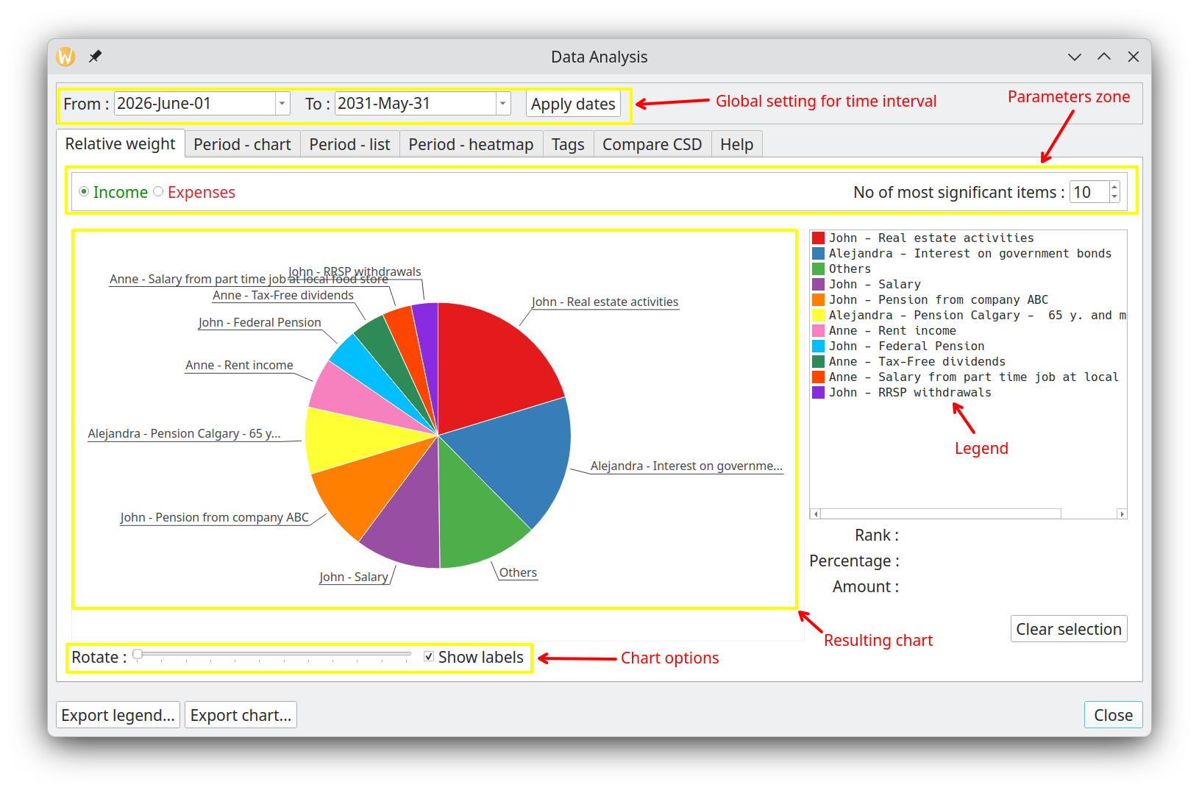A very important analysis module that provides quite useful information on the current scenario. Its goal is to show on a pie chart the comparative weight of either incomes or expenses, spread over a user-specified time interval.

For example, it will tell you what are the biggest expenses expected during the next 2 years or what is the percentage of the 10 most important incomes compared to all the expected incomes for the next 10 years.

Parameters zone
This is where you can change parameters that affect the calculation of the Pie Chart below

From
Specify the start of the date interval to consider in the calculation. Financial Events occurring before this date will not be taken into account.

To
Specify the end of the date interval to consider in the calculation. Financial Events occurring after this date will not be taken into account. Must not be smaller than "To" date.

Apply dates
Apply the dates specified in “From” and “To”.

Incomes / Expenses radio buttons
Specify if we want to consider incomes or expenses (cannot do both at the same time)

No of most significant incomes/expenses
Specify how many slices the pie chart will have. If this number is greater or equal to the total number of incomes (or expenses), then it is the latter that is used. Otherwise, there will be 1 more slice than this number, dedicated to all the "other" incomes (or expenses) taken all together (named "Others" on the chart).

Result chart
The area where the chart is displayed, along with the legend mapping the pie color to the actual incomes (or expenses). Colors of the slices are pre-configured and cannot be changed by the user.

User can select multiple items in the legend : the corresponding total amount and total percentage will be displayed and the related slices will be “exploded” (that is pulled-out).

Chart options
- Use the slider to rotate the pie chart and reposition labels for better visibility.
- Labels can be hidden by unchecking the “Show labels” checkbox.

Period – chart
This tab combines the Monthly chart and Annual chart from previous GBP versions. A radio button pair at the top of the parameters zone switches between Monthly and Annual granularity. Both views share the same controls.

Parameters zone
This is where you can change parameters that affect the calculation of the Bar Chart.

Monthly / Annual
Selects the type of the chart: monthly (one bar per month) or annual (one bar per year).

Duration
Sets how many periods (months or years) to display simultaneously on the bar chart.

Incomes / Expenses / Deltas
Specifies what information is displayed in the Bar Chart:
- Incomes : only income Financial Events are used.
- Expenses : only expense Financial Events are used.
- Incomes and Expenses : all Financial Events are used.
- Deltas : all Financial Events are used, and the chart shows Incomes – Expenses. Bars in green indicate a surplus; bars in red indicate a deficit. This is particularly useful to track the evolution of the monthly or yearly surplus over time.

Panning controls zone
The two arrow buttons shift the Bar Chart left or right by an amount of periods equal to the "Duration", acting as a scroll control.

Result chart
The Bar Chart is displayed here. Hovering over a bar shows a tooltip with the series name, period, and formatted amount.

Period – list
Provides a tabular summary of your financial activity for every month or year covered by the scenario. Unlike most other analysis views, this tab always displays the full scenario range — the global date range set at the top of the dialog has no effect here.

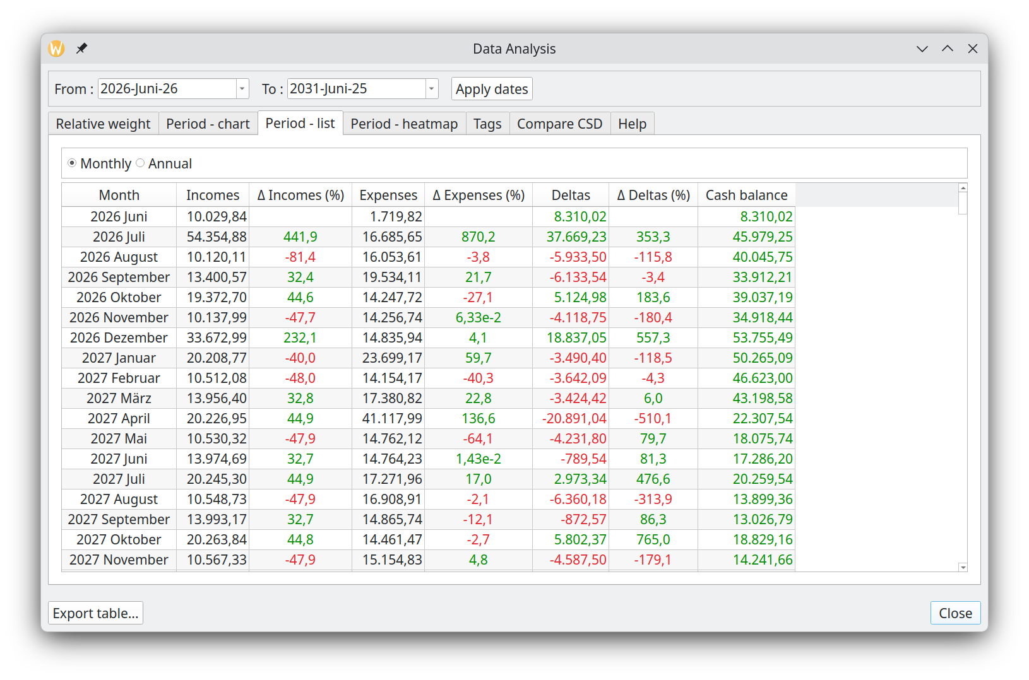

Granularity
Use the Monthly and Annual radio buttons to switch between two levels of detail:

- Monthly — one row per calendar month, labeled with the full year and month name (e.g. 2026 June).
- Annual — one row per calendar year.

Columns
Each row contains the following information for the corresponding period:

- Period — the month or year label.
- Income — total income received during the period.
- Income change % — change relative to the previous period; shown in green if positive, in red if negative.
- Expenses — total expenses incurred during the period.
- Expense change % — change relative to the previous period; color-coded accordingly.
- Delta (Δ) — net cashflow for the period (income minus expenses); shown in green if positive, in red if negative.
- Delta change % — change in delta relative to the previous period.
- Cash balance — running cumulative balance at the end of the period, using the starting amount entered in the main window as its initial value.

Change percentages are left blank for the very first period, since there is no prior period to compare against.

Sorting
Click any column header to sort the table ascending or descending by that column.

Period – heatmap
Displays a color-coded grid that encodes your financial activity visually, making it easy to spot the busiest or most profitable periods at a glance. Like the Period — List tab, it always covers the full scenario range regardless of the global date range.

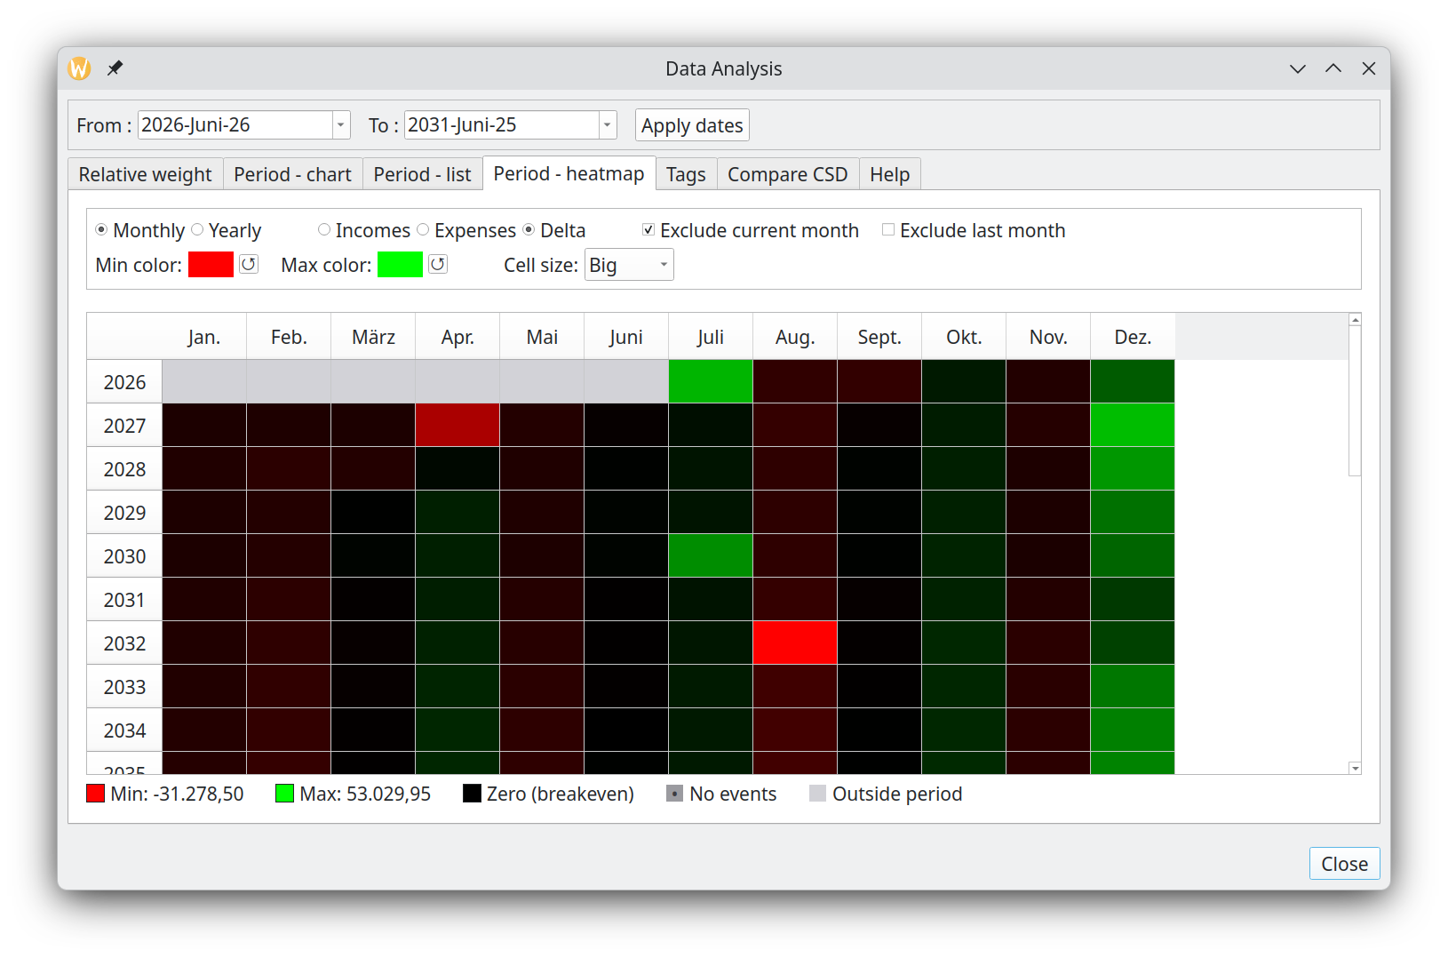

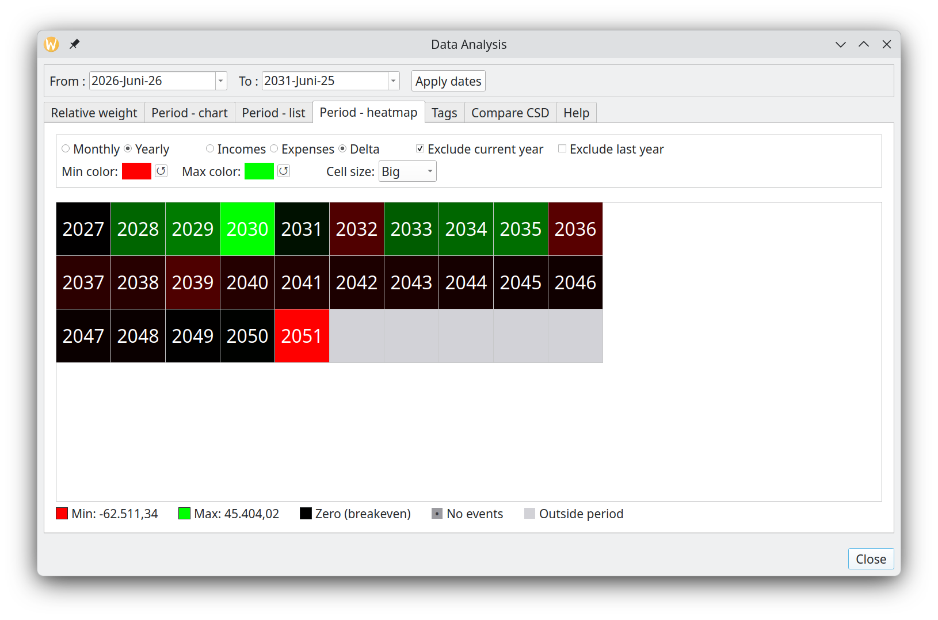

Granularity
A radio button pair selects the granularity:
- Monthly : one row per year, one column per month (Jan–Dec), with year and abbreviated month-name headers.
- Yearly : years fill a fixed 10-column grid left-to-right, top-to-bottom; the year is written inside each cell and no headers are shown.

Display modes
Three display modes are selectable via radio buttons:
- Incomes : sequential color scale. The smallest non-zero income shows a near-background tint of the income color; the highest income shows full saturation. The minimum tint is derived automatically from the maximum color.
- Expenses : same sequential scale applied to expenses.
- Delta (income − expense) : diverging scale centered on pure black (breakeven). Positive periods blend toward the positive-side color; negative periods blend toward the negative-side color. Each side is normalized independently so both extremes always reach full saturation.

Cell states
- Periods with no financial events are shown with a forward-diagonal hatch (/).
- Periods outside the scenario range, or excluded by the "Exclude current period" checkbox, use a backward-diagonal hatch (\).
- In Income or Expense mode, a period that has events but zero activity for the active type is treated as no-events rather than colored, because its zero is uninformative rather than a meaningful breakeven.
- In Delta mode, zero (income equals expense) is always colored pure black.

Exclude current month / year
When checked, the in-progress period is omitted from both the grid display and the color-normalization calculation.

Color configuration
Color pickers are shown in the header area:
- Income or Expense mode: one color picker sets the maximum (saturated) color; the minimum tint is derived automatically.
- Delta mode: two color pickers set the positive-extreme and negative-extreme colors independently. Defaults are green (positive) and red (negative).
- Each picker has a one-click reset button (↺) to restore its factory default color.

Legend
A legend at the bottom of the heatmap shows color swatches for: minimum value, maximum value, breakeven (delta mode only), no-events hatch, and out-of-period hatch, with formatted currency labels for the minimum and maximum values.

Cell size
Cell size can be set to Normal, Big (1.5×, default), or Bigger (2×) via a combo box in the header. The table scrolls automatically when cells exceed the available space.

Tooltips
Hovering over any cell shows a tooltip with the full income, expenses, delta, and balance breakdown for that period.

Tags
This section of the Analysis module provides a detailed breakdown of how each tag influences your total income and expenses during a selected time period. It works by aggregating all Cash Stream Definitions associated with each tag, calculating their combined contribution, and then comparing that subtotal against your overall income or overall expenses for the chosen interval. This comparison allows you to understand what percentage of your total income or expenses each tag represents, helping you identify which tags have the most significant financial impact on your budget scenario.
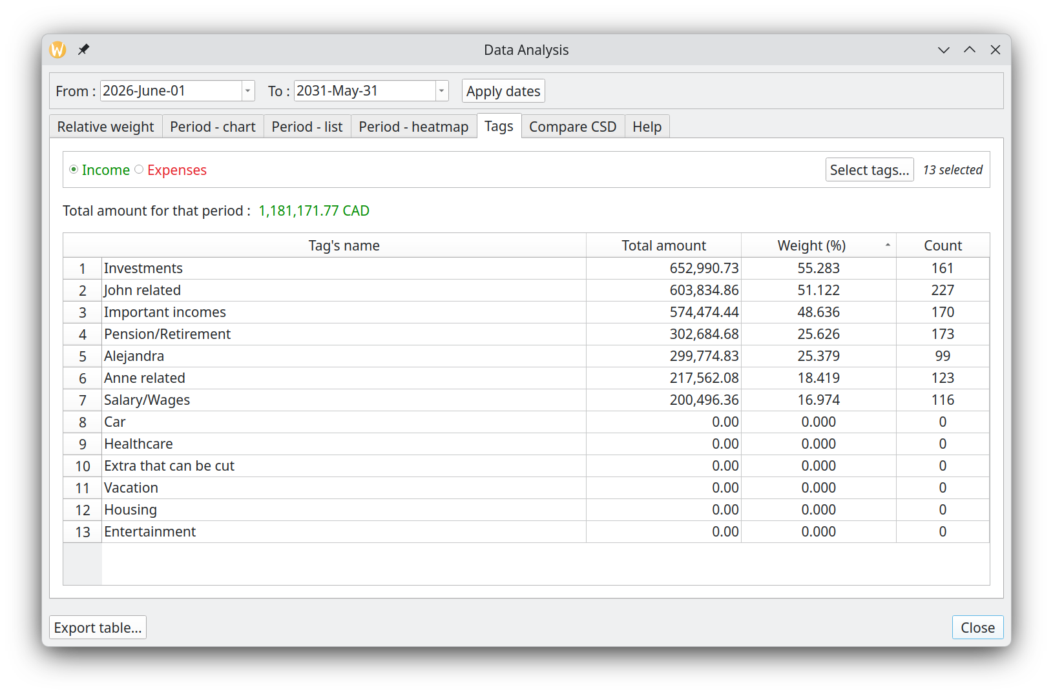

Tags selection
By default, all the tags defined in the scenario are used for the study. It is possible to reduce this set by pressing the “Select tags...” button and then selecting just the tags you are interested in.
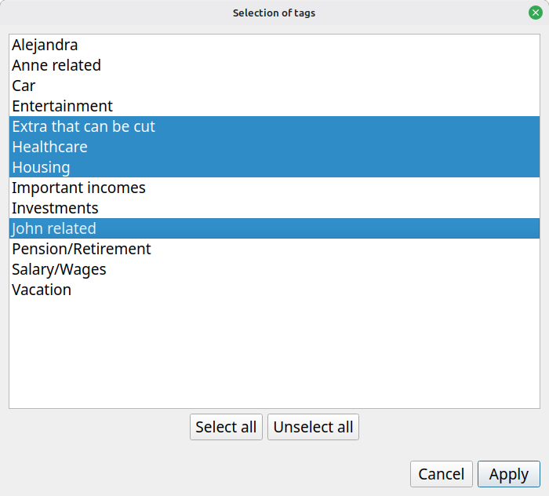

Choosing between incomes and expenses
You must choose the type of Cash Stream Definitions that will be aggregated. It is not possible to have both.
For example, supposed a tag “X” is linked to CSD “A”, “B” and “C”. Lets also suppose “A” is income, “B” and “C” are expenses. If “incomes” is chosen, then only the contribution of CSD “A” will be taken into account in the total contribution of tag “X”.

Compare CSD
This new tab in gbp version 1.8 allows direct visual comparison of up to 10 Cash Stream Definitions on a single line chart, overlaying their financial events over the same time axis.

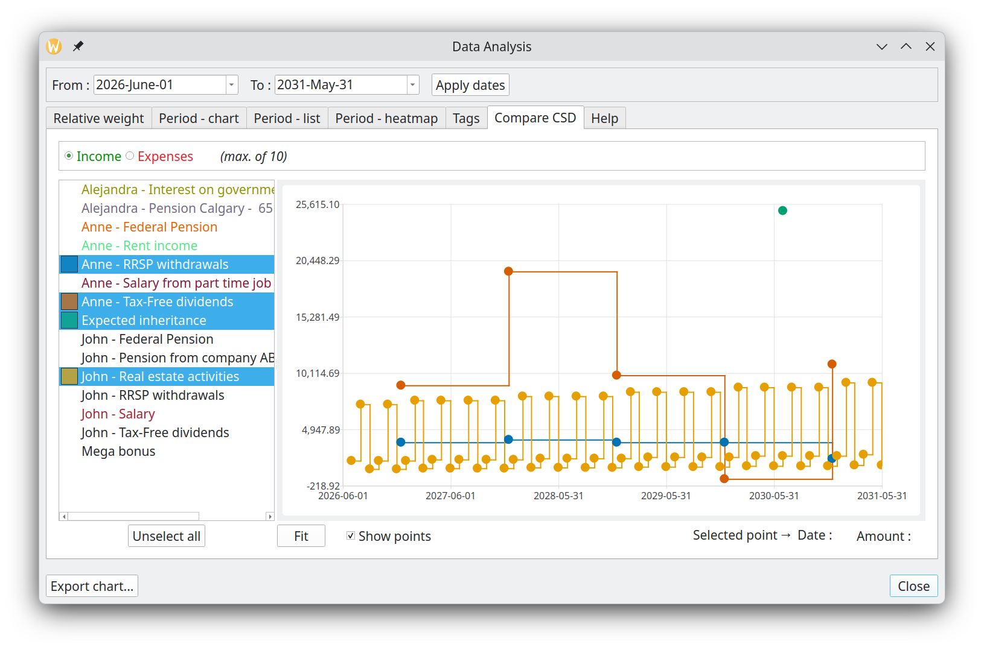

CSD selection list
A side panel lists all Cash Stream Definitions active in the current date range, sorted alphabetically. Selecting up to 10 entries adds them to the chart. A radio button pair at the top switches between Incomes and Expenses mode; each mode maintains its own independent selection.
Each selected CSD is drawn with a distinct color from the Okabe-Ito palette. Colors are assigned persistently per CSD: adding or removing other CSDs does not change the color of an already-selected one. A colored square icon next to each list entry reflects the assigned chart color.

Result chart
The line chart overlays the financial events of all selected CSDs over the current date range. Lines use step rendering: the value holds flat until the exact moment the next event occurs.

Show points
When this checkbox is checked, scatter markers are overlaid at each individual financial event. Clicking a marker highlights it and displays its date and value below the chart; clicking again deselects it.

Controls
- Fit : rescales the chart axes to fit the current data and date range.
- Unselect all : clears the CSD selection for the active mode (Incomes or Expenses).

Present value calculator
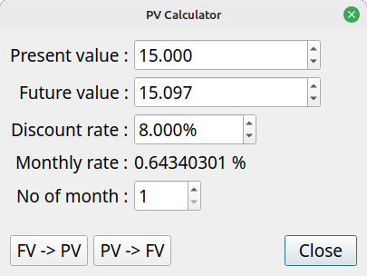
This calculator is accessible through the “Tools” menu. It is use to convert a Present value (PV) to a Future value (FV) or vice-versa. Compounding period is always monthly.

Formulas used

PV to FV
PV = FV / powl((1 + 0.01L*monthlyDiscountRate), noOfMonth);

FV to PV
FV = PV * powl((1 + (0.01L*monthlyDiscountRate)), noOfMonth)

Description of the fields

Present value
If you want to convert a PV to a FV, enter the PV here. If you want to convert a FV to a PV, the result of the operation will be displayed here.

Future value
If you want to convert a FV to PV, enter the FV here. If you want to convert a PV to FV, the result of the operation will be displayed here.

Discount rate
The annual discount rate used in the calculation. It is expressed in percentage, so a value of “8” means 0.08 or 8%.

Monthly rate
This is a calculated field, deduced from the discount rate.

No of month
No of periods. Period is always provided in number of months.

FV → PV
Calculate the present value of the future value found in the field FV.

PV → FV
Calculate the future value of the present value found in the field FV.

Usage

Preparing to create a budget
Here are the steps to create your first budget.

Collecting information
As explained before, a budget in GBP is called a "scenario". The name comes from the fact that you can create as many budgets as you want with the application, each one being a specific "scenario" covering a given set of options or possibilities.

Before creating a new budget, you must remember that GBP will focus only on the future incomes and expenses to come. The past is irrelevant for GBP and essentially discarded.

Define your cash streams
List all sources of incomes and expenses you expect from tomorrow onward (over your desired timeframe). Each will be implemented as a Cash Stream Definition. For each, determine:

- Type - Is it recurring at fixed intervals (daily, weekly, monthly, end-of-month, or yearly)? If yes, use Periodic. Otherwise, use Irregular
- Frequency (Periodic only) - When does it start and end?
- Amount (Periodic only) - Is it constant, or does it change over time?
  - If it changes with a constant growth rate (annually or monthly), specify the annual percentage
  - If it follows a variable growth pattern, define each growth transition as (date, percentage)
  - If the pattern doesn't fit these rules, use Irregular instead

Set inflation
Define the inflation rate for the scenario. As a reminder, inflation is defined at the scenario level. A simple approach is to define inflation as constant through the years (for example 4%, but it can also be 0% or even negative if you want). For a more complex situation (this is more advanced stuff), you can model inflation that varies through the months and years.

Practical examples of periodic Cash Stream Definitions

Salary received every 2 weeks, no growth
Period is "week", Period Multiplier is 2. Start Date must be the first day of occurrence (here on Friday).

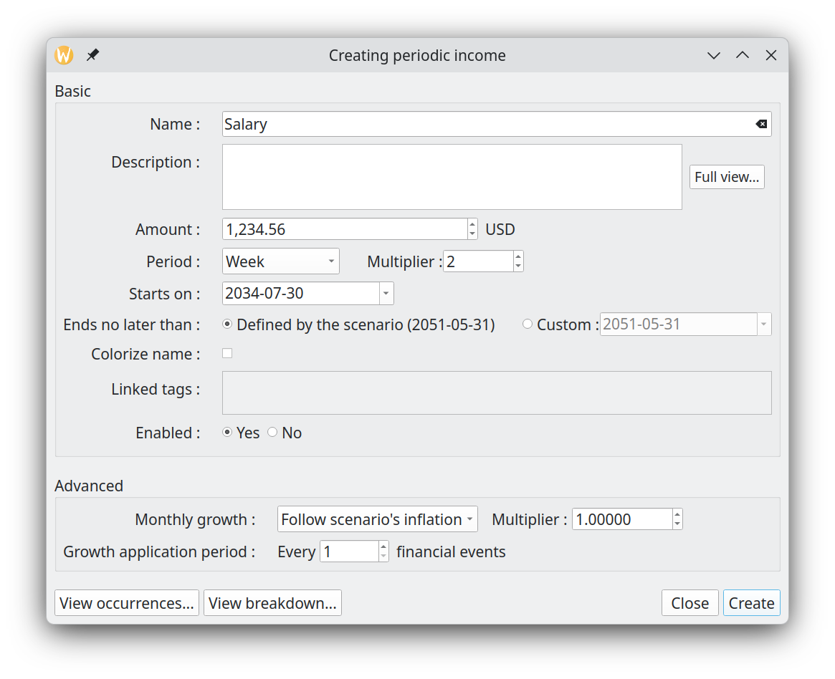
The salary will repeat until it reaches the End Date :

2034-07-30 : 1,234.56
2034-08-13 : 1,234.56
2034-08-27 : 1,234.56
2034-09-10 : 1,234.56
2034-09-24 : 1,234.56
...
2040-05-27 : 1,234.56
2040-06-10 : 1,234.56
2040-06-24 : 1,234.56
...

Salary received twice a month (15th , end of month), no growth
This one is a little bit tricky, because when we look at it closely, it is a strange "regular" time interval (end of month can be 28,29,30,31). To fix that, we need to have 2 separate incomes : Salary 1 and Salary 2.

=> Salary 1 is received on the 15th of each month, with a period of 1 Month.
=> Salary 2 will occur at the end of every month. We specify a start date of 01 July, but as explained before, when period is end-of-month, the first occurrence is actually at the end of the month of the start date.
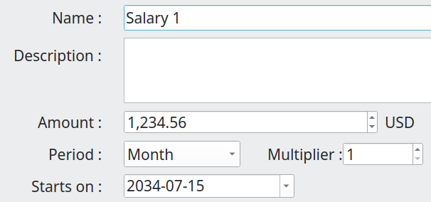

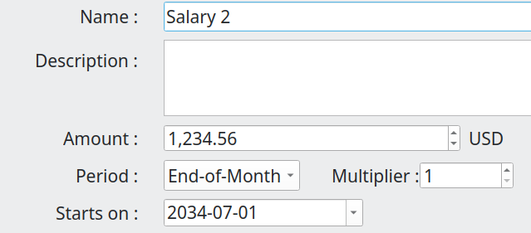

Salary 1 will generate the expected Financial Events :

2034-07-15 1234.56
2034-08-15 1234.56
2034-09-15 1234.56
2034-10-15 1234.56
...

Salary 2 will also generate the expected Financial Events : note how the end-of-month dates change.

2034-07-31 1234.56
2034-08-31 1234.56
2034-09-30 1234.56
2034-10-31 1234.56
...

An annual rent with fixed monthly payment
Lets say we have a rent with a 1000$ monthly payment, renewed every 12 month with an annual rent increase of 5 %. Monthly payment are constant within a 12 month contract. This can be modeled in GBP the following way :

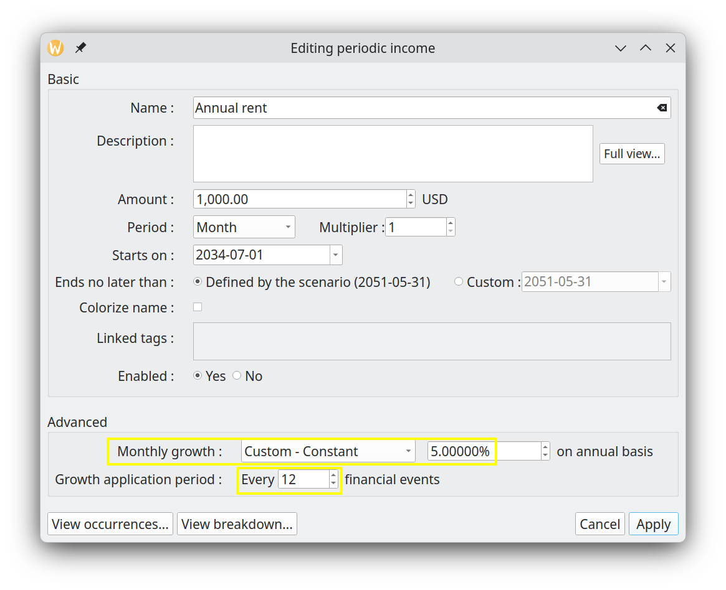
The Period is "1 monthly", since we pay the rent every month. The amount is 1000. Growth is set to "Constant – 5% annually). The trick here is to set "Growth Application Period" to 12, because we want the rent raise to be applied only once a year, at renewal. The generated Financial Events will be, as expected :

2034-07-01 1000.00
2034-08-01 1000.00
2034-09-01 1000.00
...
2035-06-01 1000.00
2035-07-01 1050.00
2035-08-01 1050.00
...

Weekly grocery bill that follows scenario’s inflation
This is a weekly expense that should follow inflation, which we set at 5% in the scenario. So the period is "1 week" and growth must be set to "Follow scenario’s inflation". Lets assume a 300$ weekly grocery expense. In GBP, we then have this periodic Cash Stream Definition :

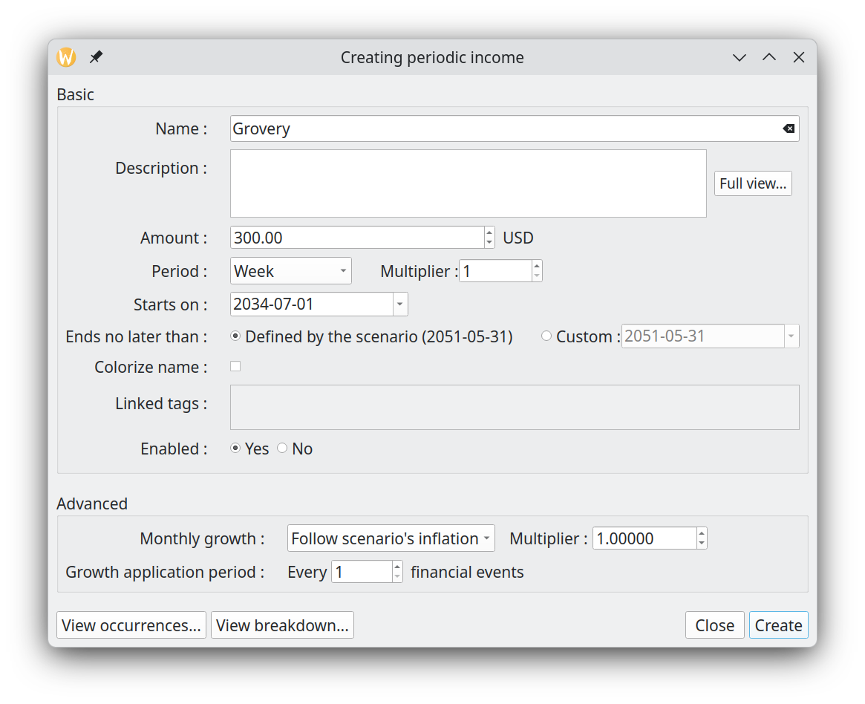
Since inflation (and any defined growth for any Cash Stream Definition) is always converted internally to monthly value and applied on the 1st of each month, we should have the weekly grocery expense stay the same for a whole month. Monthly growth will be 0.4074% (equivalent of 5% annual). Also, remember that the first occurrence never has growth applied. We then get, as expected :

2034-07-01 300.00 <= no growth applied for first occurrence
2034-07-08 300.00
2034-07-15 300.00
2034-07-22 300.00
2034-07-29 300.00
2034-08-05 301.22 <= Monthly inflation applied
2034-08-12 301.22
2034-08-19 301.22
2034-08-26 301.22
2034-09-02 302.45
2034-09-09 302.45

Monthly loan payment at each end-of-month
Lets say we have a loan payment of 100$ that is due at every end of month, with the first occurrence being on 30 nov 2034 and end on 31 oct 2039. In GBP, that translates to :

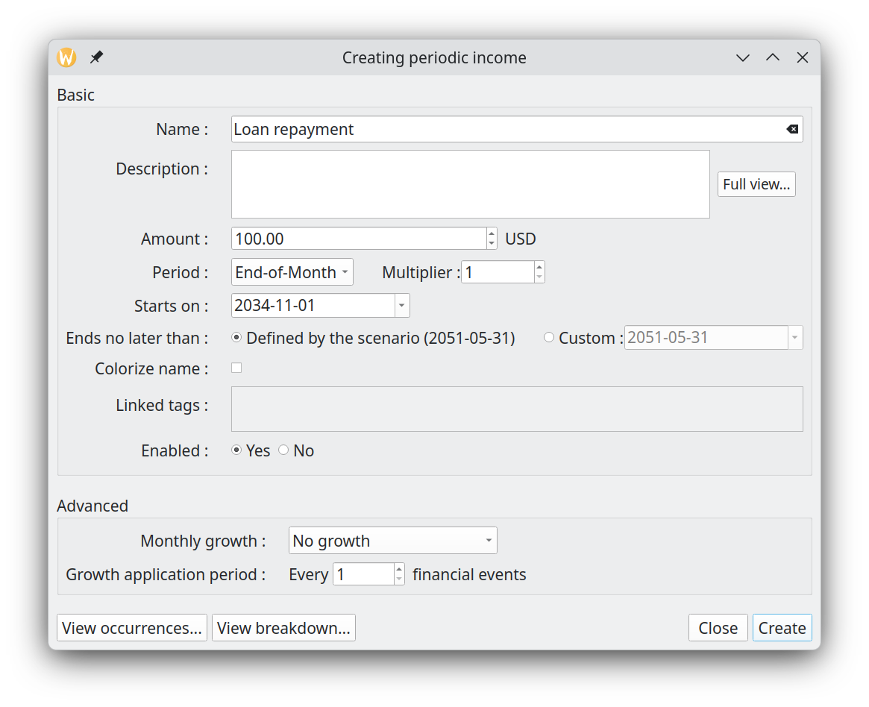
The use of "End-of-Month" for the Period make sure that, as we go forward in time, one always get the real end of month, and not just "date + 1 month" as it would be if we would use Period = "Month". The resulting Financial events are, as expected :

2034-11-30 100.00
2034-12-31 100.00
2035-01-31 100.00
2035-02-28 100.00
2035-03-31 100.00
...

Monthly car maintenance that increases by a variable amount
Lets say we have a 50$ monthly car maintenance fee (I know, this is ridiculously low :-) ). We want this amount to increase by a different growth rate each year, because the car is getting older. Let say that :

- Year 1 : 5% increase (annual basis)
- Year 2 : 10% increase (annual basis)
- Year 3 : 15% increase (annual basis)
- Year 4 and following : 20% increase (annual basis)

To model that in GBP, we have to use a variable growth rate applied to a period Stream Definition.
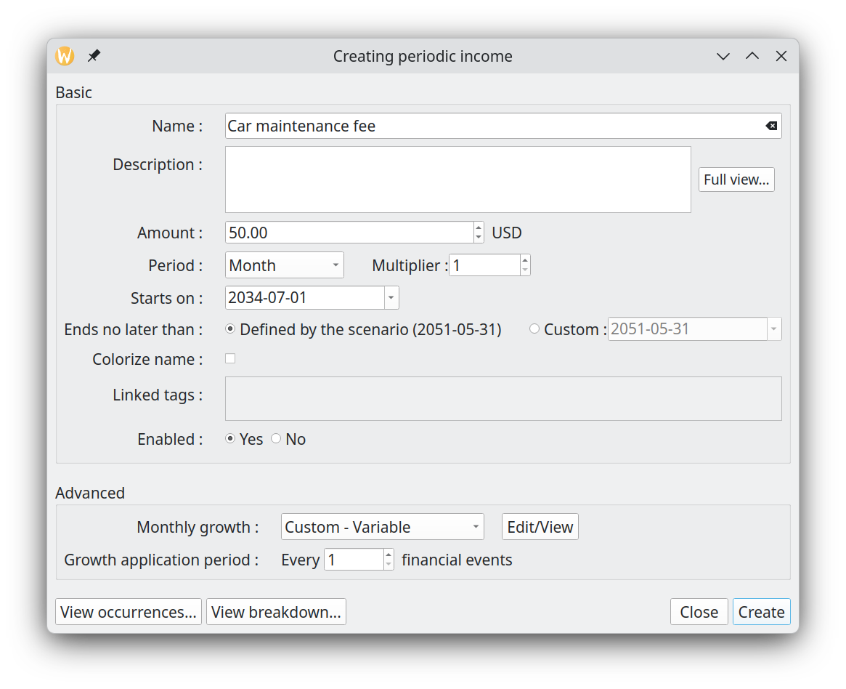
with the definition of the variable growth like the following :

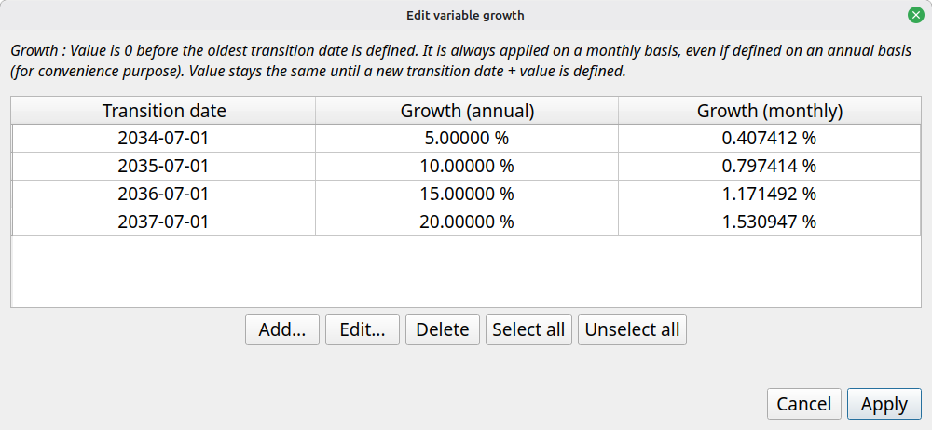

It is worth noting the following :

- Even if the first growth is defined for 2034-07-01, since the first event occurred also in that month, it means there wont be any growth applied to the first occurrence on 2034-07-01
- We don’t need to enter a 20% growth for 2038-07-01, since the 20% defined on 2037-07-01 continue for ever

We get the following Financial events, which are as expected :

2034-07-01 50.00 <= growth never applied on the first occurrence
2034-08-01 50.20 <= growth of 0.4074%
2034-09-01 50.41 <= growth of 0.4074%
...
2035-06-01 52.29 <= growth of 0.4074%
2035-07-01 52.70 <= new growth of 0.7974%
2035-08-01 53.12 <= growth of 0.7974%
...
2036-06-01 57.52 <= growth of 0.7974%
2036-07-01 58.19 <= new growth of 1.1715%
...
2037-06-01 66.14 <= growth of 1.1715%
2037-07-01 67.16 <= new growth of 1.5309%
...
2038-06-01 79.37 <= growth of 1.5309%
2038-07-01 80.59 <= STILL growth of 1.5309%, for ever
2038-08-01 81.82
...

Practical examples of irregular Cash Stream Definitions

One-time tax return
A one-time event is easily modeled in GBP with an Irregular Cash Stream Definition. If for example one plans to receive a 1000$ tax return on May 15 2035, this would look like this, with German locale :

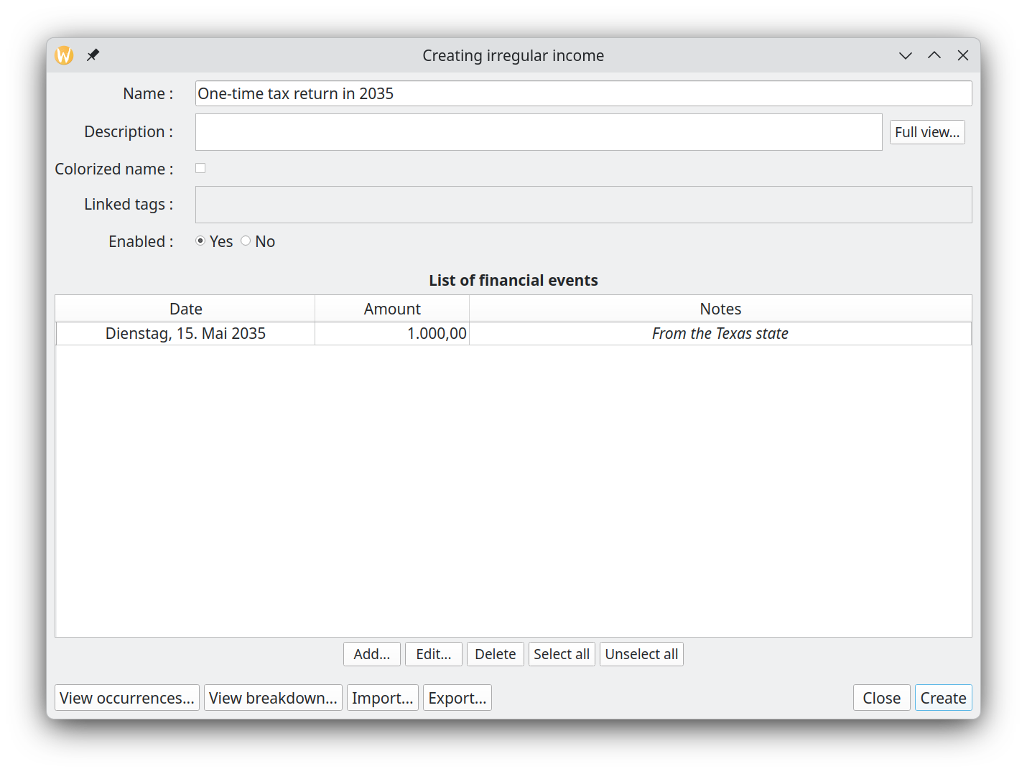
The list of Financial Events hold the expected Financial Events. Use "Add" button to create a new one, "Edit" to modify an existing one, "Delete" to remove all items selected.

Irregular incomes from selling goods
When a set of incomes occurred at irregular intervals, the best approach is to use irregular Cash Stream Definition. For example, if you expect the following incomes from selling some furniture before moving to a new place :

- 25 nov 2036 : 2000$
- 30 jan 2037 : 1500$
- 4 jun 2037 : 1200$

This would translate in GBP with the following irregular Cash Stream Definition :

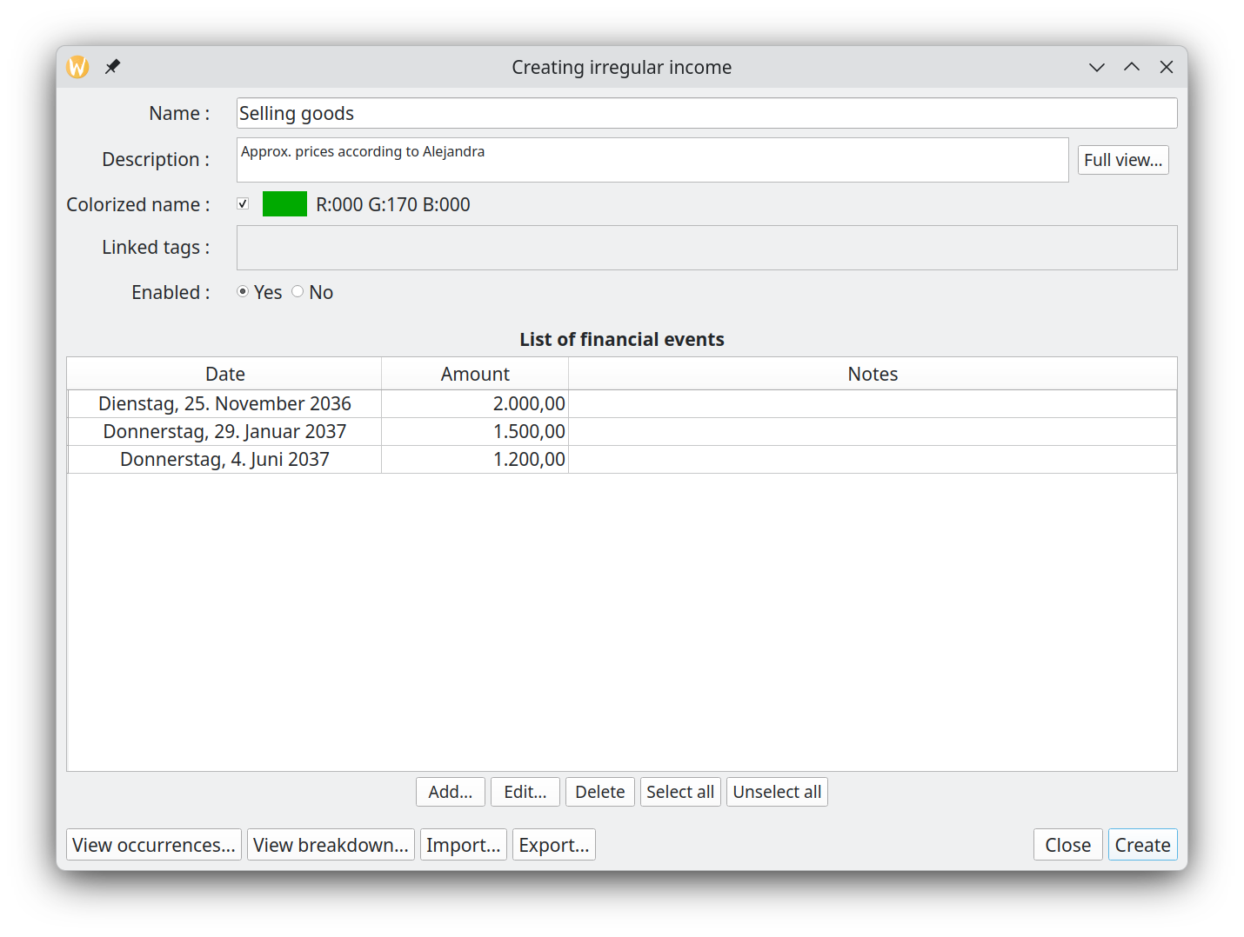

Periodic expenses but irregular amounts
Even if a set of financial events occur at regular periodic intervals, it does not means this should be modeled as periodic Cash Stream Definition. In the case where amounts are not constant or cannot be simply determined by Growth pattern (constant or variable), then irregular Cash Stream Definition is the way to go.

Lets say we get dividends from a investment portfolio every 3 months, on day 1. The amount varies enormously and are given by :
- 1 jan 2036 : 5000$
- 1 avr 2036 : 10000$
- 1 july 2036 : 12345.67$

In GBP, we would have the following Irregular Cash Stream Definition :

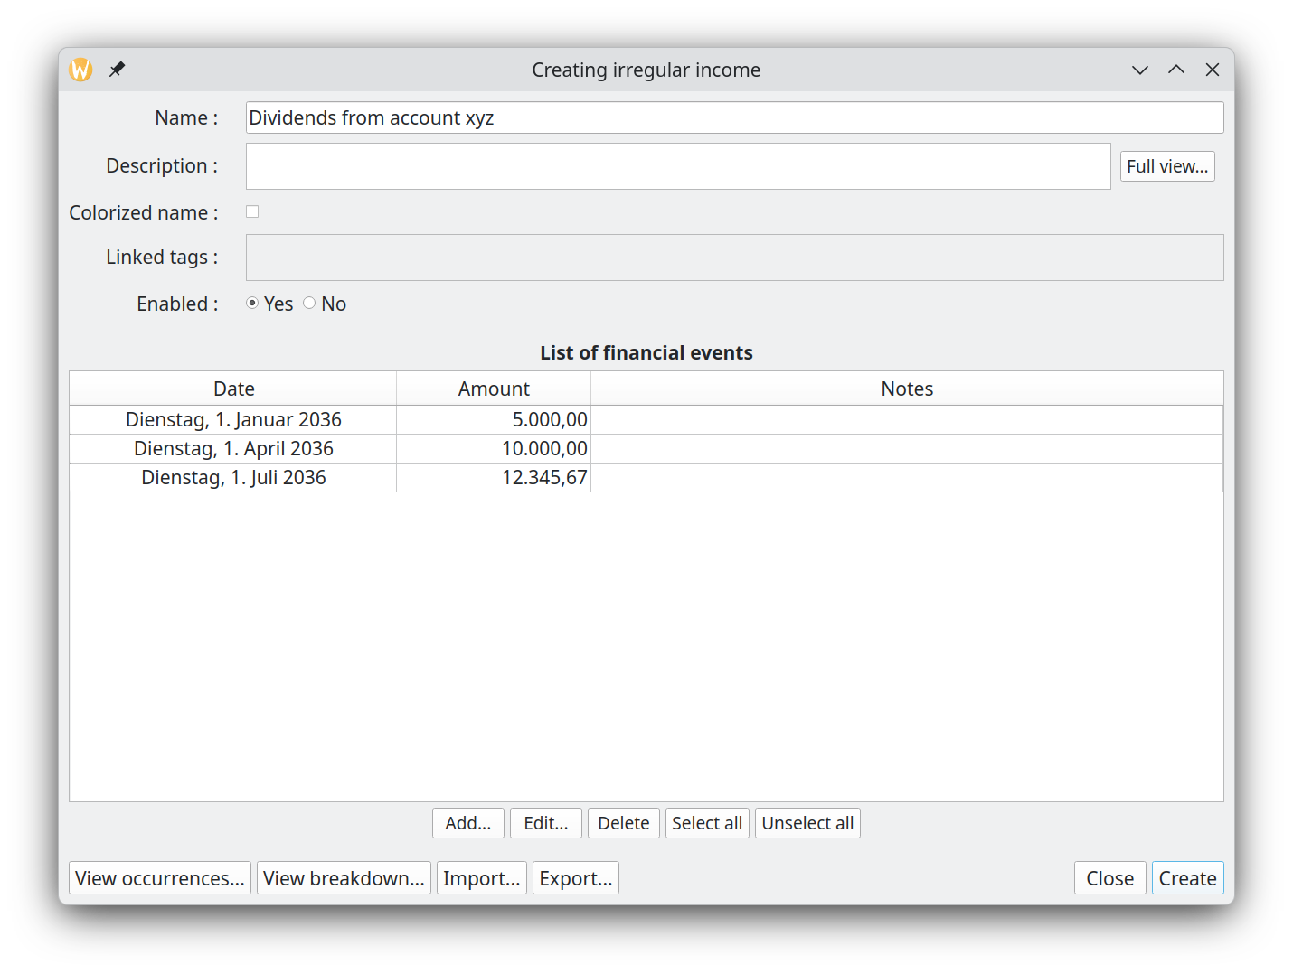

Importing a complex set of incomes
If your income or expense projections are calculated using a complex external model, you can import the results directly into GBP by creating an irregular Cash Stream Definition and uploading the data via a CSV file.

To do so, create a new irregular Stream Definition and press the "Load from file" button at the bottom left :

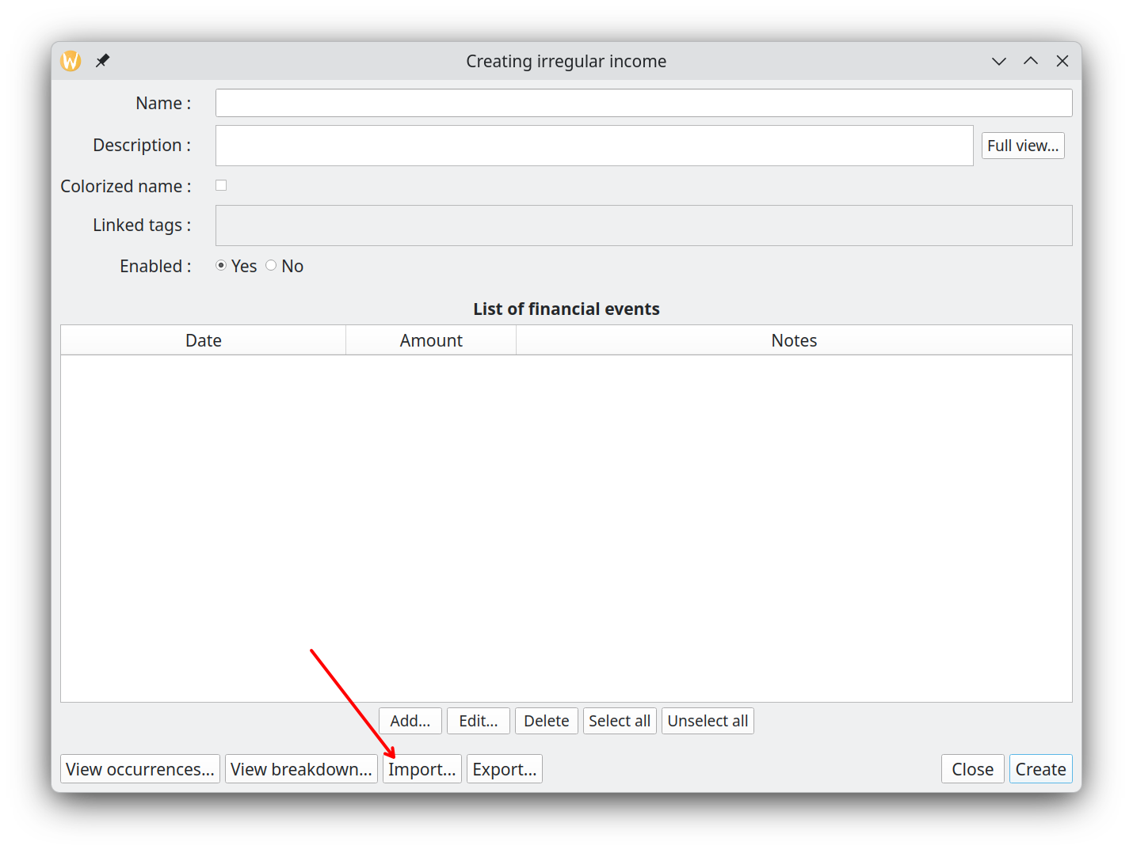

The File import Dialog is shown : proceed by selecting a CSV file using the "Browse" button and press "Import" :

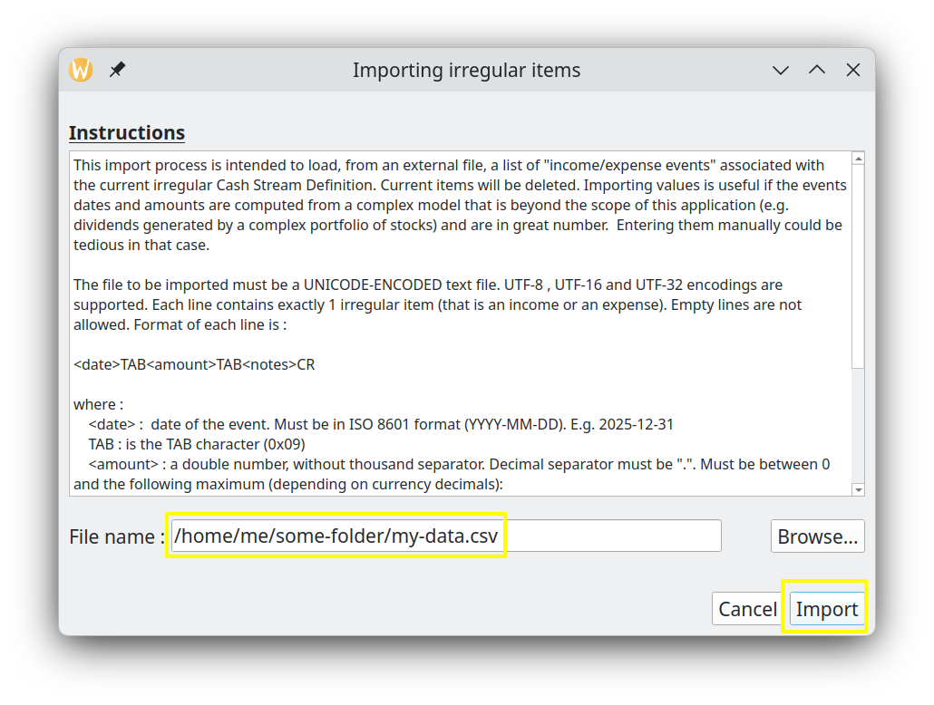

The content of the CSV file will be brought into the irregular Cash Stream Definition, replacing the current content.

Creating the budget in GBP
Once you gather all this information, you can create a new scenario by using the "Scenario→New…" menu. The following Dialog will be shown :

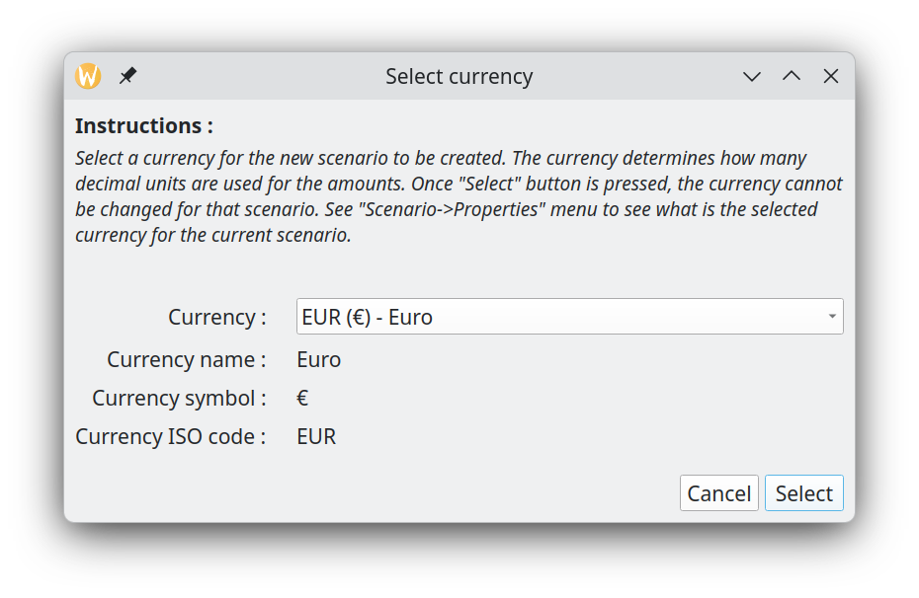

Select the currency to be used. After pressing "Select", you will have access to the "Edit Scenario" Dialog : enter the collected data and then press "Apply changes" button at the bottom right.

The last step would be to save the scenario in a disk file, using the "Scenario→Save As…" menu.

Using tags efficiently
Tags are a very powerful way to categorize the Cash Stream Definitions. Once defined, useful analysis can be conducted on their individual contributions.

Overlapping categorization
A single Cash Stream Definition can be assigned multiple tags, enabling you to analyze your income and expenses from different perspectives simultaneously. For example, a single expense can be tagged by both category (e.g., "Office Supplies") and department (e.g., "Marketing"), allowing you to view the same financial data across multiple dimensions at once.

Impact for CSD view
Lets say we define the following expense Cash Stream Definitions :

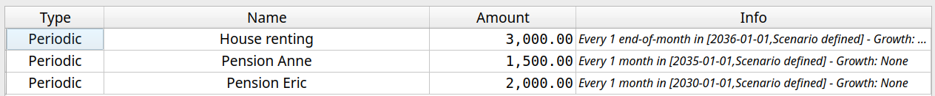

and the following tags :
- Anne
- Eric
- Stable
- At risk

and finally here are the links we create :
- Pension Anne → Anne
- Pension Eric → Eric
- House renting →Anne
- House renting →Eric
- Pension Anne → Stable
- House renting →Stable
- Pension Eric → At risk

It is then easy in the Cash Stream Definition view to display only the CSDs related to Anne , using the “By tags” filter and selecting only “Anne”:

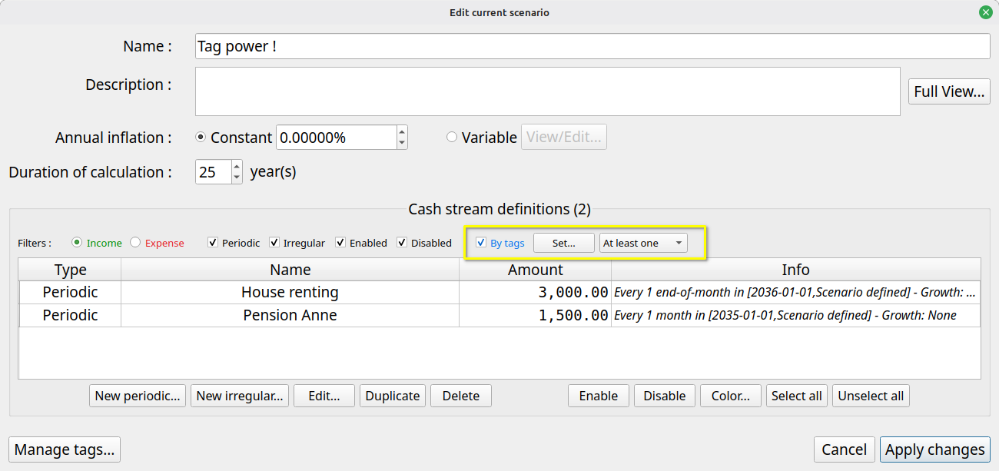

Similarly, we can see only the “At risk” income stream by using the “By tags” filter and selecting only “Stable”:

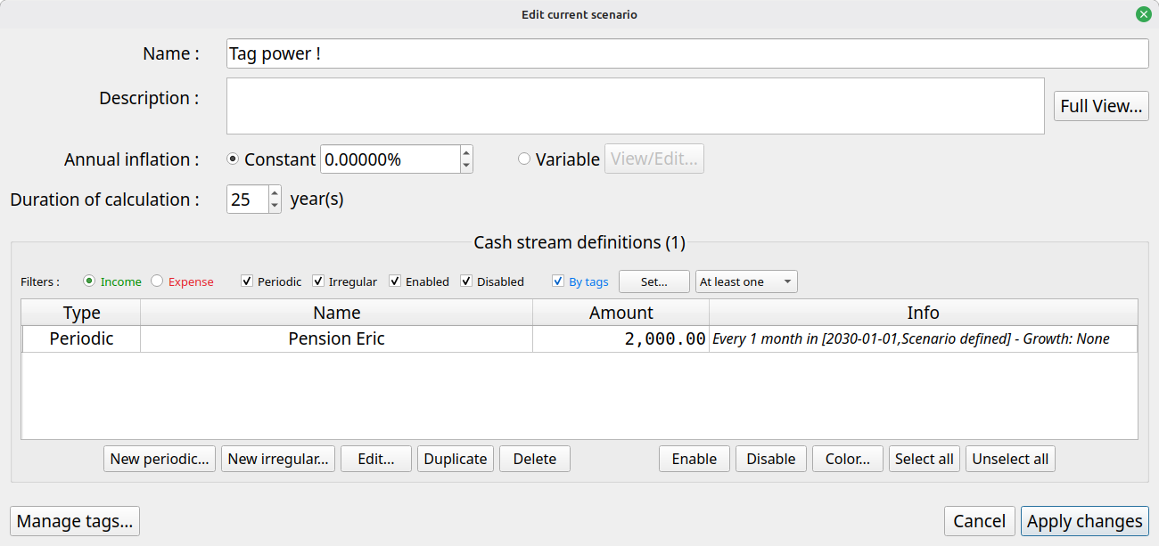

Impact for tag analysis
Using the same definitions than above, the Analysis module provides the following result, where we can see the influence of each tag :

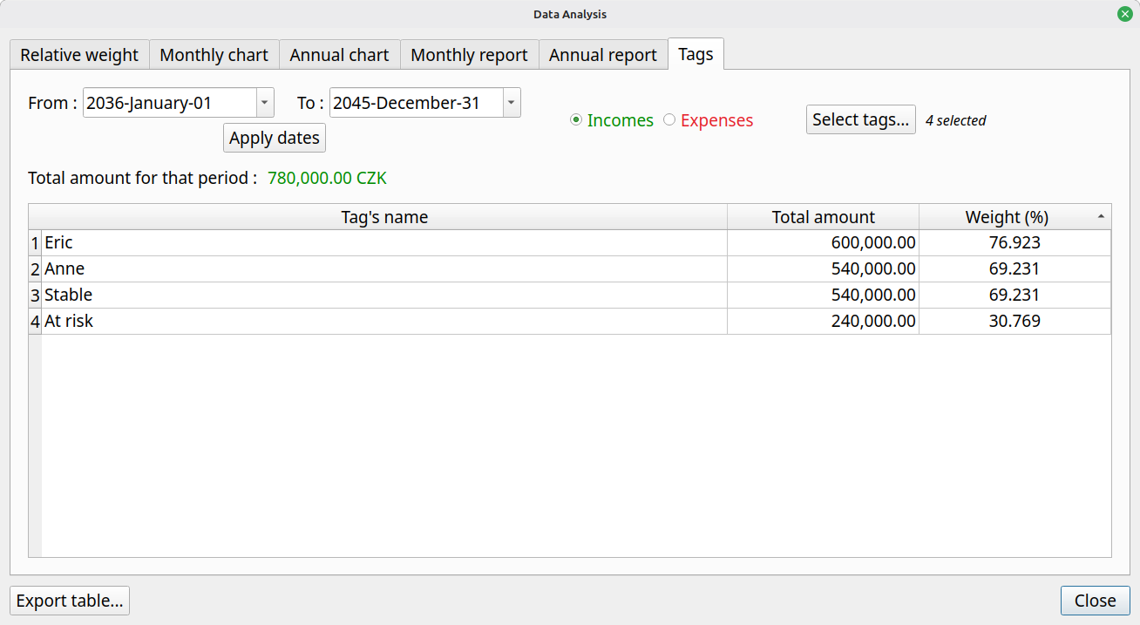

Representation of hierarchies
Lets say you have the following conceptual arrangement of a suite of expenses :

Living Expenses
├── Housing
│ ├── Rent
│ │ ├── Monthly Apartment Rent
│ │ └── Renter's Insurance
│ ├── Maintenance
│ │ ├── Annual Home Repairs
│ │ └── Pest Control Service
│ └── Property Tax
│ ├── Yearly Property Tax Payment
│ └── Home Assessment Fee
├── Utilities
│ ├── Electricity
│ │ ├── Monthly Electric Bill
│ │ └── Emergency Generator Fuel
│ ├── Water
│ │ ├── Monthly Water Bill
│ │ └── Sewage Fee
│ └── Internet
│ ├── Monthly Internet Service
│ └── Phone Service
├── Food & Groceries
│ ├── Groceries
│ │ ├── Weekly Shopping
│ │ └── Specialty Items
│ └── Dining Out
│ ├── Restaurant Meals
│ └── Takeout Food
└── Transportation
├── Vehicle Payment
│ ├── Monthly Car Loan
│ └── Gap Insurance
├── Fuel
│ ├── Monthly Fuel Expenses
│ └── Fuel Surcharge
└── Insurance
├── Annual Car Insurance
└── Extended Warranty

Each “leaf” of level 4 is a Cash Stream Definition, but hierarchies are not allowed in GBP. So it is not possible to represent explicitly this relationship tree in GBP.

This is where tags come into play.

Each element of level 1,2 and 3 can be defined as a tag and associated to the related Csd. For example, we could define these tags for the scenario :

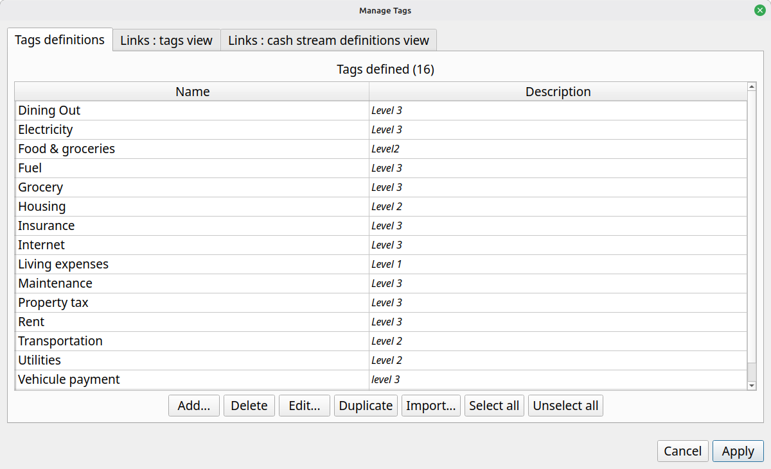

Then we could link each tag to the appropriate Csd. For example, for “Transportation” tag :

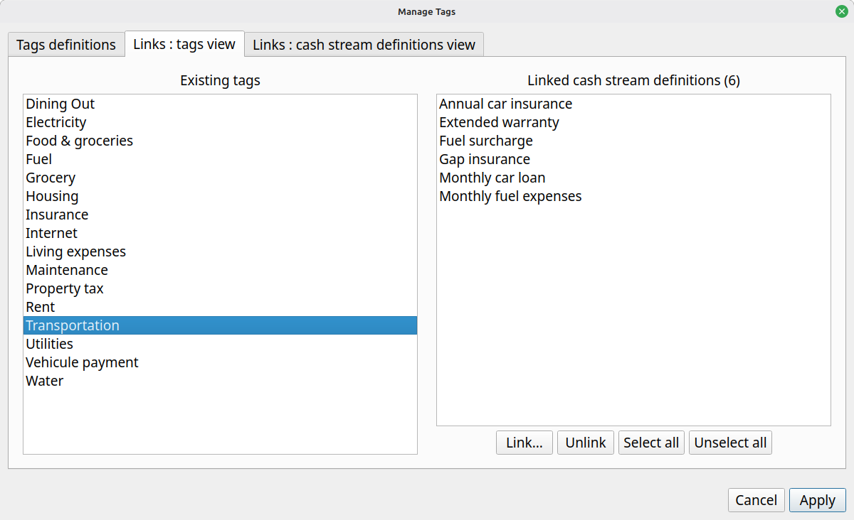

The end result of this is that in the “Tags” section of the Analysis module, every tag defined would see their real total contributions of every “level” of the hierarchy. To illustrate this, if we define the following amounts for the CSDs :

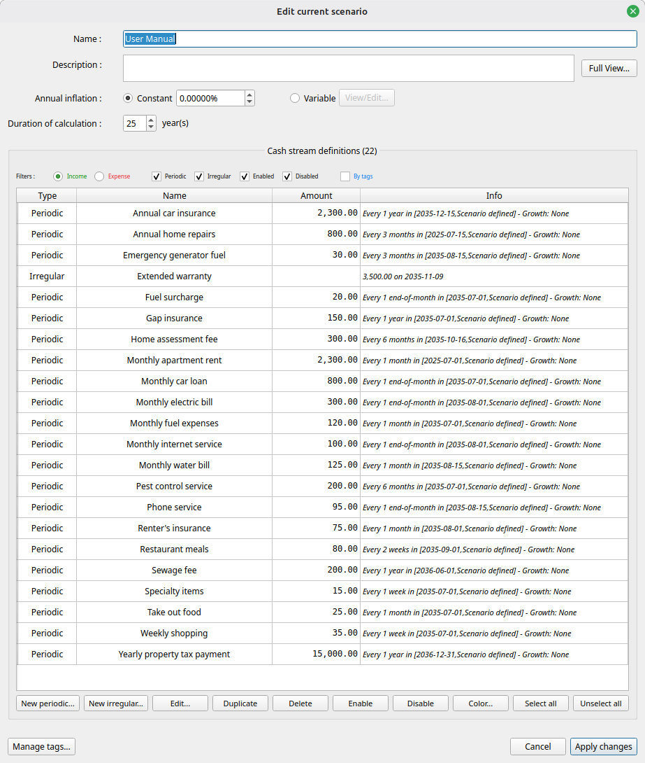

We then get the following tag report :

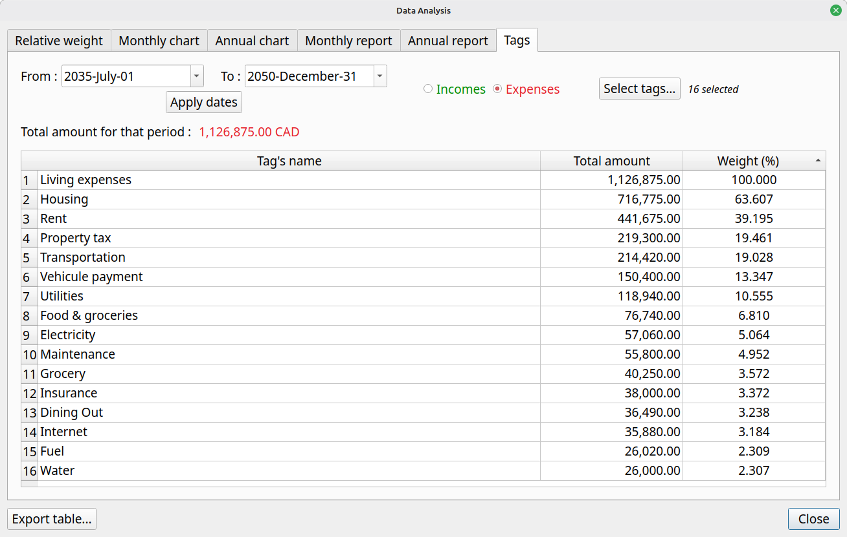

Using a budget scenario as time goes by

Typical workflow
Once a budget is created, user will launch the program from time to time in order to either look at the budget, to modify the scenario’s data or to make some analysis. The following is a brief description of the typical way to use GBP, as intended by the author.

The standard workflow relies on the default behavior of GBP to read the date of "today" from the system’s date at launch time. This can be changed in the Options, but in that case it leads to the "alternate workflow" described in the following section.

Set "Start amount as of today" value
First, right after launching GBP and a scenario is loaded, the user should update as soon as possible the "Start amount as of today" value.

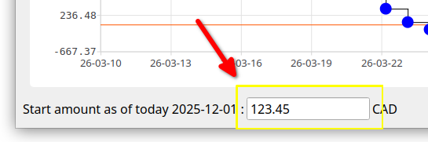

The basic assumption behind this approach is that it is easy to collect the net cash balance of the user (e.g. by looking at the balance of all "checking" bank accounts) or net value. This is what is entered in the "Start amount as of today" field, as it represent the current cash balance as of "today" (or net value) and constitutes the initial condition on top of which the future incomes/expenses will be added. Think of it as a "baseline".

Inspect the cash balance curve and analysis module
Once this is done, user will typically do the following :

- Spend a lot of time changing the range of the displayed Cash Balance curve (zooming, panning, predefined range buttons at the top) and looking at how the cash balance evolves over time. This gives a good idea of how well the user is doing.
- Selecting miscellaneous points in order to know what financial events that occurred on a specific day and see their effects.
- Looking at the Analysis module to inspect the evolution of monthly/yearly cash balance or to evaluate the relative weight of incomes/expenses over a custom period of time. The latter allows for quick identification of the most influential incomes or expenses.

These activities will allow the user to better understand his current financial situation and help making appropriate decisions, which is the goal of GBP. For example :
- If the cash Balance curve gets dangerously close to 0 during a certain period of time, user may decide to delay or to reduce some expenses, like vacations, buying a new car, etc, or rather increase its incomes.
- A monthly cash balance (as reported in Analysis module) that is decreasing over time may lead to the conclusion that some decisions are required in order to be in better shape financially speaking.

Play with the scenario data and look at the results
- By changing the amounts or properties of some Cash Stream Definitions and seeing the effect on the curve, user can see for example if he can afford certain expenses (e.g. "Should I reduce the budget allocated to eating out and by how much ?")
- Many simulations can be conducted by playing with the Cash Stream Definitions of a scenario, including enabling/disabling them, in order to see the financial impact of major life changing decisions (e.g. retirement, changing job, starting a business, moving to a different country, doing a PHD or not, go back to school, downsizing the housing expectation) .

Improve readability using colorization of name
In order to distinguish groups of incomes/expenses from one another, user will typically use the "Colorize name" feature of a Cash Stream Definition. For example, he may use blue color to identify expenses related to car :

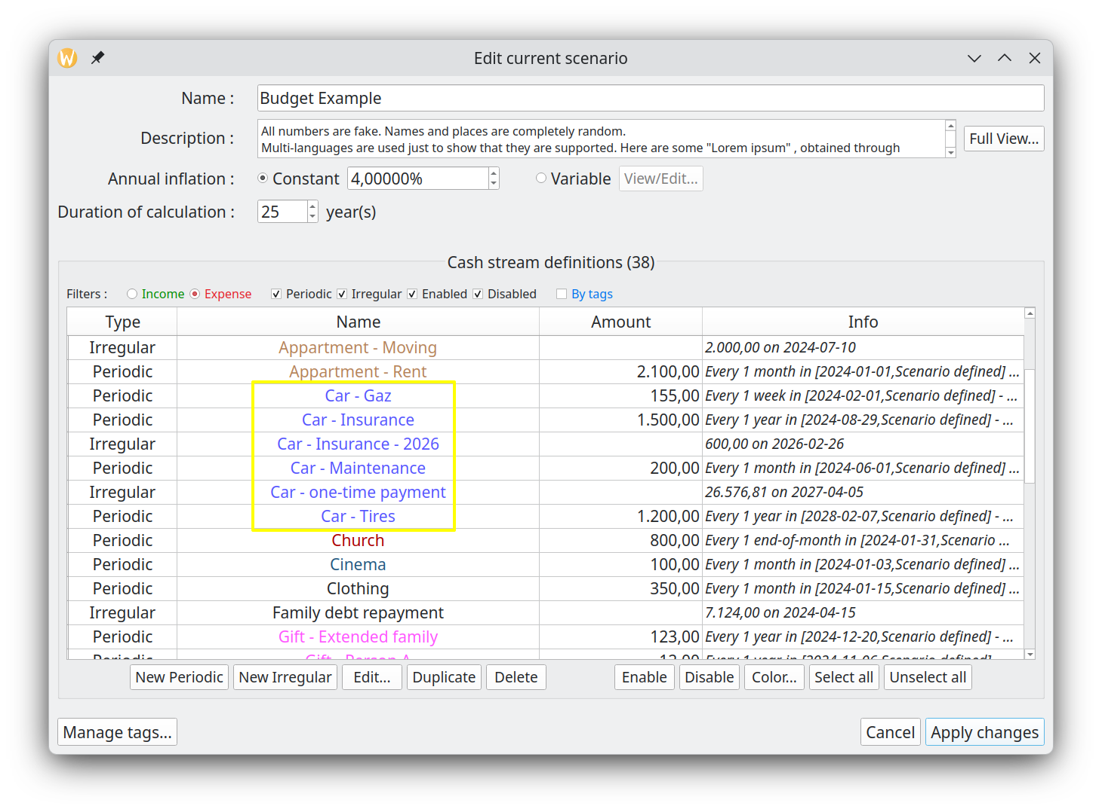
Not only is it easier to identify them in the list of Cash Stream Definitions in the "Edit Scenario" window, but identification is also easier in the "Selected Point Info" of the Main Window :

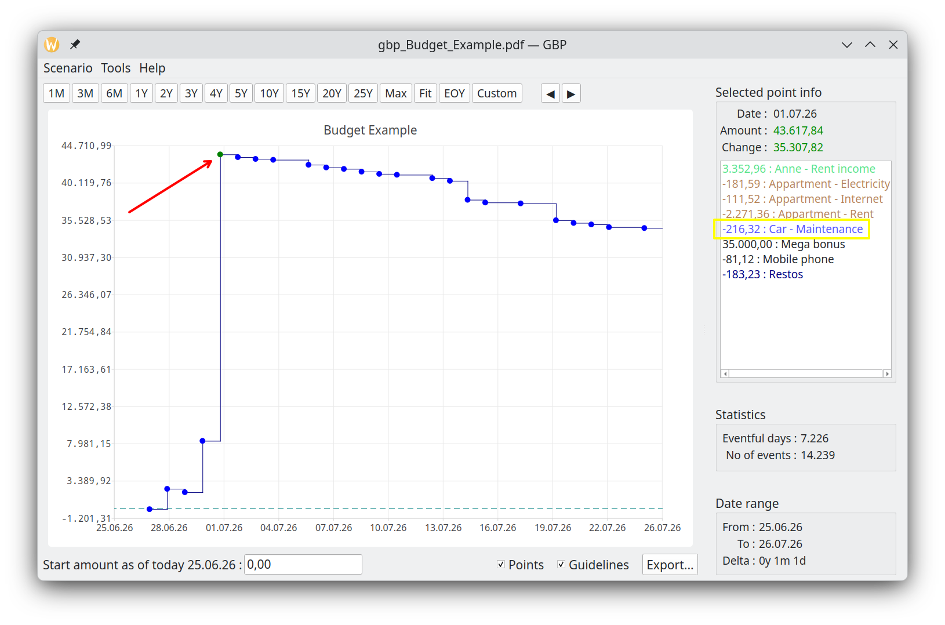

Alternate workflow

What is the alternate workflow ?
It is essentially the same as the "typical" one, with one very important difference : the date of "today" is not read from system’s date at startup (which is the default behavior), but is rather set to a custom value obtained from GBP configuration settings.

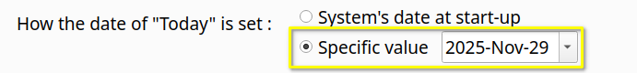

This means that the view provided by GBP is "frozen in time", since the date of "today" does not change each time the program is launched. The date of "today" can be seen at the bottom of the Main Window :

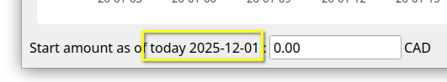

When can this alternate workflow be useful ?
There could be some situations where :

- For an income/expense, you may have configured it to occur at a specific day in the month for example, but in reality you don’t know for sure when it occurs
- For an income/expenses, the day of occurrence may change from time to time.
- The current cash balance can be difficult to collect

For example :

- Case 1 - Periodic monthly Health Care expense : you may set it for the 15 of every month, for convenience purpose, but in reality it may happen anytime in the month, more than one time. You could also decide to make it a daily expense, which kind of average it out and makes the use of the alternate workflow not required. But the inconvenient is that you will get a lot of Financial Events daily that are "less real".
- Case 2 - Periodic investment incomes due for end-of-month : you may get them sometimes earlier in the month. It could be dividend payments that you scheduled every end-of-month for sake of simplicity, but in reality they occur at different moments in a month from time to time. For example :
    - mars 2035
      - on the 15th : monthly dividend from stock A
      - on the 28th : trimestrial dividend from stock B
    - April 2035
      - on the 15th : monthly dividend from stock A
    - June 2035
      - on the 15th : monthly dividend from stock A
    - July 2035
      - on the 15th : monthly dividend from stock A
      - on the 27th : trimestrial dividend from stock B
All is fine if you "retrieve" the dividends from your investment accounts at the end of the month, since they will have have been collected and be part of your end-of-month Cash Balance amount. But if you get some of them on, lets say, the 15th and transfer the amount on the 16th, you will have an inaccuracy if you log in GBP the [16 – 31] period, as your cash balance will already have been increased by the dividends collected and transferred, but your Financial Event Stream definition states that you still have to receive it by the end of the month.
- Case 3 - you may have difficulty accessing the accounts or you have too many sources that contribute to determine your "current cash balance" amount.

To alleviate these situation, you may decide to use the alternate workflow and update the budget only at the end of the month for example, where all the intra-month incomes/expenses will have occurred. Meanwhile, to work with GBP before the coming end of the month, you :

- set the date of today as the "last end-of-month"
- set the same "current cash balance" you had at the end of the last month.

Future values vs present values
*** This is an advanced topic. ***

By default, all the financial event amounts produced by GBP are "Future Values", meaning the actual "nominal" values, as produced by the Cash Stream Definitions. A periodic income of 1000$ a month will still produce 1000$ for every month until the end of the validation interval.

The problem is that these amounts occurring so far in the future are in fact worth less than today’s equivalent nominal amounts, due to several economic factors, such as :

- Inflation: The value of money depreciates over time due to inflation. As prices rise, the purchasing power of a dollar decreases, making future values worth less.
- Opportunity Cost: Money received in the future has less value because it cannot be invested or used immediately. This means that money received today can produce return on investment (interest, dividend, capital gain, etc) or be used for immediate needs, whereas money received later has less potential for growth or utilization.

Inflation is already modeled quite well in GBP. For "opportunity cost", it can be approximated using the conversion to Present Value. The conversion is enabled in the Options Dialog (item "Use Present Value"), where a "annual discount rate" in percentage must be provided by the user for the calculation to proceed. The conversion not only affect the Cash Balance curve displayed in the Main Window, but also all the data presented in the Analysis Window. Note that the conversion is on a monthly basis, meaning that all the amounts in a given month use the same conversion factor from future to present values. This simplification is perfectly adequate considering that we are looking at data in the far future and the annual discount rate is by itself an approximation.

The conversion to "Present Values" is useful when one looks at the general trend of the Cash Balance curve over a long period of time (many years). This can help to prevent misinterpretation of a climbing curve by thinking one accumulates a surplus over the years, as in reality it could be the inverse. The inconvenient of using this option is that all the financial event amounts (specially the short term ones because they are so close to the present) lose their intuitive interpretation : a Salary of 1000$ in 24 months will be actually a different amount (like e.g. 800$, depending on the discount rate used).

Take for example this 50-year cash balance curve : a simple monthly salary of 1000$ following a 4% inflation rate.

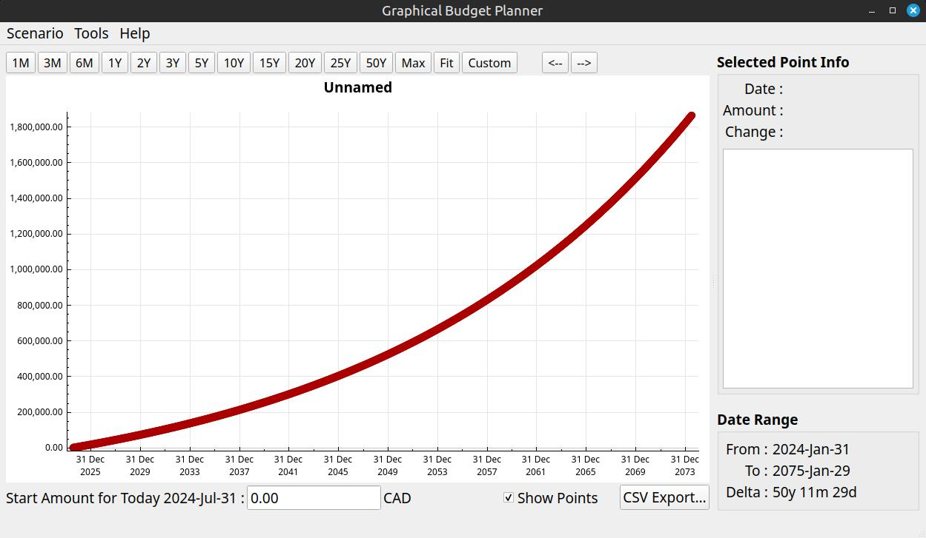

All seems fine, as the curve is "ascending"... However, by converting to Present Values using a discount rate of 8% (the "opportunity cost"), we obtain this :

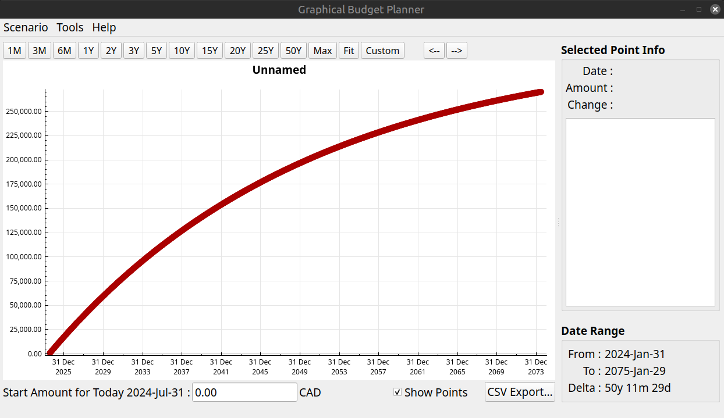

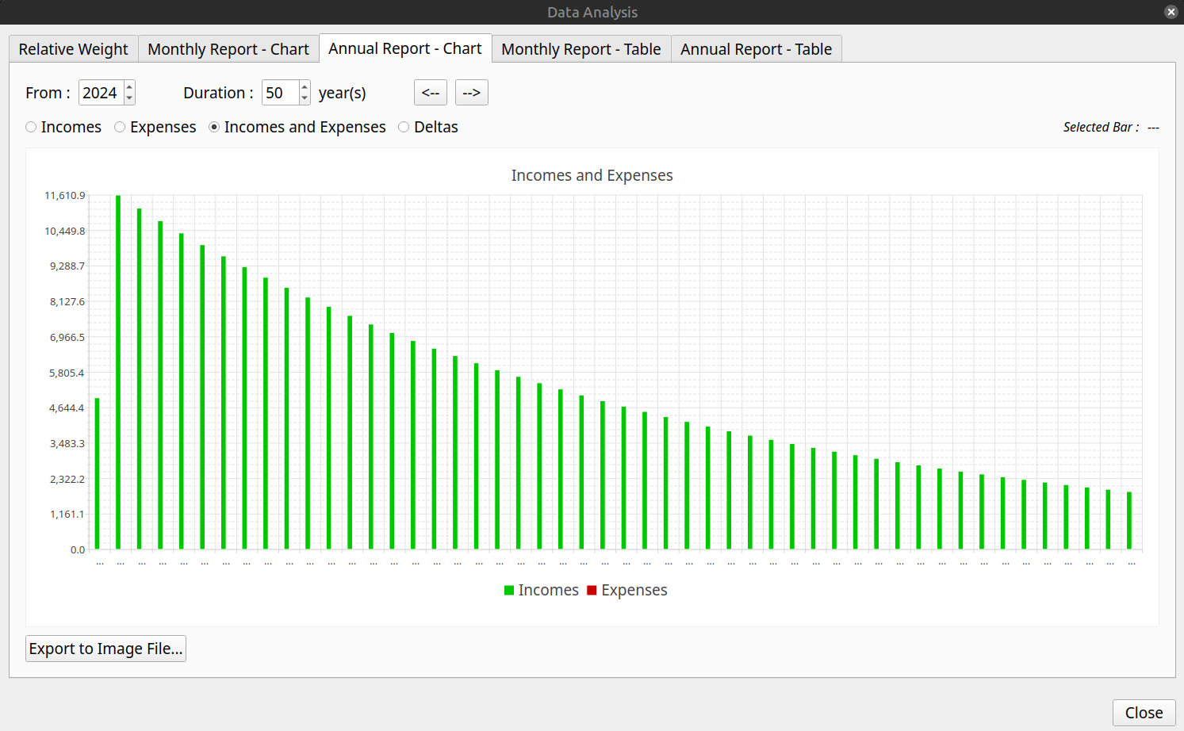

We can see that the surplus is actually diminishing every year in terms of Present Values, which may represent a problem for a personal budget. This is a conclusion that would not be possible to make as easily if only future values would be used.

Command line parameters
It is possible to alter some behaviors of GBP by passing some parameters on the command line when starting the application.

Getting help

-h, --help
Goal :
Display help message and exit.

Appearance options

-usesystemfont
Goal:
Force the use of the default system font (all platforms).

Explanation :
In Options, if ever the user selects a font that make the text unreadable to him, GBP can be started again in a terminal window with the argument "-usesystemfont". This will reset the font to system font.

-windowslook=STYLE
Goal:
Set Windows style (Windows only).

Explanation:
STYLE can be:
- fusion - Cross-platform Fusion style (default)
- native - Windows 11 native style
- vista - Windows Vista style

Example :
-windowslook=fusion

Display server options

-xwayland
Goal:
Force XWayland instead of using native Wayland (Linux only).

-noxwayland
Goal:
Prevent switching to XWayland, use native Wayland only (Linux only).

Localization options

-locale=LANG-TERRITORY
Goal:
Override system locale (all platforms).

Explanation:
By default, GBP uses the System Locale (language and regional settings). This for example influences how numbers are entered and displayed (decimal separator character, thousands separator character, etc). It is possible to alter this behavior by passing an argument on the command line that forces GBP to use a specific locale. The format of the argument is :

-locale=<L>-<T>

where :
- <L> is a 2 or 3 char string representing ISO 639, e.g. "en", "fr", "ar"
- <T> is a 2 or 3 char string representing ISO 3166 code, e.g. "CA", "US", "SA"

If ever the argument is ill formatted, GBP will revert to default System Locale. The selected final Locale is displayed in the "About box".

Note finally that the UI language itself wont change to something other than French or English if the Locale is overridden by this method. At the moment, only French and English are available for the UI language. If the Locale has the "French" language specified ("fr") (e.g. fr-BE), then the UI will be in French, otherwise it defaults to English.

Example :
-locale=en-US

Logging options

-logprivacy=PRIVACY_CHOICE
Goal:
Enable or disable sensitive data in logs (all platforms).

Explanation:
PRIVACY_CHOICE can be :
- ALLOW_PRIVATE : Allow sensitive data in logs
- PUBLIC_ONLY : Hide sensitive data from logs (default)

Example:
-logprivacy=ALLOW_PRIVATE

-logverbosity=VERBOSITY_CHOICE
Goal:
Set verbose or normal debug logging (all platforms)

Explanation:
VERBOSITY_CHOICE can be:
- DEBUG : Set “debug” logging verbosity
- NORMAL : Set normal logging verbosity (default)

Example:
-logverbosity=DEBUG

Workspace options
Workspace support allows multiple isolated instances of GBP to run side-by-side, each with its own settings file and log files. A workspace is identified by a name of 1–20 alphanumeric characters (letters and digits only).

-workspace=WORKSPACE_NAME
Goal:
Run an isolated instance of GBP with its own settings and log files (all platforms).
Explanation:
WORKSPACE_NAME must be 1–20 alphanumeric characters. The settings file used will be named graphical-budget-planner_WORKSPACE_NAME.ini. Log files will include the workspace name as a suffix (see "Naming" in the Logs section). This allows different configurations for different use cases, for example one workspace for personal accounts and another for testing.
Example:
-workspace=personal

-workspace_list
Goal:
List all workspace configuration files found in the config directory (all platforms).
Explanation:
Prints each workspace configuration file with its workspace ID, file size, last-modified date, and full path. Useful to review which workspaces exist before running a cleanup.
Example:
-workspace_list

-workspace_cleanup
Goal:
Remove all non-default workspace .ini files from the config directory (all platforms).
Explanation:
Deletes all workspace-specific configuration files, keeping only the default graphical-budget-planner.ini. Use this to clean up orphaned workspace files that are no longer needed.
Example:
-workspace_cleanup

Logs
GBP has an internal logging mechanism intended to help debugging, if the need arises. All logs are in English only.

Location
Log files location is indicated on the terminal when GBP starts. The log files location is also indicated in the “About GBP” dialog. On Linux, it should be:

~/.local/share/graphical-budget-planner/logs

Naming
Log file name is created when GBP starts and follows the pattern :

YYYY-MM-DD__HH_MM_SS.txt
When a workspace is active (see -workspace command-line argument), the workspace name is appended:
YYYY-MM-DD__HH_MM_SS_WORKSPACE_NAME.txt

where :
- YYYY is the year of creation
- MM is the month (01 to 12) of creation
- DD is the day in the month of creation
- hh is the hour of creation
- mm is the minute of creation
- ss is the second of creation

Cleaning
Every time GBP starts, it automatically launches a log cleaning process : any log file that has been created more than 100 days ago is erased (i.e. trashed).

Glossary
GBP
Acronym for this application, that is graphical-budget-planner.

Financial event (FE)
The occurrence of a single amount of money at a specific date in time, adding to your global cash balance. The amount is >= 0 for an income, <=0 for an expense. For example, an income of 100.00 on 2029-12-31 or an expense of -234.56 on 2045-01-31

Cash Stream Definitions (CSD)
The set of data that defines an income or an expense, in a conceptual (i.e. declarative) form. For example, a monthly salary of 1234 Euro. From this definition, a series of Financial Events (a financial "stream") can be generated (from the previous example, a series of monthly 1234 Euro).

Financial stream generation
From a CSD, the application automatically "generates" all the financial events when the scenario is loaded. For example, a CSD could define a periodic salary of 2000 USD starting on 2032-01-15 , with no growth, to be repeated every week. The financial events that will be generated by the application would be :
- 2031-01-15 : 2000
- 2031-01-22 : 2000
- 2031-01-29 : 2000
- etc

Periodic Cash Stream Definition (PCSD)
A type of CSD that defines a Periodic Cash Stream Definition, that is an amount that repeat regularly over time. Growth can also be defined to the amount, so that it can actually change with time.

Irregular Cash Stream Definition (ICSD)
A type of CSD that defines a set of financial events occurring in time. Amounts cannot have growth associated with.

Scenario
A file that contains a set of CSD (between 0 and 500), along with some information associated to the context, like a scenario name, inflation rate, etc.

